Table of contents
List of abbreviations 2
PART 1 TECHNICAL GUIDLINES 4
General Information 4
Assigning users to a Partner Report 4
Accessing the Partner Report 5
Editing the Partner Report 6
PART 2 CONTENT OF THE PARTNER REPORT 8
Report Identification 8
Work Plan Progress 10
Public Procurements 11
List of Expenditures 12
Contributions 14
Report Annexes 14
Report Export 15
Financial Overview 15
Submit 16
Reopening partner reports/ Completions to partner report 16
Annex 1: Numbering of Reports jEMS / Subsidy Contract 18

List of abbreviations

DRP Danube Region Programme
Jems Joint electronic monitoring system
LP Lead partner
MA/JS Managing authority and Joint secretariat
PP Project partner
PR Partner report
PPR Project Progress Report

Introduction

This document provides an overview on the content of the partner report (PR) to be provided by project partners.
Reporting is one of the tools used by the Programme to regularly monitor the progress of the projects implementation both financially (spending, budget reallocations), content-wise (progress of activities, delivery of outputs and deliverables, subsequent contribution to the achievement of Programme output indicators and objectives).
Reporting also represents the basis for the reimbursement of the EU contribution (INTERREG funds) associated with incurred project expenditures. Reporting periods are regulated in the Subsidy Contract (SC) concluded by MA/JS with the lead partner (LP).
PRs are comprehensive accounts of project activities performed, deliverables and outputs to which the project partner contributed to as it is concluded in the Application Form. Partner reports do also reflects expenditures incurred and paid during the respective reporting period by PPs in their efforts to succeed with project objectives.
The financial part of the PRs are reviewed by controllers, verifying expenditures reported by PPs.
Verified expenditures (and activities) are consolidated by LP in Project Progress Reports (PPRs) that is subject to MA/JS review and approval. Applications for reimbursements (AfRs) are integral part of the PPRs reflecting EU funds to be reimbursed to the project and to each project partner.

PART 1 TECHNICAL GUIDLINES

General Information
Joint Electronic Monitoring System (JEMS – jems.allamkincstar.gov.hu) is the platform to record and to reflect details on the Programme and on call for proposals, details on projects and on project partners.
Once a project proposal is selected for contracting and after contracting documents are submitted and accepted, the project status in JEMS will display “Contracted”. LP assigns project partner users in the Project privileges section, and partner reporting becomes available for PPs.
PRs cover activities and expenditure on partner level in the respective reporting period. All PRs need to be created for reporting periods as defined in the Subsidy Contract and in the application form. The deadline for the preparation and submission of the partner report for verification by the controller is 15 days from the end date of the respective reporting period. The PP is expected to brief the LP on project activities even in case no expenditures are reported in a reporting period.

Assigning users to a Partner Report
It is the task of LP to assign users for Project Partners (PP). PPs can have one or more users. User(s) will then have access rights to the PR of the PP they are assigned for.
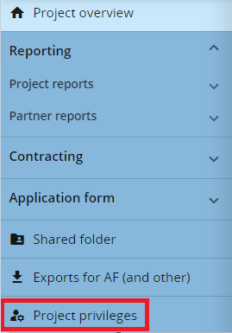

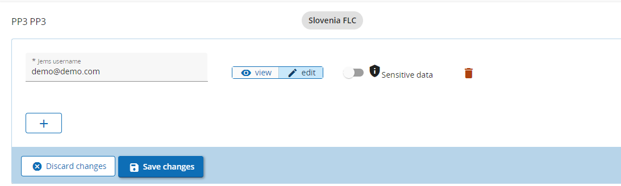

Credentials for users might be to view partner reports and to edit partner reports. Sensitive data switch controls access to data marked as sensitive. Data marked sensitive will be displayed only to users with Sensitive data control switched on.
One project partner can have one or more users added.

Accessing the Partner Report
To access the PR, the partner has to log in with his/her username and password and then select the project from the Dashboard.
If a user has multiple roles in the project (e.g. LP and PP), it is necessary to select the role from the navigation pane.
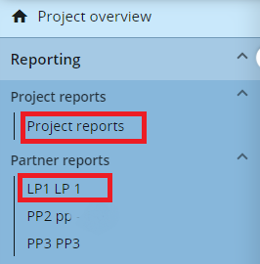
PPs will prepare PRs clicking on the +Add Partner Report button.
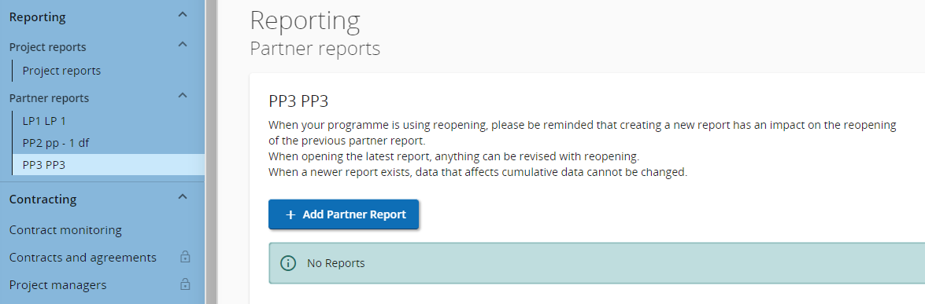

Editing the Partner Report
Partner reports have multiple sections:
- Report identification
- Work plan progress
- Public procurements
- List of Expenditures
- Contributions
- Report annexes
- Report export
- Financial overview
- Submit
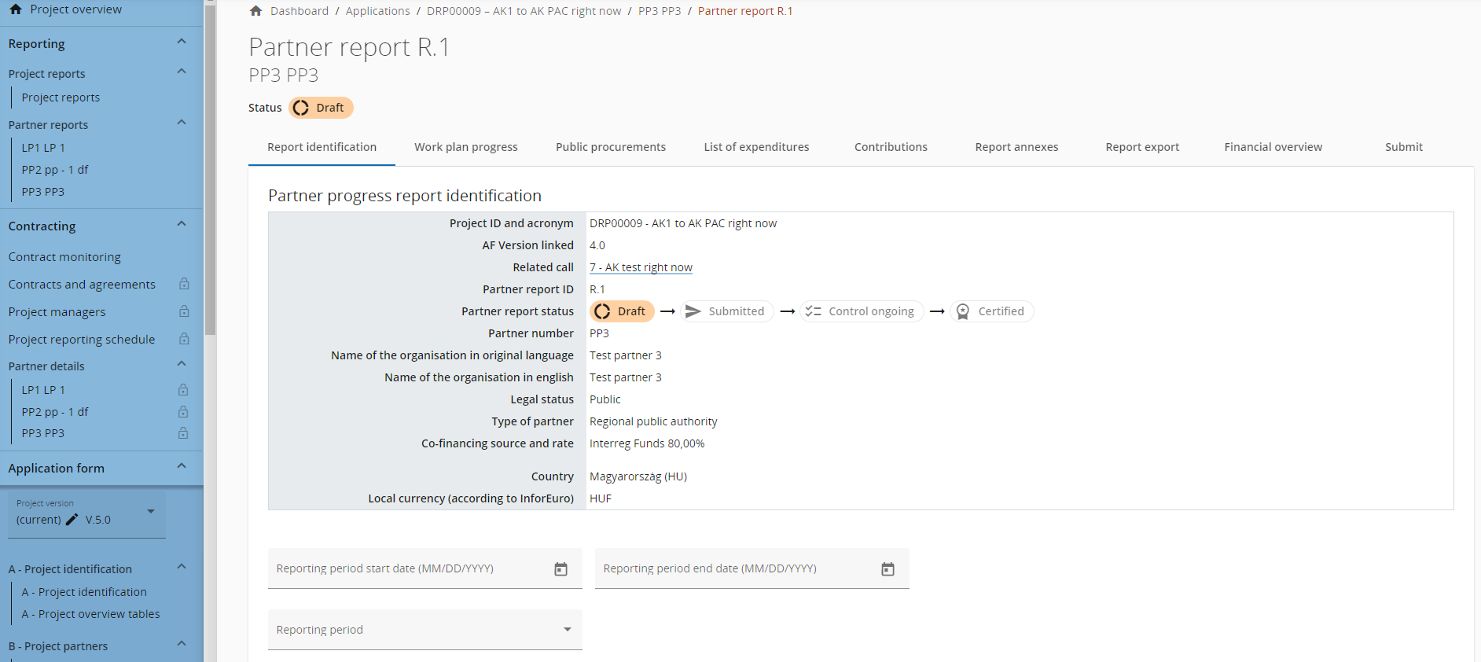

Each field has a label with short description advising on the expected information to be inserted.
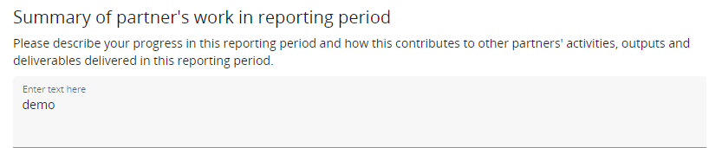
Once started editing, Discard changes and Save changes buttons at the bottom of the page will became active. The partner can stop editing anytime and can decide to keep or to discard changes.
It is recommended to Save each completed step in the Partner Report.
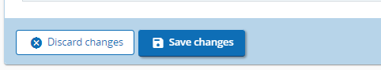
Editing can be resumed anytime upon convenience.
If partner report editing has been stopped its status will be on Draft. Editing can be resumed by clicking on the relevant partner report.
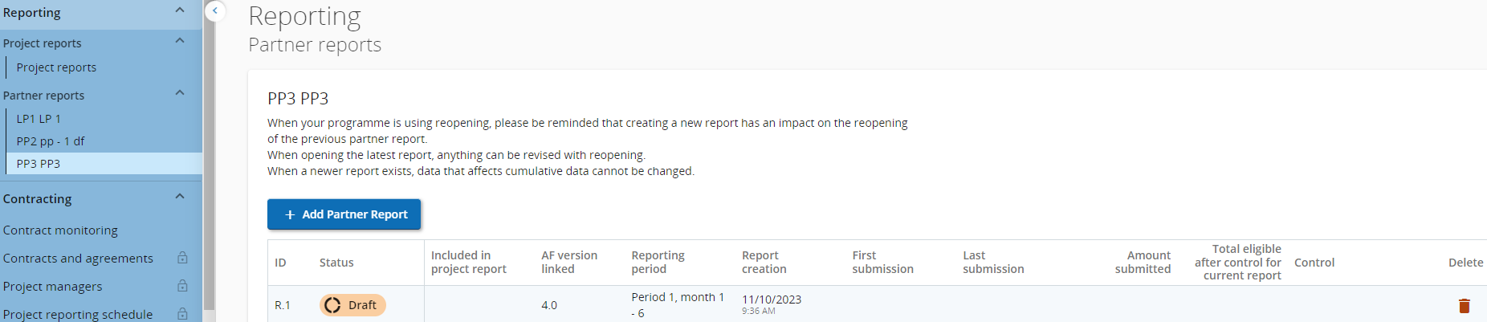
In PART 2 Content of the Partner Report of this document there is a presentation of each section to be addressed in the partner report.

PART 2 CONTENT OF THE PARTNER REPORT

Report Identification
It collects information about the Reporting Period, Summary of partner's work in reporting period, PP problems and deviations, Partner spending profile including explanation for deviations from the spending target, Target groups and their involvement in the project implementation during the reporting period.
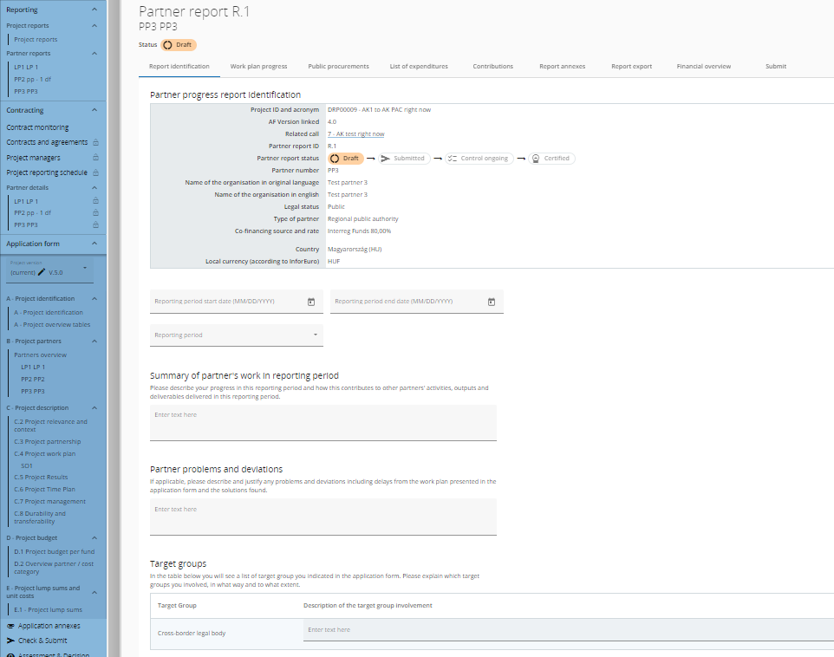
The start date and the end date of the reporting period needs to be inserted manually and normally it needs to be in line with the start date and end date of the respective reporting period from the Subsidy Contract. In duly justified cases, based on MA/JS confirmation, shorter reporting periods (interim reports) are possible.

1st PR - IMPORTANT: the first PR covers as per DRP Programme rules exceptionally 12 months (whereas all other PRs cover just 6 months). For handling the 1st PR in jEMS please proceed as follows:
- Open a PR directly for period 2 (do not open a PR for period 1 at all, start with period 2)
- Enter in the field “Reporting period starting date” 01.01.2023 and under “Reporting period ending date” 31.12.2023.
- Provide all content-related information and all expenditure for the entire year 2023 in this report
- Please add in the content part of the PR under “Summary of partner's work in reporting period” a brief reference that this first PR is covering the 12 starting-months of the project, in line with DRP Programme rules.
- Inconsistencies between jEMS and the Subsidy Contract in terms of numbering the reports cannot be avoided. Annex1 of this document gives clear guidance on the numbering of reports for LPs and PPs

Summary of partner's work in reporting period
The description should focus on the content related achievements and should not tackle project management and administration issues. The qualitative aspect of the outputs and results should be highlighted, rather than the quantitative one.
The summary should be coherent, easy-to-read, self-explanatory, and it should not refer to other parts of the report. The PP shall pay attention to the quality of the text (which should be neither too technical/ scientific, nor too specialised so that it is easily understood by any non-expert).
Partner problems and deviations
Problems and deviations to work plan should be presented, and the solutions proposed to overcome them.
Partner spending profile
Partner spending profile mirrors the financial progress of the partner toward its budgeted objectives.
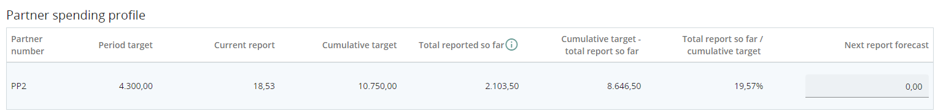
It provides information on the current reporting period in terms of expenditures planned and expenditures reported, and it also mirrors sum of expenditures reported in all past reporting periods vs plans.
Field to edit is in the last column “Next report forecast” where project partners needs to advise on foreseeable expenditures for the next reporting period.
Target groups
It is a table with target groups indicated in the application form. Explain which target groups have been involved, in what way and to what extent.

Work Plan Progress
The work plan progress tab reflects specific objectives listed in the application form.
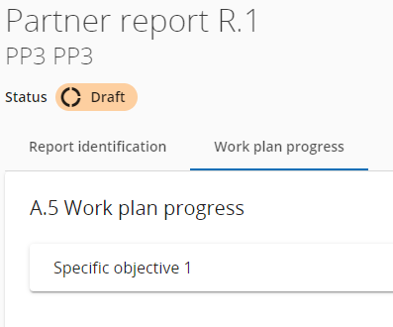
Click on the specific objective to start editing.
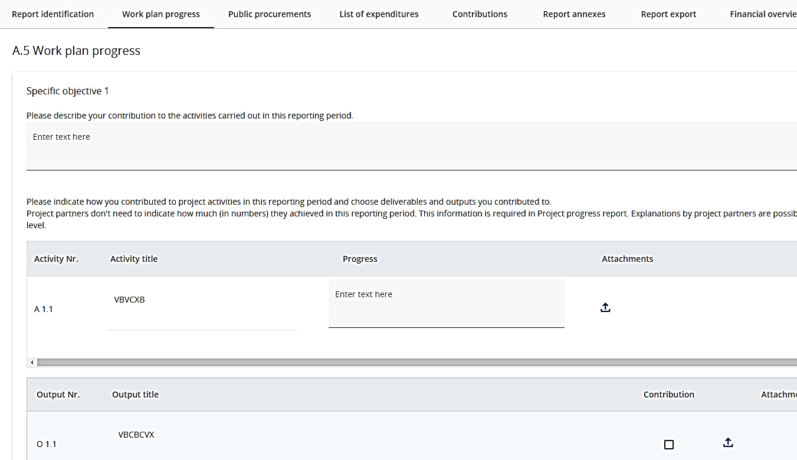

The PP should describe the progress of his activities in the concerned reporting period. For each deliverable and output the PP can mark its contribution by ticking the box and upload proofs and attachments to deliverables and outputs, if relevant.

Public Procurements
In the “Public procurements” section project partners should fill in information on project related procurements. This applies for contracts above €10.000 (excl. VAT) – unless stricter national rules apply. Regardless in which report a procurement is added, it will show up in all following partner reports. A procurement can only be deleted and edited in the report where it was created. Beneficial owners, Sub-contractors and attachments can still be added in future reports
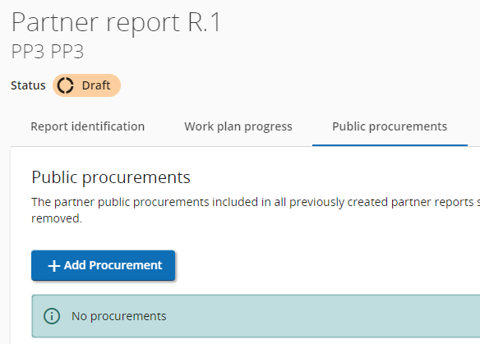
Adding a Public procurement will bring up multiple fields to edit. For procurement above the EU threshold, it is obligatory to provide information on the beneficial owner(s) and subcontractor(s). In case of amendment(s) to the procurement, the amended contract(s) should be uploaded in the attachment section of the procurement concerned.
GDPR sensitive data can be uploaded in section GDPR Attachment(s). Visibility of this section can be configured in Project privileges. A user without privilege to view sensitive data cannot download a file in this section and can also not see File name and Description.

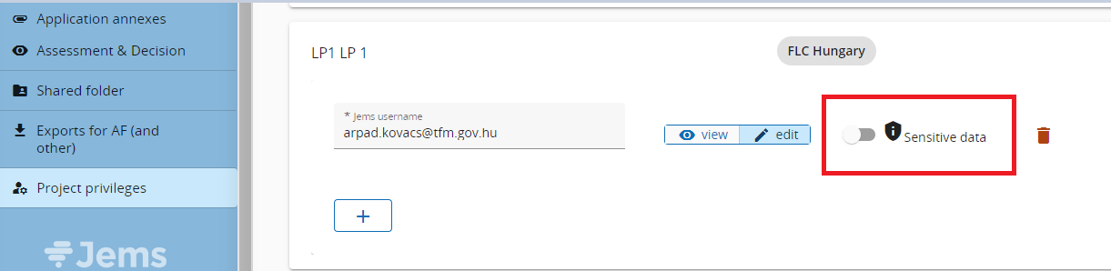
It is possible to add one or more Public procurements.
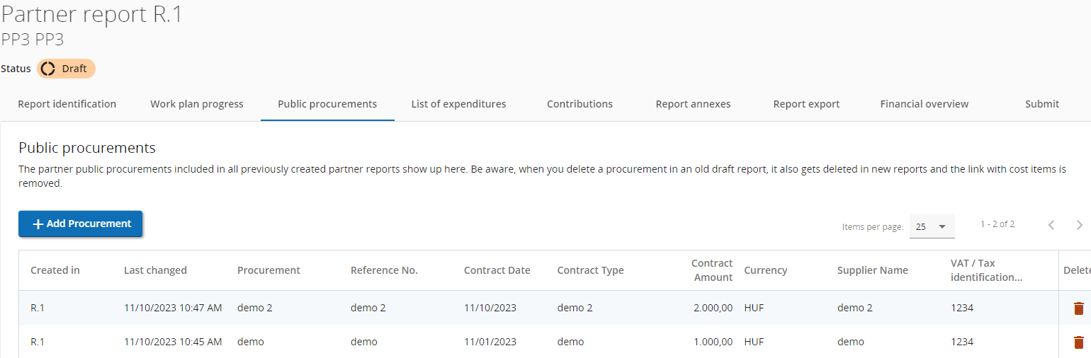

List of Expenditures
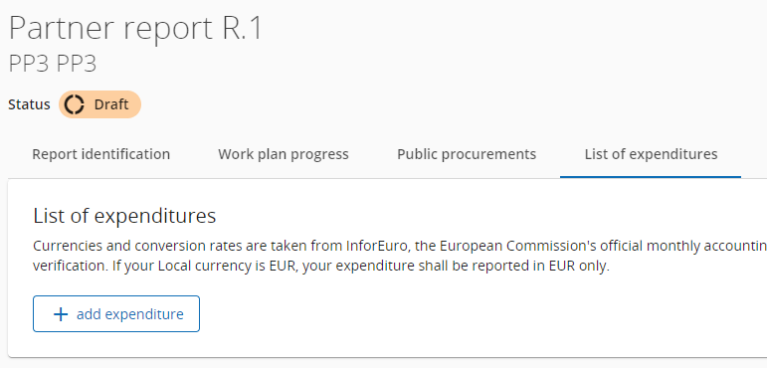
Use the linear scrollbar to display all fields to edit.
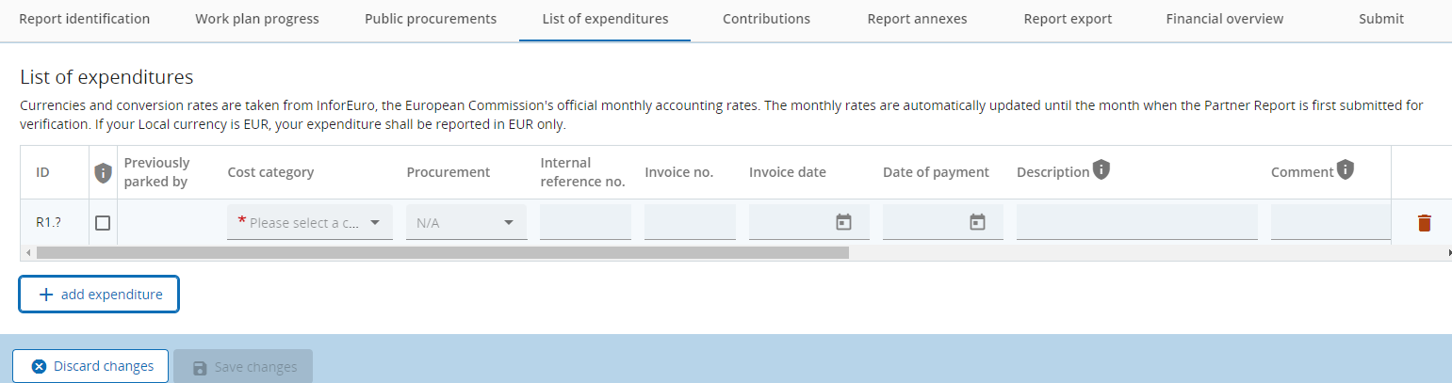
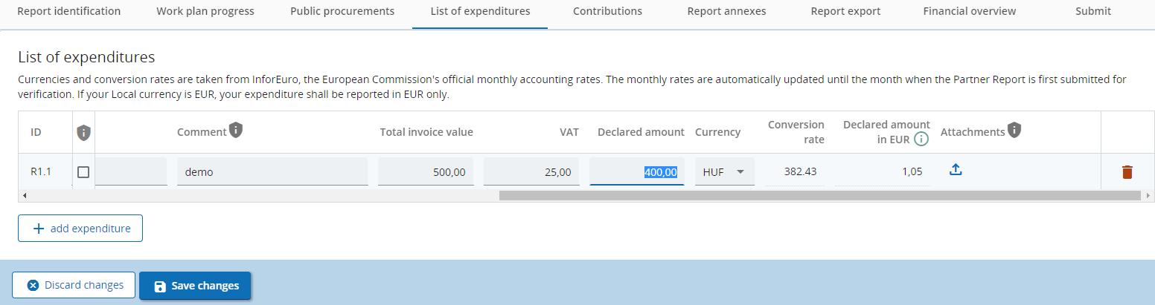
The conversion rate is automatically selected.
Upload proofs on expenditures to Attachments at the end of the records. The Upload will be active after the record is previously being Saved.
Expenditures parked by Controllers in previous reports will be displayed in the Parked Expenditures sub-section. Actions on parked expenditures might be to Re-Include or to Delete. If no action performed, parked expenditures will be carried forward to subsequent reporting periods.
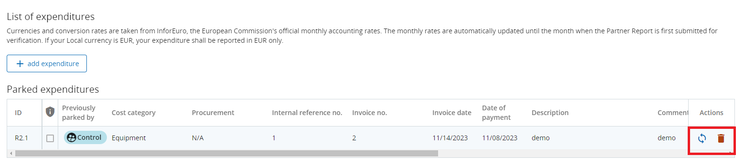
Please report expenditures that are in line with provisions of DRP Manual on eligibility of expenditure, EC and national regulations. Pay attention the payment date does not exceed the end date of the reporting period (except the last reporting period where payment date can exceed the end date of the project with max 60 days).

Contributions
Partner Contributions are followed-up and are monitored with each report and should reflect the Application Form in each reporting period. Project partners should always fill in this section as per the values reflected in the Financial overview section.
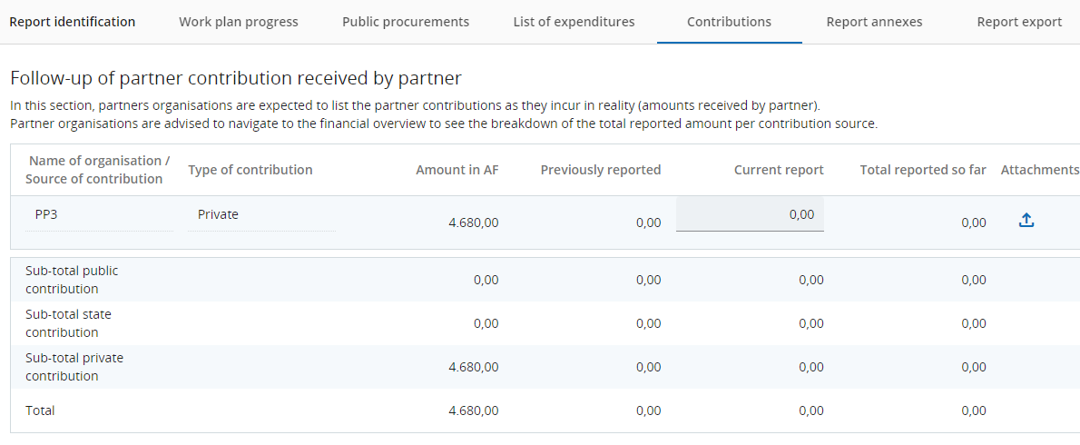

Report Annexes
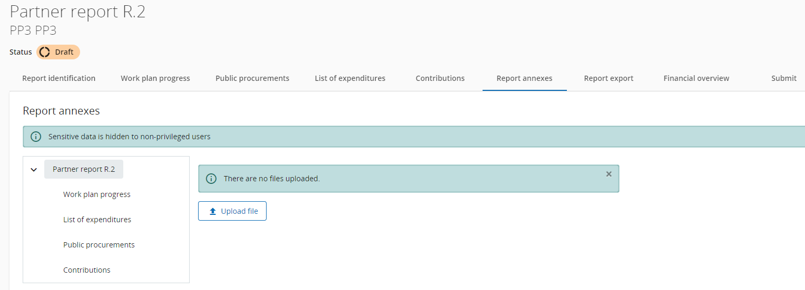
Report Annexes lists attachments uploaded in other sections of the current partner report. It also offers the possibility to upload additional attachments, like approvals and supporting documents regarding on minor changes to the project.
Project changes (major changes and minor changes) to projects are regulated by the Implementation Manual, however in case of minor changes to the partner budget, supporting documents and/or MA/JS approvals concerning those changes are to be uploaded within the Report annexes section (this section) of the partner report: B1_Change Log File providing justification for the reallocations and Annex B2 Minor reallocation tool.

Report Export

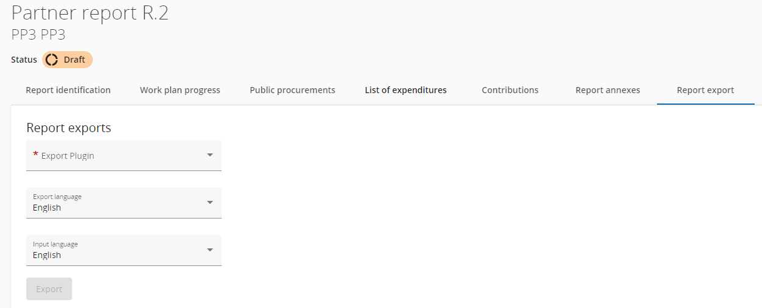

Report Export is optional. It offers the possibility to export details of the partner report. into an excel or PDF file. Selecting one of the Export plugins activates the Export button.

Financial Overview
This section of the partner report summarizes expenditures included in the partner report. It also reflects the partner budget, amounts previously reported, expenditures previously parked by the controllers and parked expenditures re-included in the current report. The financial overview tables show how the project partner is proceeding in terms of spending.
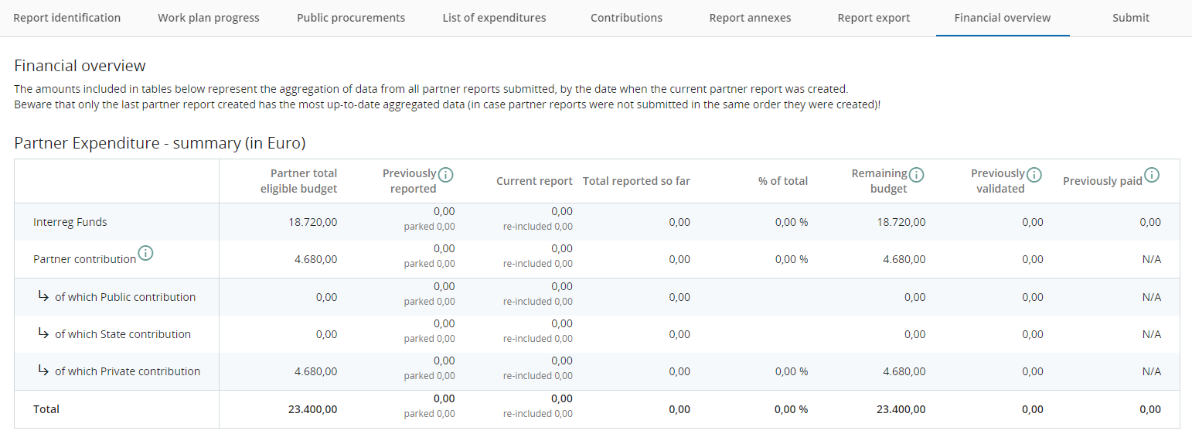
There is a sub-section reflecting Partner expenditure breakdown per cost category.
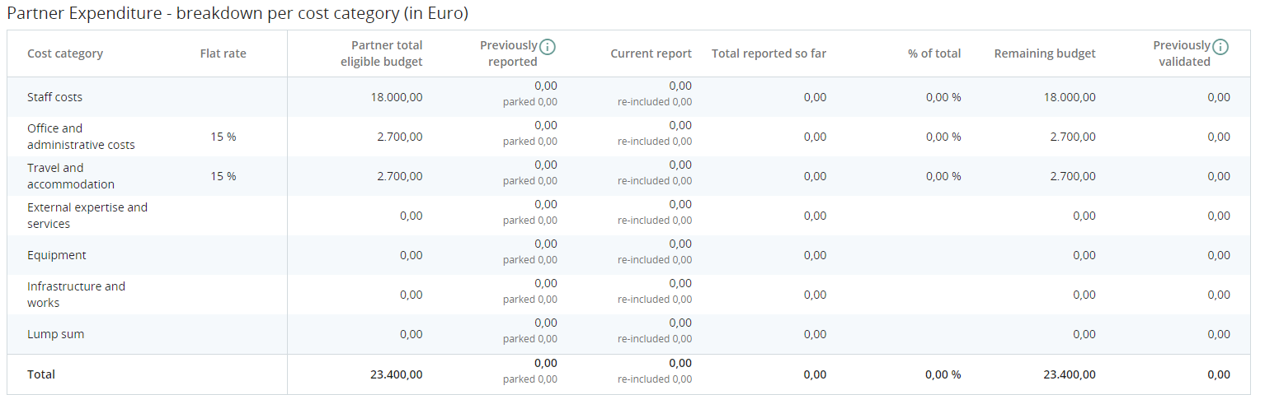
If the partner has preparation costs or investment costs there will be 2 separate tables with the relevant data.

Submit
Before submitting a partner report running pre-submission check is mandatory. If it is the case, hints on missing mandatory records will be displayed. Submit partner report button will be active after successful pre-submission check.
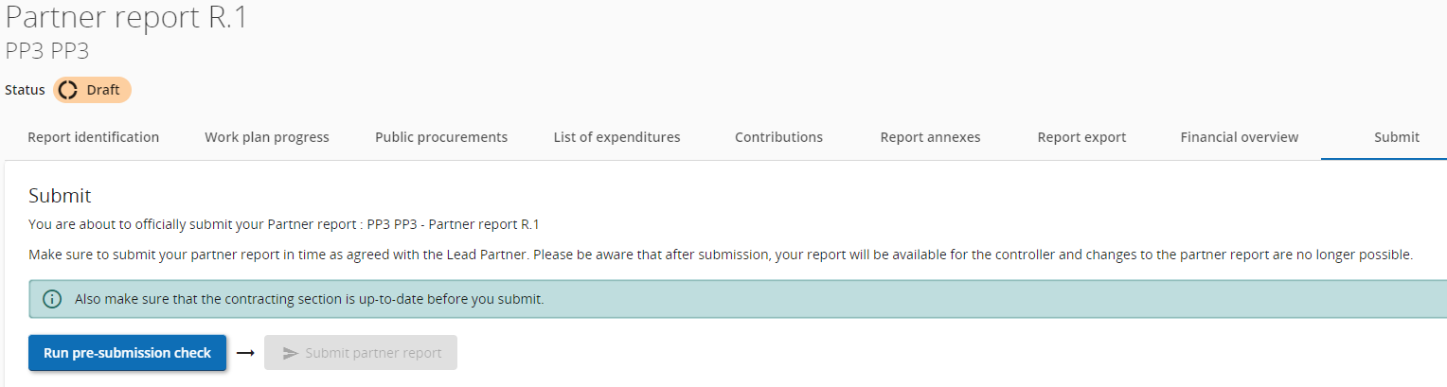
After submitting the PR is frozen and the control work can start.

Reopening partner reports/ Completions to partner report
During the control work, Controllers have the possibility to reopen partner’s reports to allow PPs to apply Completions to the partner report.
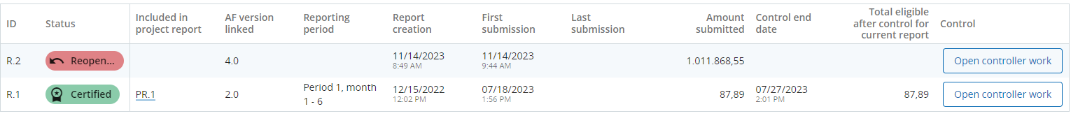
Partner reports reopened will have most fields editable, with the following exceptions:
- expenditure item ID, currency and exchange rates are frozen from initial report
- no new expenditure item can be deleted (but can be edited)
- no new expenditure item can be added (in order to avoid exchange rate issues)
- Parked expenditure list is visible and any item from it can be deleted or added to the reopened partner report
Procurements created in current partner report can be further edited, for older ones only new additions of beneficial owners/subcontractors/attachments is allowed.
Previous uploads are displayed and can be changed, except in Report Annexes tab, where user can only add new ones.
Not only the last created partner report can be reopened, but also previous reports. In that case only the following data will be editable:
List of expenditure tab:
- following fields are editable: GDPR flag, Link to procurement, Description and Comment
- no expenditure item can be deleted / no new expenditure item can be added (in order to avoid exchange rate issues)
- Parked expenditure list is not visible
- Expenditure item attachment can be changed/uploaded
Public Procurements created in current partner report cannot be deleted, but can be further edited, except procurement name, which is locked.
Contributions tab: only changing attachment is allowed
Report Annexes tab: user can add new uploads
Upon (re)submission of a Reopened partner report the partner report goes back to the status from before reopening, namely Submitted or Control ongoing. No recalculation of exchange rates happens but financial overviews are refreshed, reflecting changes done. The partner report overview is populated with updated Amount submitted and Date of last submission.

Annex 1: Numbering of Reports jEMS / Subsidy Contract
Report Nr. SC | Report Nr. jEMS | Timeframe | Submission
1 | 1 | 01/01/2023–31/12/2023 | 15/01/2024
 | 2
2 | 3 | 01/01/2024-30/06/2024 | 15/07/2024
3 | 4 | 01/07/2024-31/12/2024 | 15/01/2025
4 | 5 | 01/01/2025-30/06/2025 | 15/07/2025
5 | 6 | 01/07/2025-31/12/2025 | 15/01/2026
6 | 7 | 01/01/2026-30/06/2026 | 15/07/2026
7 | 8 | 01/07/2026-31/12/2026 | 15/01/2027
8 | 9 | 01/01/2027-30/06/2027 | 15/07/2027
9 | 10 | 01/07/2027-31/12/2027 | 15/01/2028
10 | 11 | 01/01/2028-30/06/2028 | 15/07/2028
11 | 12 | 01/07/2028-31/12/2028 | 15/01/2029

