Table of contents
PART 1 TECHNICAL GUIDELINES 4
Accessing and opening a PPR 4
Editing the PPR 6
Certificates 6
Attachments 6
Submitting the PPR 7
PART 2 CONTENT OF THE PPR 9
Project Report Identification 9
Work Plan Progress 9
Project Results & Horizontal Principles 11
List of Partner Certificates 11
Project Progress Report Annexes 12
Financial Overview 12
Report Exports 13
PART 3 Application for Reimbursement 13

List of abbreviations

AF | Application Form
AfR | Application for Reimbursement
Jems | Joint Electronic Monitoring System
EUSDR | European Union Strategy for the Danube Region
LP | Lead Partner
MA/JS | Managing Authority / Joint Secretariat
PAC | Priority Area Coordinator
PP | Project Partner
PPR | Project Progress Report
PR | Partner Report
SC | Subsidy Contract
SO | Specific Objective

Introduction
This document provides an overview on the content of the Project Progress Report (PPR) and the information to be provided by the LP in each section of the PPR.
Reporting is one of the tools used by the Programme to regularly monitor the progress of the projects implementation both financially (spending, budget reallocations), content-wise (progress of activities, delivery of outputs and results, subsequent contribution to the achievement of Programme output indicators and objectives).
Reporting also represents the basis for the reimbursement of the EU contribution (INTERREG funds) associated with incurred project expenditures.
Based on the contractual obligation, the LP has to submit a half-yearly PPR. The reporting periods are regulated in the Subsidy Contract (SC). The Application for Reimbursement (AfR) is an integral part of the PPR.
The PPR and AfR have to be submitted by the LP to the MA/JS within 3 months from the end date of each reporting period. The PPR is compiled by the LP based on the information provided by the project partners (PPs) in the Partner Report (PR). The PPR must contain a detailed description of the activities implemented as well as the expenditures in relation to a given reporting period.
In the content-related sections of the PPR, the LP has to provide a comprehensive account of the general progress of project activities and related status of deliverables and outputs. Implemented activities have to be in line with the ones described and approved in the AF and have to provide proper justification for the reported expenditure.
In the financial sections, the LP will include all expenditures verified by the Controllers at national level in relation to the reported activities of the project, which are incurred and paid by the LP and the PPs during the respective reporting period.

PART 1 TECHNICAL GUIDELINES

Accessing and opening a PPR

Once a project is set to the status “contracted” in Jems, all steps in relation to the reporting can be performed by a LP.
When entering a project, the section “Project Reports” can be found in the upper left menu.

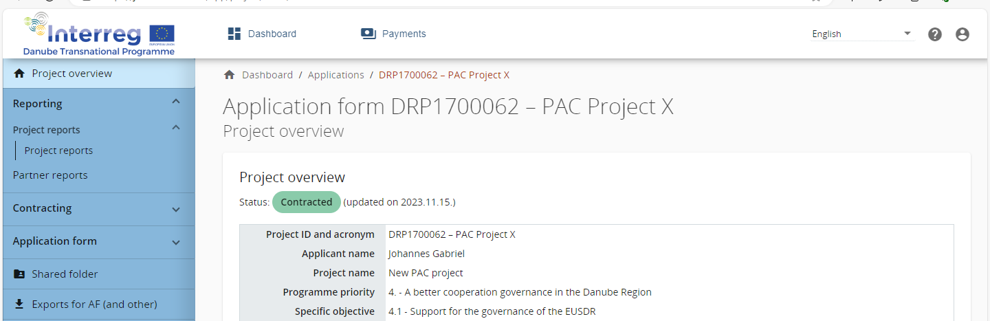

For opening / creating a PPR please click on “Add Project Report”.

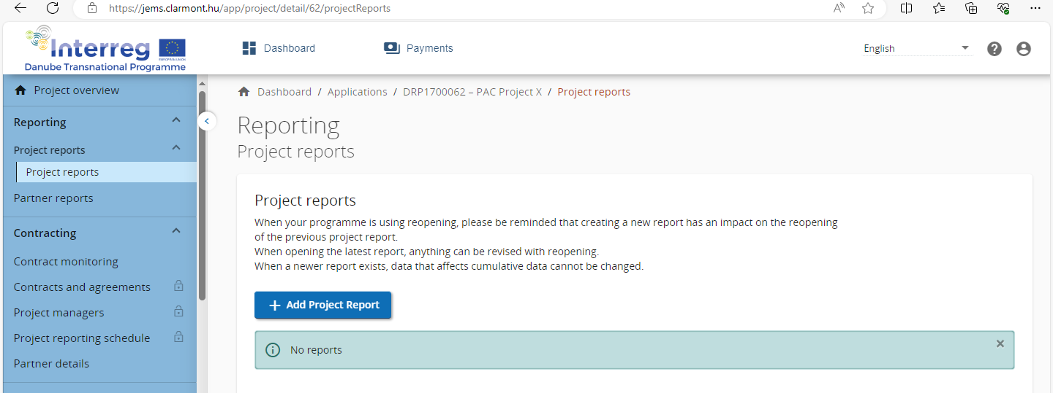

Please select under “Link to the reporting schedule” the reporting period. The fields “reporting period starting date” and “reporting period ending date” have to be filled manually, ensuring that the inserted dates are fully in line with the ones defined in the Subsidy Contract for your project. Further fields are auto-generated.
Press the “create”-button for opening the PPR.

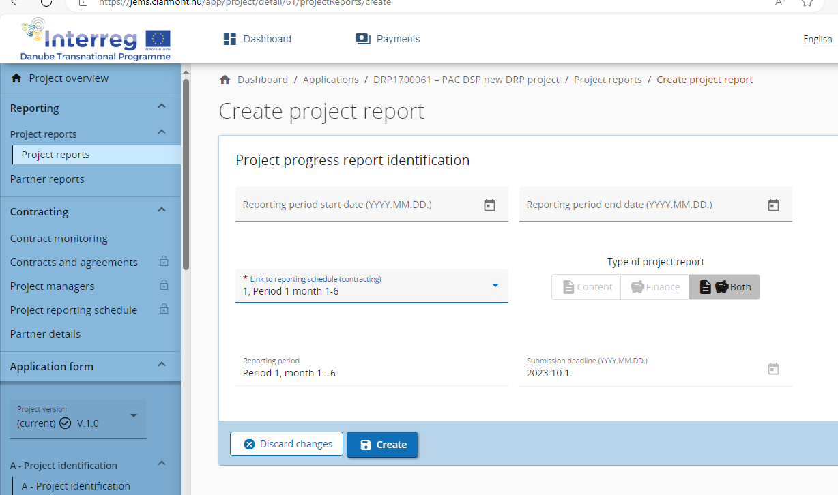
1st PPR - IMPORTANT: the first PPR covers as per DRP Programme rules exceptionally 12 months (whereas all other PPRs cover just 6 months). For handling the 1st PPR in jEMS please proceed as follows:
- Open a PPR directly for period 2 (do not open a PPR for period 1 at all, start with period 2)
- Enter in the field “reporting period starting date” 01.01.2023 and under “reporting period ending date” 31.12.2023.
- Provide all content-related information and all expenditure for the entire year 2023 in this report
- Please add in the content part of the PPR under “main achievements” a brief reference that this first PPR is covering the 12 starting-months of the project, in line with DRP Programme rules.
- Inconsistencies between jEMS and the Subsidy Contract in terms of numbering the reports cannot be avoided. Annex1 of this document gives clear guidance on the numbering of reports for LPs and PPs

Multiple PPRs can be created at any time. There are no restrictions for the number of reports created. Be reminded that any report (if in draft) can be deleted from the overview (most likely only used in the case of a misclick). When reports are created they can be accessed via the overview table.
Important to note is that the data from the last approved AF version is taken into the PPR in the moment of its creation. Ongoing modifications will have no impact on the data in existing reports.

Editing the PPR
The different sections of the PPR are completed either by inserting text, figures, selecting options from drop-down menus and uploading supporting material.
Please always remember to press “SAVE CHANGES” before leaving a section!
Guidance on how to edit each section are provided in Part 2 of this guidelines.

Certificates
Partner certificates are issued by National Controls, who verify of the expenditures reported by PPs in Partner Reports. Partner certificates are electronic, and are used by LPs to consolidate and to compile PPRs.

Attachments
Supporting material can be attached to the PPR either under “deliverables”, outputs” and results by clicking on the respective symbol.
Whereas attachments uploaded in these sections shall specifically relate to certain deliverables, outputs (e.g. evidence for a specific deliverable, output or result, output factsheets or quality reports), more general material (e.g. press releases, information on additional/unforeseen measures or similar) as well as the AfR can be uploaded under the tab “project report annexes”

Submitting the PPR
In this section the PPR can be submitted. In order to be able to submit the PPR the LP has to run the “Pre-submission check”
After submission, the PPR cannot longer be modified and the MA/JS verification can be started.

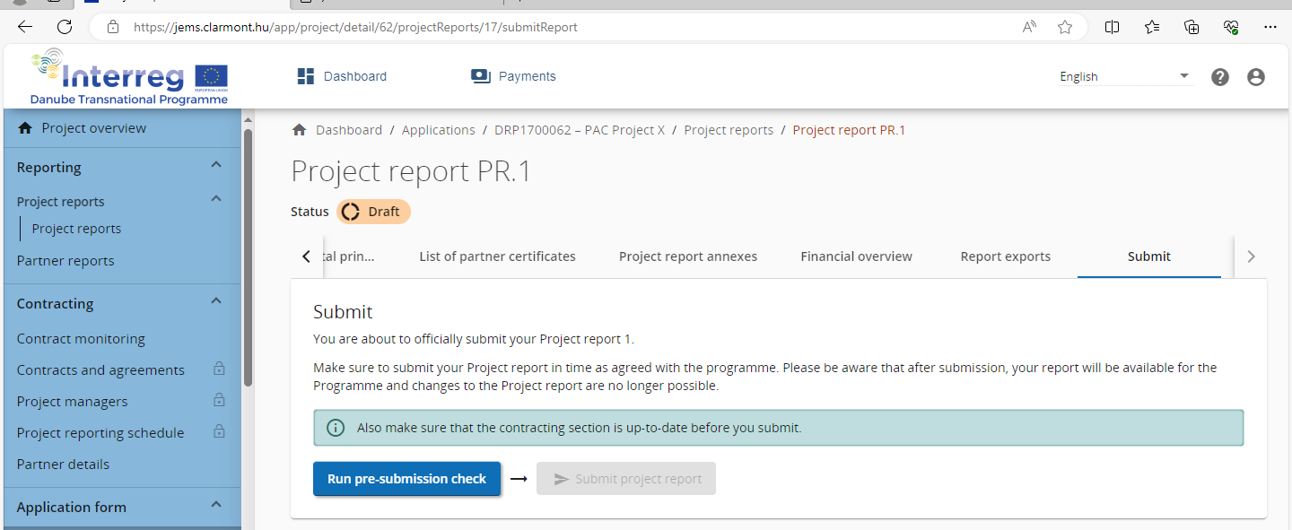

Once submitted, the status of the report changes, which is shown in the project reports section:

PART 2 CONTENT OF THE PPR

Project Report Identification
In this section general information on the overall progress of the project shall be provided in relation to Highlights of main achievements, Partner problems and deviations as well as Target Groups. Explanations shall provide a concise and authentic snapshot of the project progress, avoiding as far as possible mere duplications of details described in the further section of the PPR.
In addition this section serves to visualize accumulated features of the PPR. These self-generated parts – like an overview table of the outputs and results– do not require any action from user-side.

Work Plan Progress
In this section users shall describe the progress on the activities under each specific project objective and communication objective, as well as report on finalised deliverables, outputs and the planned investments.
At the top of each SO form, there is a tickbox to confirm whether “This specific objective is completed.” which has to be marked only when all the deliverables and outputs have been finalised, including Output factsheet and Output quality report has been submitted to the MA/ JS.
For both the project specific objective and the connected communication objective the LP should select the status of achievement between “Fully achieved”, “Partly achieved” or “Not achieved” and summarise the progress made in the reporting period. When the first PPR is created, the Status fields of the Project specific objective, the Communication objective or the Activities are empty. If a prior submitted PPR exists, the Status fields and related text fields of a newly created report are pre-filled with the Status selected for the respective objective or activity in the latest submitted PPR.
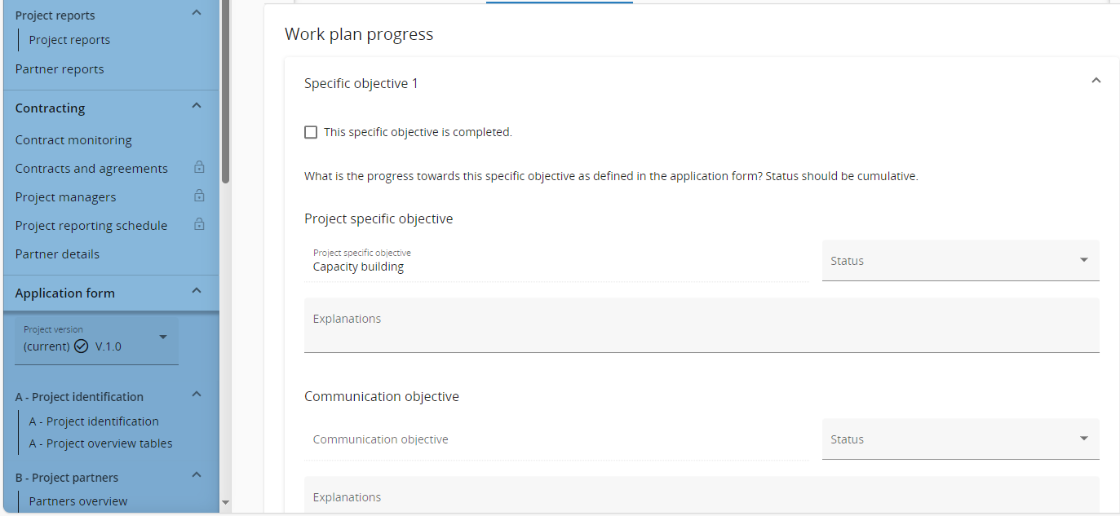
In case the project planned investments the LP should continue by describing the progress in the reporting period.
For each activity and output, there is a separate section with text fields to describe the progress in the reporting period. Similar as for objectives, for each activity there is a drop down menu to define the Status of implementation. The description of the activities should be concrete and precise highlighting who did what, where and how. The LP should avoid generic description such as description of content of outputs, deliverables.
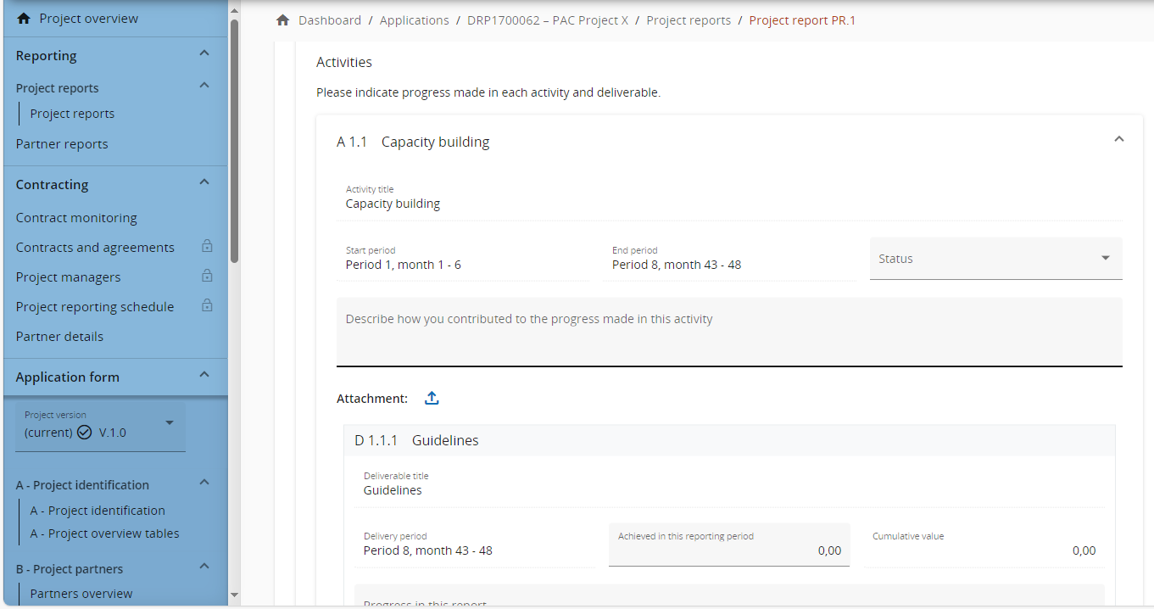
For Deliverables, the LP should indicate the values achieved in the reporting period and provide a brief explanation on the actual progress. The LP should upload the evidence to support the deliverables reported by clicking on the Attachment button.
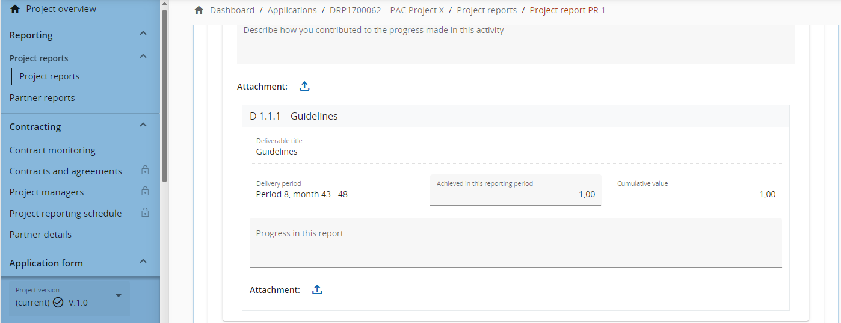
The reporting of the outputs is to be included for each output belonging to the SO. The LP shall indicate the values achieved in the reporting period as well as provide a brief explanation on the actual progress made in reaching the project targets. The LP should upload the evidence to support the outputs reported by clicking on the Attachment button. The Output factsheet and the Output quality report documents are mandatory for each finalised output. Without them the MA/ JS will not reimburse the costs connected.

Project Results & Horizontal Principles
Similar to the outputs section, the reporting of the results is to be included for each result belonging to the SO. The LP shall indicate the values achieved in the reporting period as well as provide a brief explanation on the actual progress made in reaching the project targets. The LP should upload the evidence to support the outputs reported by clicking on the Attachment button. In case of the results to be achieved after the finalisation of project implementation the LP shall provide a detailed description on the concrete measures that will lead to achievement of the results.
In case of the horizontal principles the LP shall provide a concrete description on how these are observed by the projects with references on how they are integrated in the work plan of the project. Under the Horizontal principles / Strategic Environmental Assessment section, if relevant in the project, it shall be described if in connection a project output, deliverable, or investment a SEA procedure, or EIA is carried out by the relevant PP(s).

List of Partner Certificates
Available partner certificates are listed in this section. Select the checkbox of the partner certificate to be included in the PPR. It is recommended that all partner certificates to be included in the PPR, unless duly reasons suggest otherwise.
In case a reporting period has been configured only for content reporting than sections List of Partner Certificates and Financial Overview are not visible.

Project Progress Report Annexes
In this section the LP should upload documents that are relevant for the report but not connected to the evidence of the outputs/ deliverables/ results which are to be attached in the dedicated sections described above. Among the documents to be uploaded in this section can be the AfR, evidence for project achievements not planned in the AF; additional justifications; etc.
The tree structure represents the places within that report where files can be uploaded. All uploads from all sections are shown in this list.
Files uploaded in this section can be deleted here, other files can only be deleted in the section where they were uploaded.
IMPORTANT: The Application for Reimbursement is to be uploaded in this section.

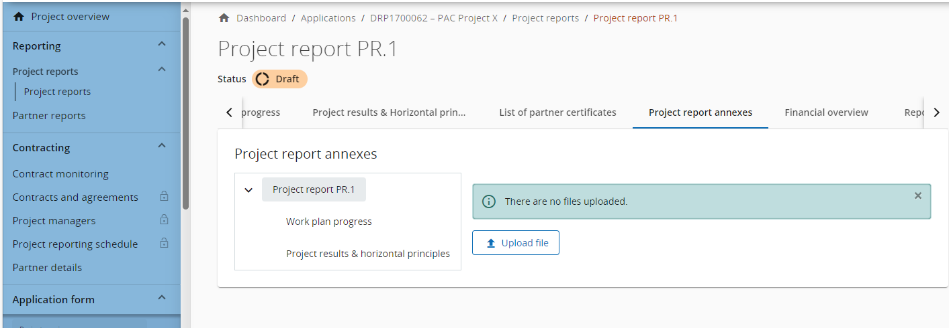

Financial Overview
This section is auto-generated and provides an overview on the financial progress of the project. It reflects expenditures included in the current report, amounts previously reported and also the remaining budget of the project.
In case a reporting period has been configured only for Content reporting than sections List of Partner Certificates and Financial Overview are not visible.

Report Exports
Report Export is optional. It offers the possibility to export details of the project report.

PART 3 Application for Reimbursement
More information on the AfR will be provided at a later stage.

Annex 1: Numbering of Reports jEMS / Subsidy Contract
Report Nr. SC | Report Nr. jEMS | Timeframe | Submission
1 | 1 | 01/01/2023–31/12/2023 | 01/04/2024
 | 2
2 | 3 | 01/01/2024-30/06/2024 | 01/10/2024
3 | 4 | 01/07/2024-31/12/2024 | 01/04/2025
4 | 5 | 01/01/2025-30/06/2025 | 01/10/2025
5 | 6 | 01/07/2025-31/12/2025 | 01/04/2026
6 | 7 | 01/01/2026-30/06/2026 | 01/10/2026
7 | 8 | 01/07/2026-31/12/2026 | 01/04/2027
8 | 9 | 01/01/2027-30/06/2027 | 01/10/2027
9 | 10 | 01/07/2027-31/12/2027 | 01/04/2028
10 | 11 | 01/01/2028-30/06/2028 | 01/10/2028
11 | 12 | 01/07/2028-31/12/2028 | 01/04/2029

