For the Interreg Danube Region project website
Project admin manual
Contents

1 Page structure
1.1 Static pages 3
1.2 Simple pages 4
2 Admin menus
2.1 Static page settings 5
2.1.1 Homepage 5
2.1.2 About us, Library documents and Results 8
2.1.3 News and events 9
2.2 Employees 10
2.3 Media 11
2.4 Publications 12
2.5. Users 17
2.6 Newsletters 18
2.7 Newsletter subscribers 18
2.8 Simple pages 19
2.9. Menus 24
2.10 Projects 25
2.11 Project Partners 27
2.12 Project Results 29

Page structure

The project website builds up from static pages and simple pages.

1.1 Static pages
Static pages are generated by the system automatically, based on JEMS information. Since these pages are the foundation of the website itself, these pages are only partially editable.
Each project website contains these static pages:
- Homepage
- About us
- Library documents
- Results
- Our news
- Our events
These pages are editable from the Static Page Settings.
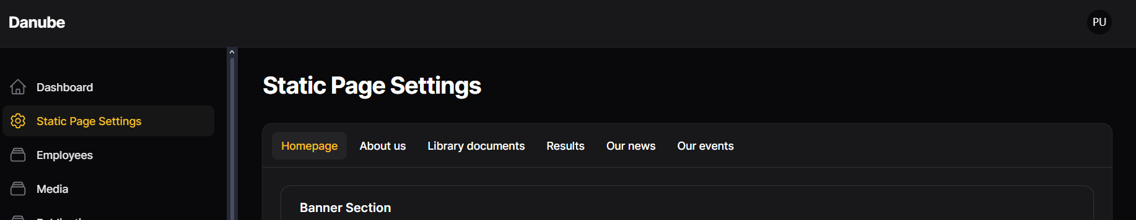
1.2 Simple pages
Simple pages are always generated by project admin. On each project website, the admin is able to add and edit this kind of simple pages to their website:
- Publications (with news articles and event descriptions)
- Project results (for a more detailed project result description)
- Additional simple pages
For an additional simple page, the admin is able to add an additional menu with submenus into the navigation bar and personalize the project page and add more content than the default static pages.

Admin menus

2.1 Static page settings
In this menu, the project admin is able to edit the content and descriptions of the static pages, however the information that come from JEMS and the infographics are not editable.
2.1.1 Homepage
Banner section
In the homepage banner section, the following are editable:
- the homepage banner (by default we display the original programme banner),
- the homepage banner’s title (this is going to be the page title as well), adding a title is required,
- the homepage banner’s short description,
- and an additional linked button, where the button’s title and the link are editable.
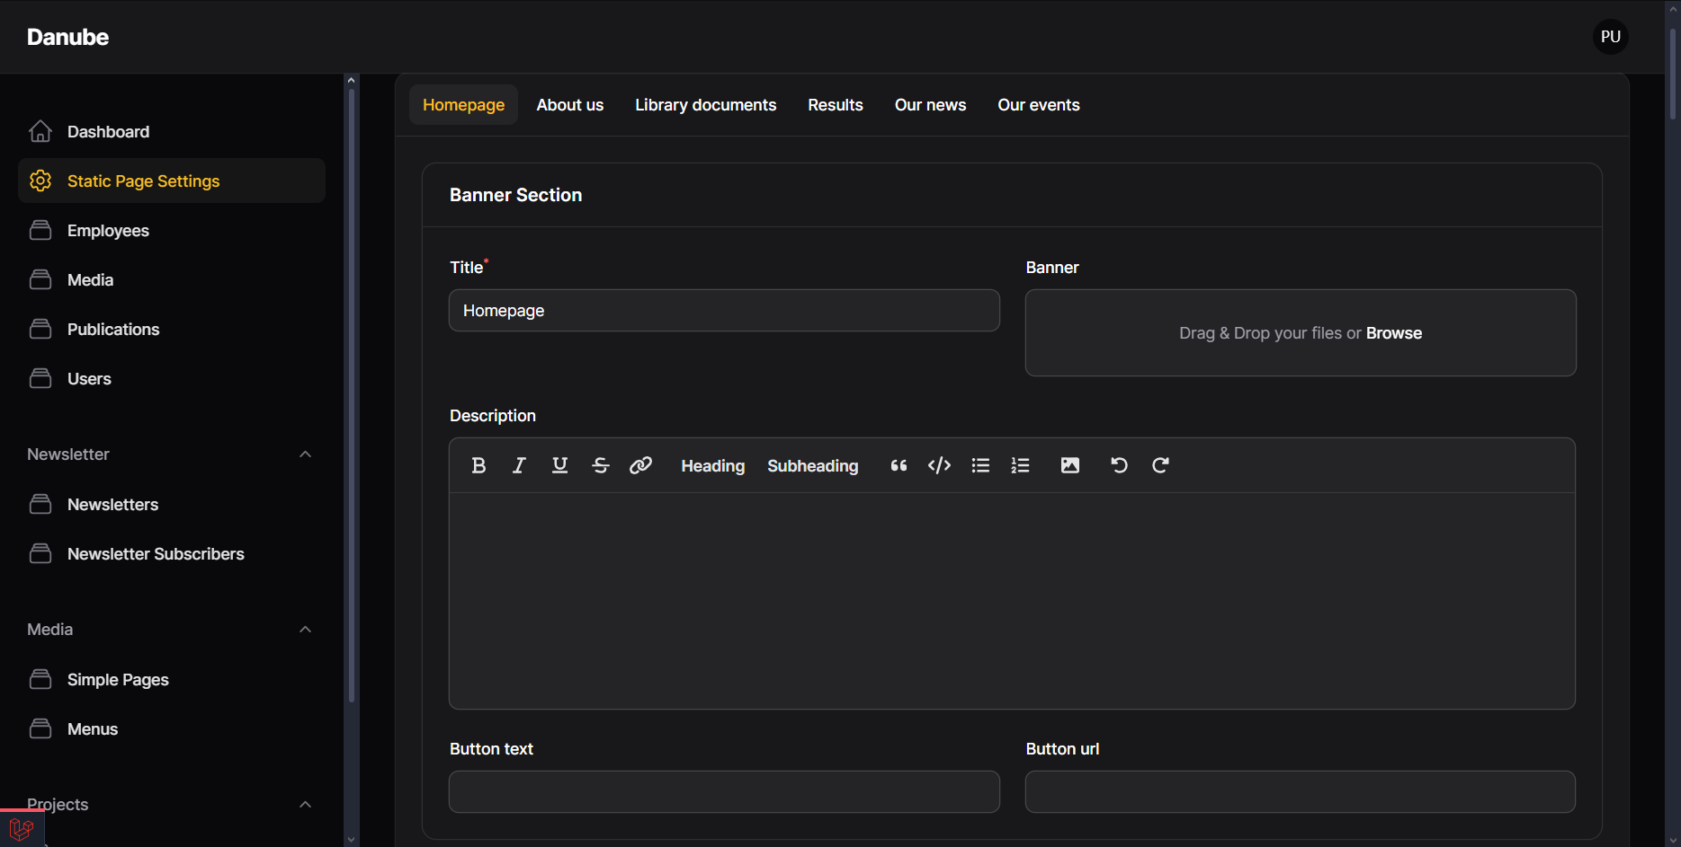

Custom fields section
In the custom fields section, the following are editable:
- Social media:
- The project admin can add Facebook, Linkedin, Twitter and Youtube social media links.
- Section 1-2-3-4, these are the introductory sections below the banner:
- Banner and caption.
- Button and Link (for text part).
- Short description.
- Title.
- Project logo
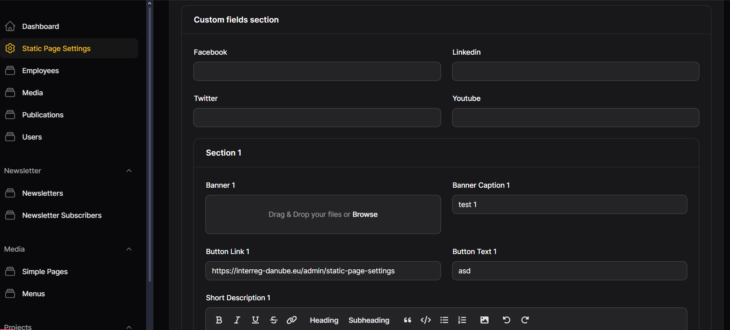
Content section
More additional content can be added through the content section, with longer description/content field, additional collapse and downloadable document display options. Project admins are able to add multiple content boxes with clicking on “Add to contents button” below.
- Content
- The description itself always displays on the left side.
- You can use some code fragments:
color change of the text, for example <color:#ff0000>red text</color>
or a “nested” collapse (collapse inside collapsed content box) is possible:
<collapse>
<collapse-title>Info</collapse-title>
<collapse-body>info text</collapse-body>
</collapse>
- Title
- Main title of the content box.
- If it’s a collapsed content box, only the title is visible when the collapse is closed.
- Medias
- Choose any media (uploaded in Media menu) to display here as well as in the Library.
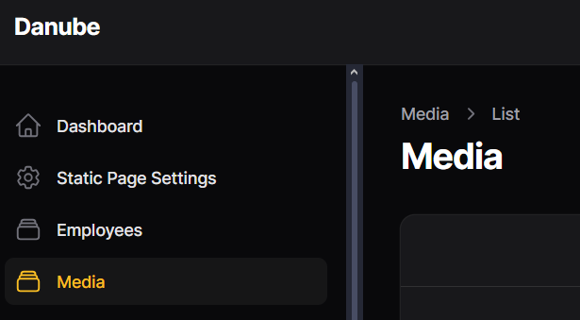
- Background color
- Choose any background color (even white) for a framed and highlighted content box display.
- In case of white background color, the text color is black.
- In case of colorful background, the text color is white.
- If no background color is chosen, there frame won’t be displayed, only the content.
- Collapsed toggle bar
- This feature makes the whole content box collapsed.
- The guidelines under the toggle bar are for using code fragments inside content.
- Banner
- To display one image on the right side of the content box.
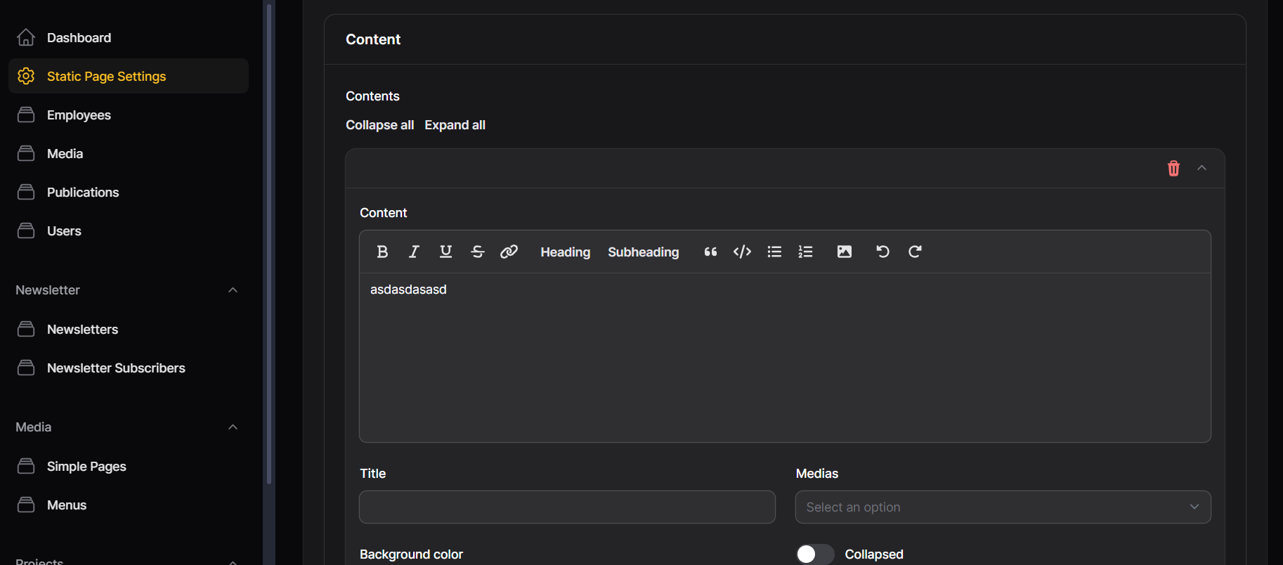

2.1.2 About us, Library documents and Results
Banner section
In the homepage banner section, the following are editable:
- the homepage banner (by default we display the original programme banner),
- the homepage banner’s title (this is going to be the page title as well), adding a title is required,
- the homepage banner’s short description,
- and an additional linked button, where the button’s title and the link are editable.
Custom fields section
In the custom fields section, it is possible to add an additional Title and description below the banner and above the partner cards.
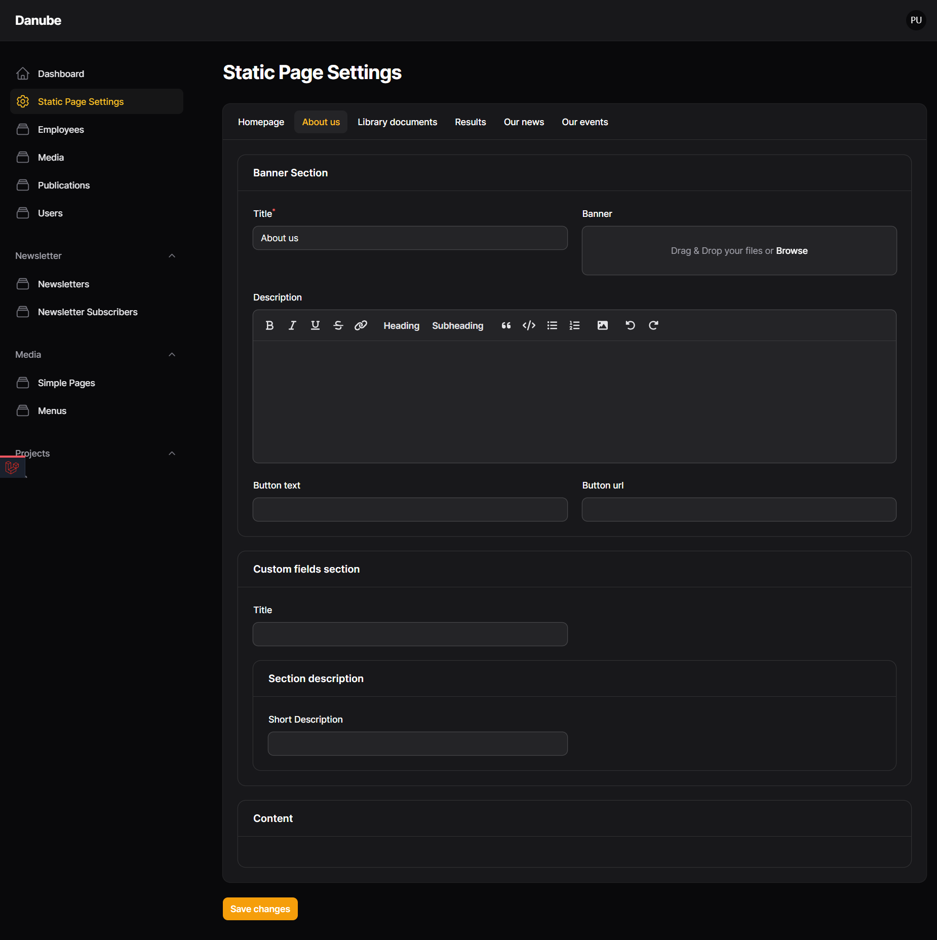

2.1.3 Our news and events
Banner section
In the homepage banner section, the following are editable:
- the homepage banner (by default we display the original programme banner),
- the homepage banner’s title (this is going to be the page title as well), adding a title is required,
- the homepage banner’s short description,
- and an additional linked button, where the button’s title and the link are editable.
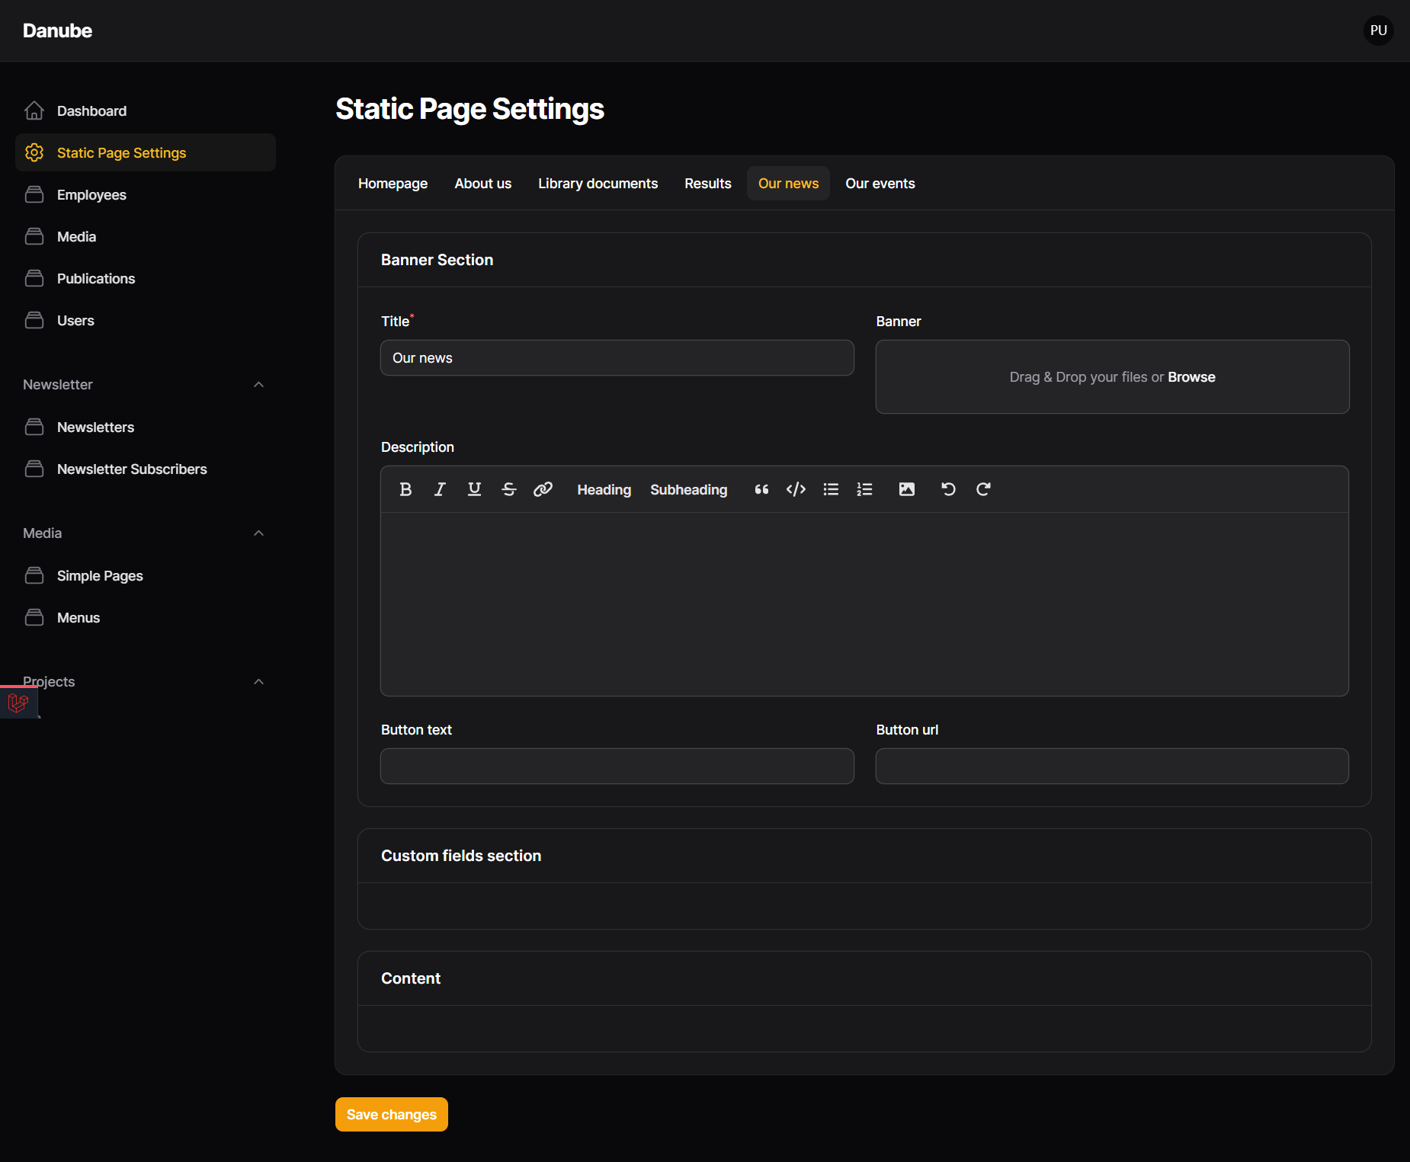

2.2 Employees
In the employees menu, the project admin is able to add contact members. The employees will be displayed as contact cards in the Homepage, Contact us sections. The following information are possible to add:
- First name - required
- Last name - required
- Position
- Email
- Phone
- Description
- Contact card image/banner
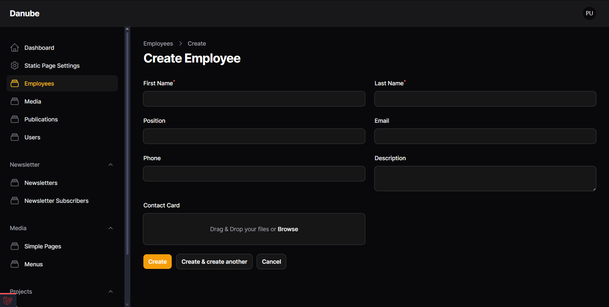

2.3 Media
In the media menu, the project admin is able to upload several types of medias. These will automatically be displayed on the Library page and they can be added to content boxes of Static homepage, Publications, Simple pages and Project results:
- Banner
This will be the banner of the media. If it is not added by the admin, for output types it is the priority color of the output, for images it is the image itself, for other types, it will be the main programme wave element.
- Types - required field
- Document, Newsletter, Image, Video, Report and publication and Output types. Output types have one additional Topic filter:
- Strategy,
- Solution,
- Pilot
- Joint action

Output type documents are also displayed on the programme main website as well.
- Name - required field
- The title name of the document, that will be displayed on the document card.
- Description to include basic information about the media.
- File - required field for uploading your file.
- Priorities
- Objectives
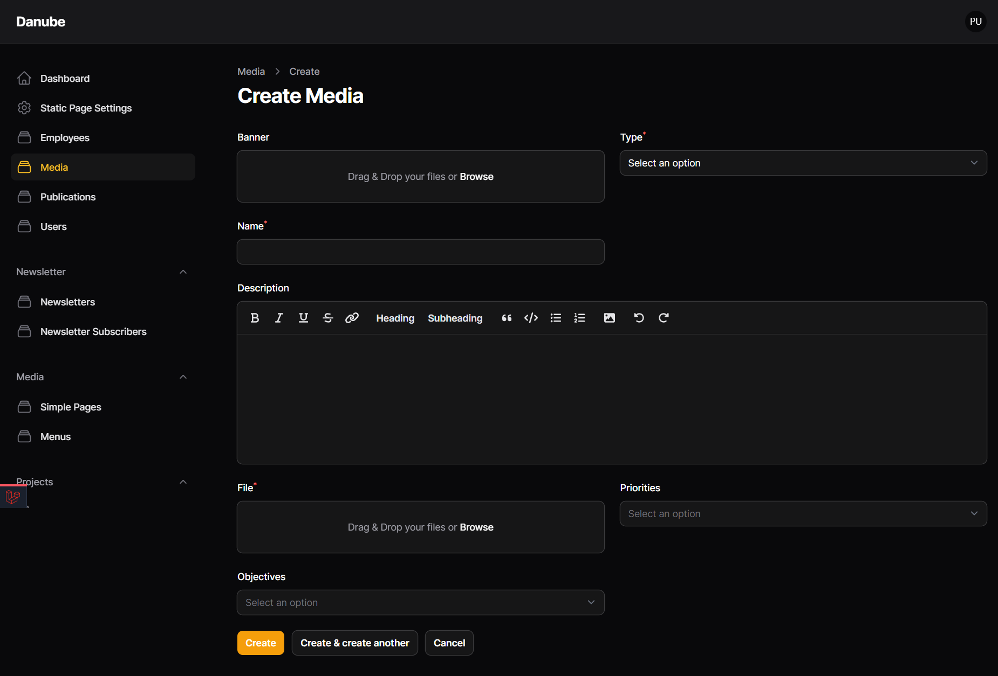

2.4 Publications
This menu is for adding news and events, and each news and events page is a type of dynamic simple page.
Basic information
- Title
- Page title, small card title and banner title.
- Banner
- Page banner, small card image.
- Banner button and URL
- Only displays on banner.
- Type
- This will be the selector of the publication type. It is possible to select news or event.
- Start date
- This field is only for event type publications, which is an additional event date besides the date of the publication.
- Tags
- For each type the admin is able to select either Project or Programme tags.
- Priorities and Objectives
Links section
An additional, first position (below banner) highlighted link section can be added with clicking on the “Add to links” button.
- Button title
- Text that is displayed on the button, always on the right side of the section. If the Links section is added, the button title is required.
- Url
- The link of the button.
- Iframe
- For external EUSurvey integrated survey forms, that displays at the bottom of the page. If the iframe is added, the URL is automatically an anchored link to the bottom of the page, where the iframe is displayed.
- Description
- This is the title of the Links section.
Video Section
For displaying videos under the content sections of a News or an Event page.
- Title
- Title of the Video section box.
- Background color
- Choose any background color (even white) for a framed and highlighted content box display.
- In case of white background color, the text color is black.
- In case of colorful background, the text color is white.
- If no background color is chosen, there frame won’t be displayed, only the content.
- Description
- An additional description below the title of the Video section.
- Videos
- By clicking on add to videos, embedded youtube videos can be added, by adding the URL (required) and a title.
Content section
More additional content can be added through the content section, with longer description/content field, additional collapse and downloadable document display options. Project admins are able to add multiple content boxes with clicking on “Add to contents button” below.
- Content
- The description itself, always displays on the left side, with using some code fragments:
color change of the text, for example <color:#ff0000>red text</color>
or a “nested” collapse (collapse inside collapsed content box) is possible:
<collapse>
<collapse-title>Info</collapse-title>
<collapse-body>info text</collapse-body>
</collapse>
- Title
- Main title of the content box.
- If it’s a collapsed content box, only the title is visible when the collapse is closed.
- Medias
- Choose any media (uploaded in Media menu) to display here as well as in the Library.
- Background color
- Choose any background color (even white) for a framed and highlighted content box display.
- In case of white background color, the text color is black.
- In case of colorful background, the text color is white.
- If no background color is chosen, there frame won’t be displayed, only the content.
- Collapsed toggle bar
- This feature makes the whole content box collapsed.
- The guidelines under the toggle bar are for using code fragments inside content.
- Banner
- To display one image on the right side of the content box.
- 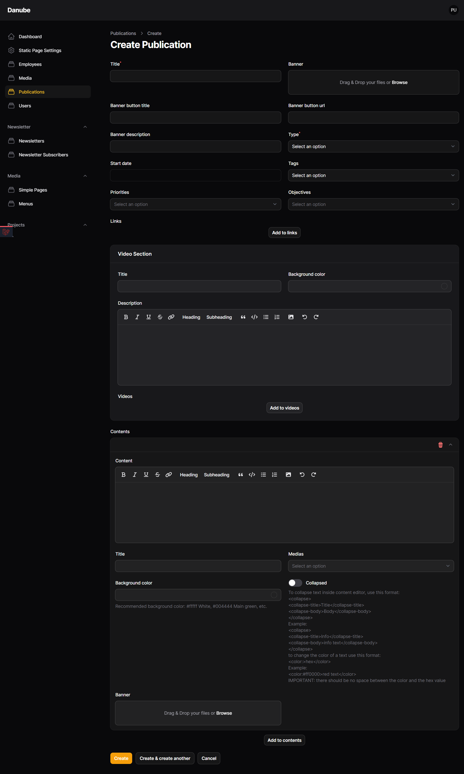
2.5. Users
Each project has the lead partner as its default user. The lead partner then is able to add more users to the project, by adding the following:
- Email (required field)
- First name (required field)
- Last name (required field)
- Phone (optional)
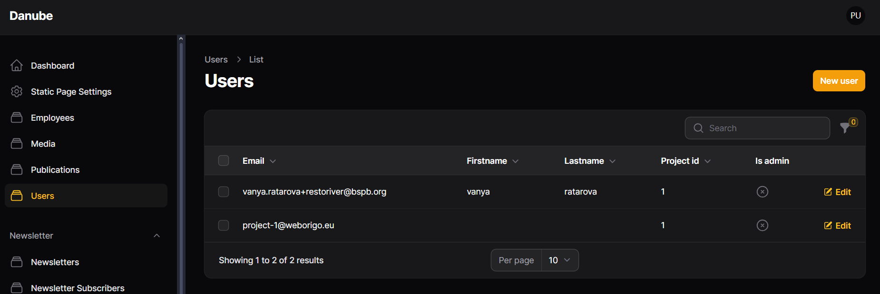
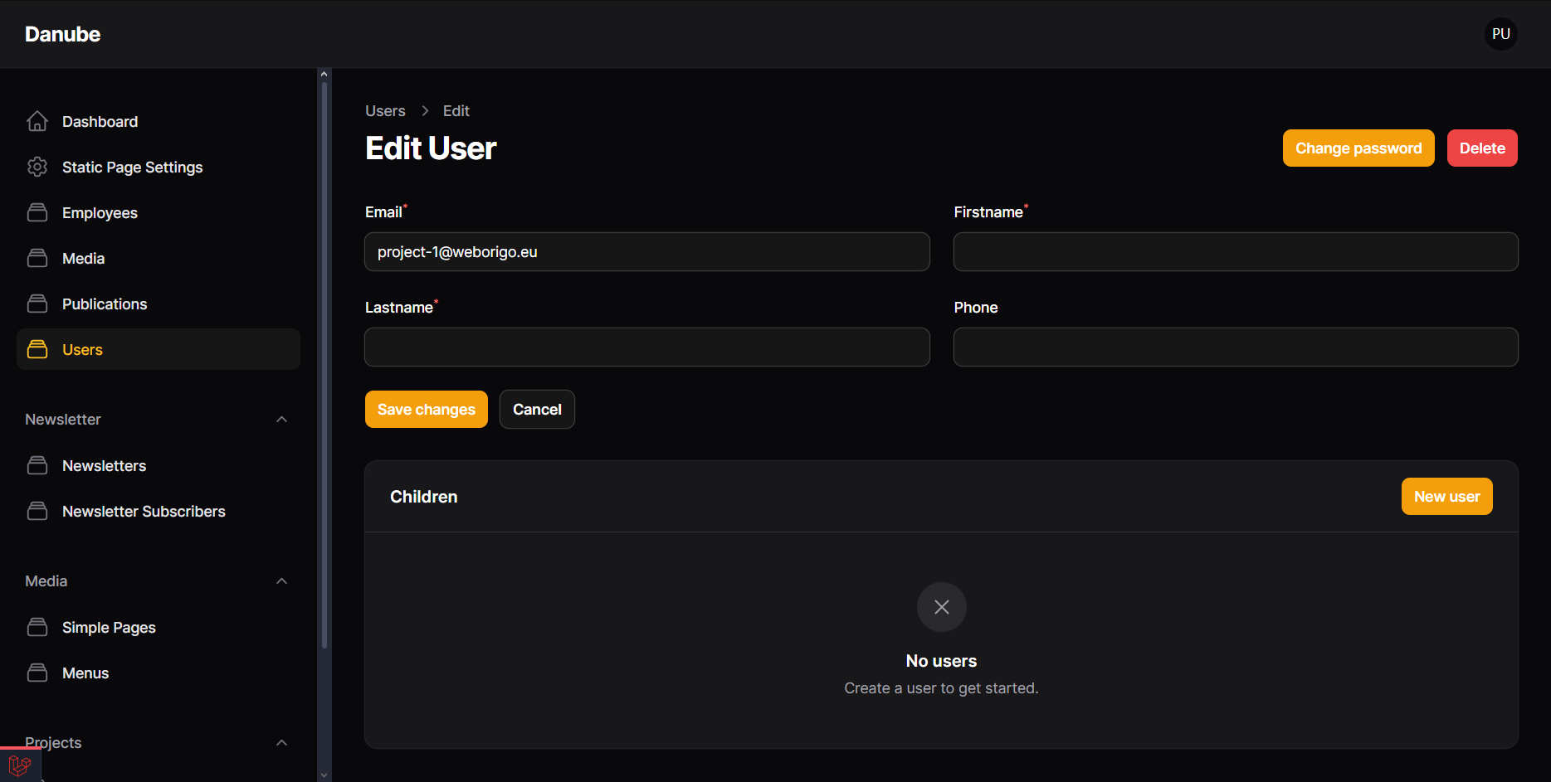

2.6 Newsletters
Each project is able to send out their own newsletter, which is based on the programme newsletter template. The project admin is able to add:
- Subject of the email
- Schedule a date when the email will be sent out
- Add description and attach image within a content editor
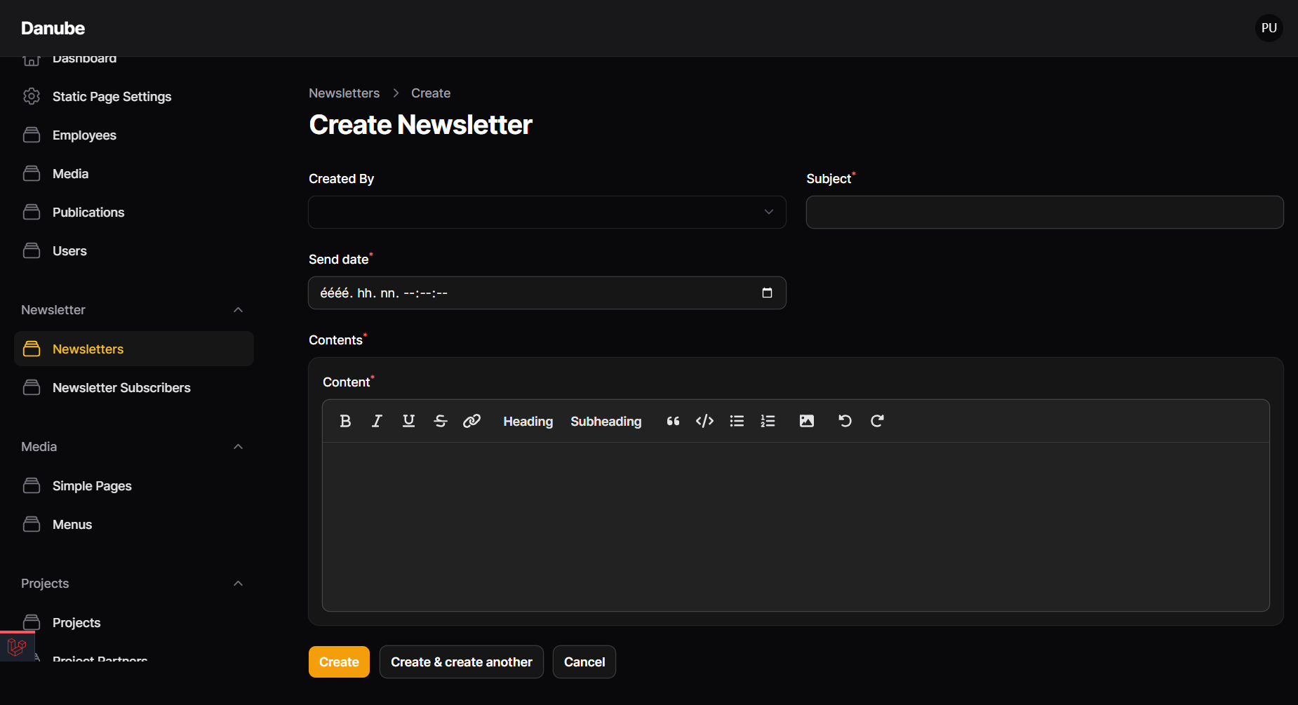

2.7 Newsletter subscribers
In this menu, the project admin can view the list of subscribers and manage subscriptions.
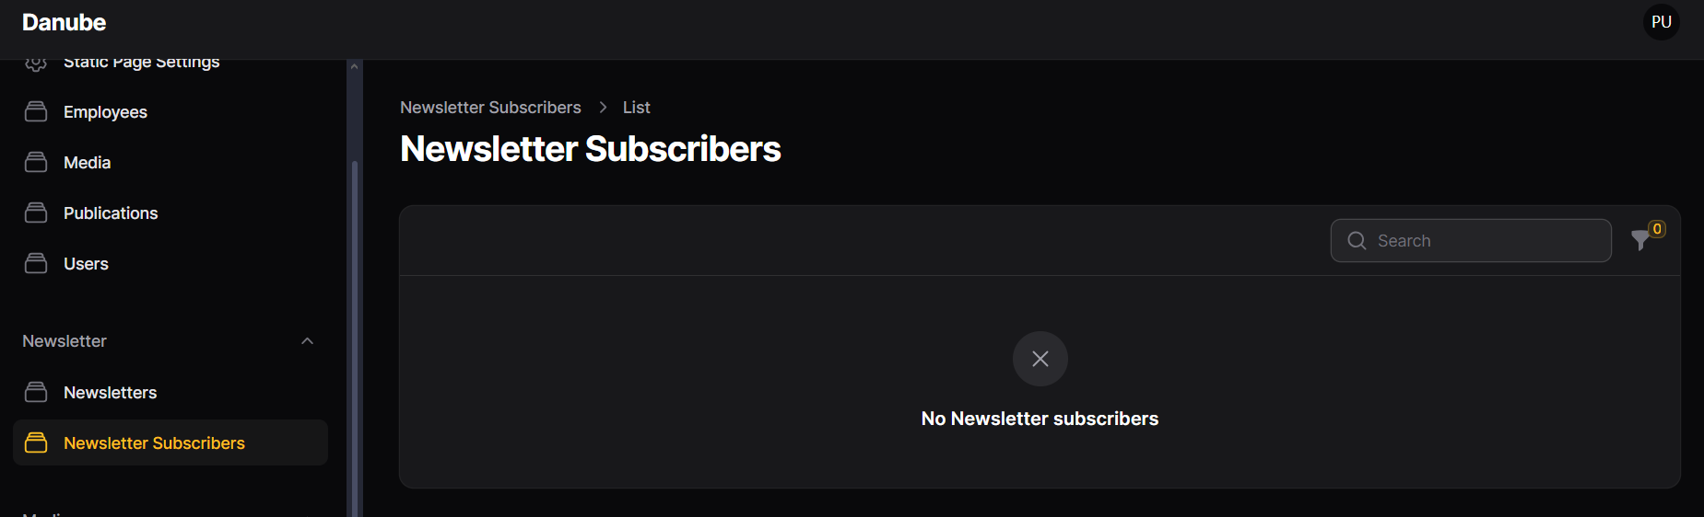

2.8 Simple pages
In this menu, the project admins are able to create more personalized pages for their project websites.
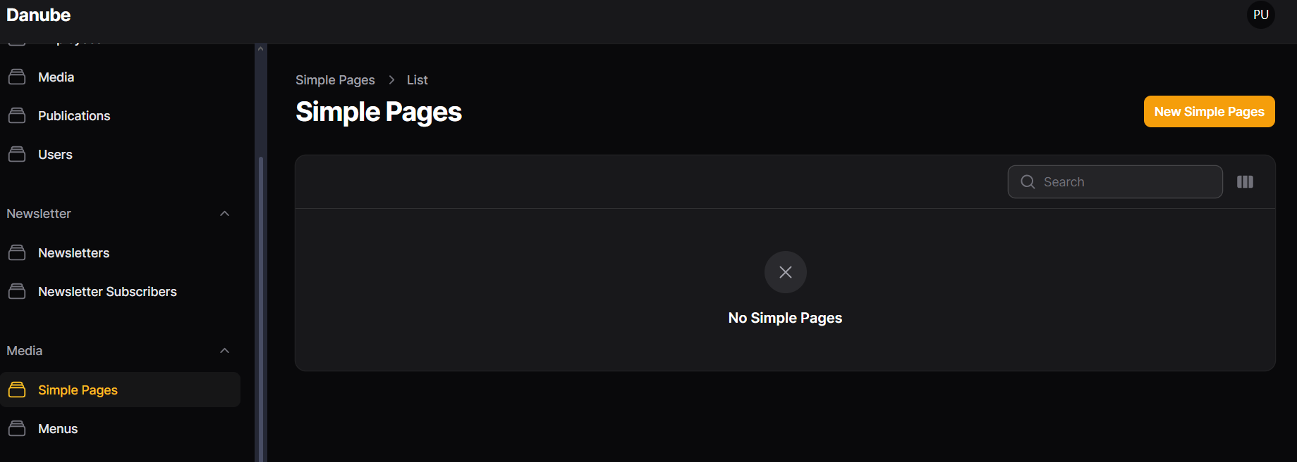
Basic information
- Title
- Page title and banner title.
- Banner short description
- Displays on the banner, can display linked text as well.
- Banner button title and URL
- Only displays on the banner, useful for highlighting one link on the banner.
- Banner
- The background image of the banner, by default it is the programme element.
Video Section
For displaying videos under the content sections, and the bottom of a Simple page.
- Title
- Title of the Video section box.
- Background color
- Choose any background color (even white) for a framed and highlighted content box display.
- In case of white background color, the text color is black.
- In case of colorful background, the text color is white.
- If no background color is chosen, there frame won’t be displayed, only the content
- Description
- An additional description below the title of the Video section.
- Videos
- By clicking on add to videos, embedded youtube videos can be added, by adding the URL (required) and a title.
Links section
An additional, first position (below banner) highlighted link section can be added with clicking on the “Add to links” button.
- Button title
- Text that is displayed on the button, always on the right side of the section. If the Links section is added, the button title is required.
- Url
- The link of the button.
- Iframe
- For external EUSurvey integrated survey forms, that displays at the bottom of the page. If the iframe is added, the URL is automatically an anchored link to the bottom of the page, where the iframe is displayed.
- Description
- This is the title of the Links section.
Content section
More additional content can be added through the content section, with longer description/content field, additional collapse and downloadable document display options. Project admins are able to add multiple content boxes with clicking on “Add to contents button” below.
- Content
- The description itself, always displays on the left side with using some code fragments:
color change of the text, for example <color:#ff0000>red text</color>
or a “nested” collapse (collapse inside collapsed content box) is possible:
<collapse>
<collapse-title>Info</collapse-title>
<collapse-body>info text</collapse-body>
</collapse>
- Title
- Main title of the content box.
- If it’s a collapsed content box, only the title is visible when the collapse is closed.
- Medias
- Choose any media (uploaded in Media menu) to display here as well as in the Library.
- Background color
- Choose any background color (even white) for a framed and highlighted content box display.
- In case of white background color, the text color is black.
- In case of colorful background, the text color is white.
- If no background color is chosen, there frame won’t be displayed, only the content.
- Collapsed toggle bar
- This feature makes the whole content box collapsed.
- The guidelines under the toggle bar are for using code fragments inside content.
- Banner
- To display one image on the right side of the content box.
- Iframe
- By adding a link to the iframe section, a custom outer-service survey can be displayed if compatible.
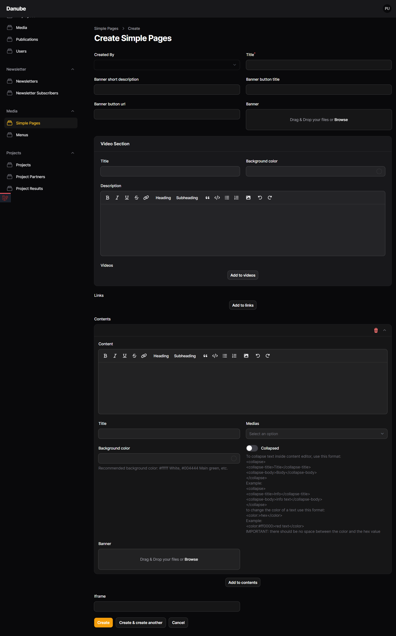
2.9 Menus
In menus, the project admin is able to add main menus (visible in the navigation bar) and sub menus (displayed under the added main menus) to the navigation bar of the website, By adding the following:
- Title (required)
- Name of the main menu.
- URL
- The page that will be displayed when someone clicks on this particular menu.
- Project
- This will be automatically filled out based on the project login.
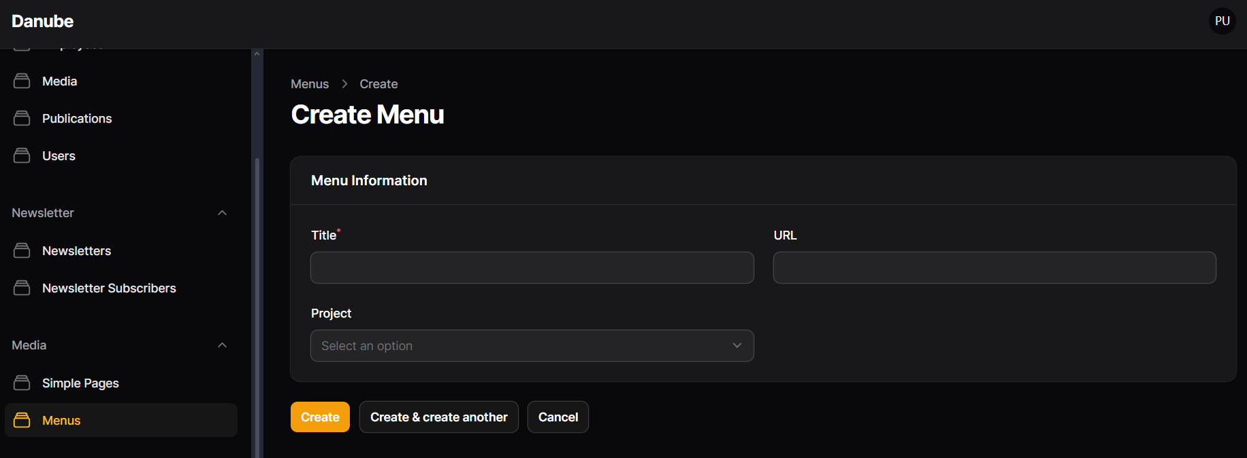
After creating a main menu, it is possible to add submenus / child menus to each main menu, and create multi-level menu system, by adding the title and URL.
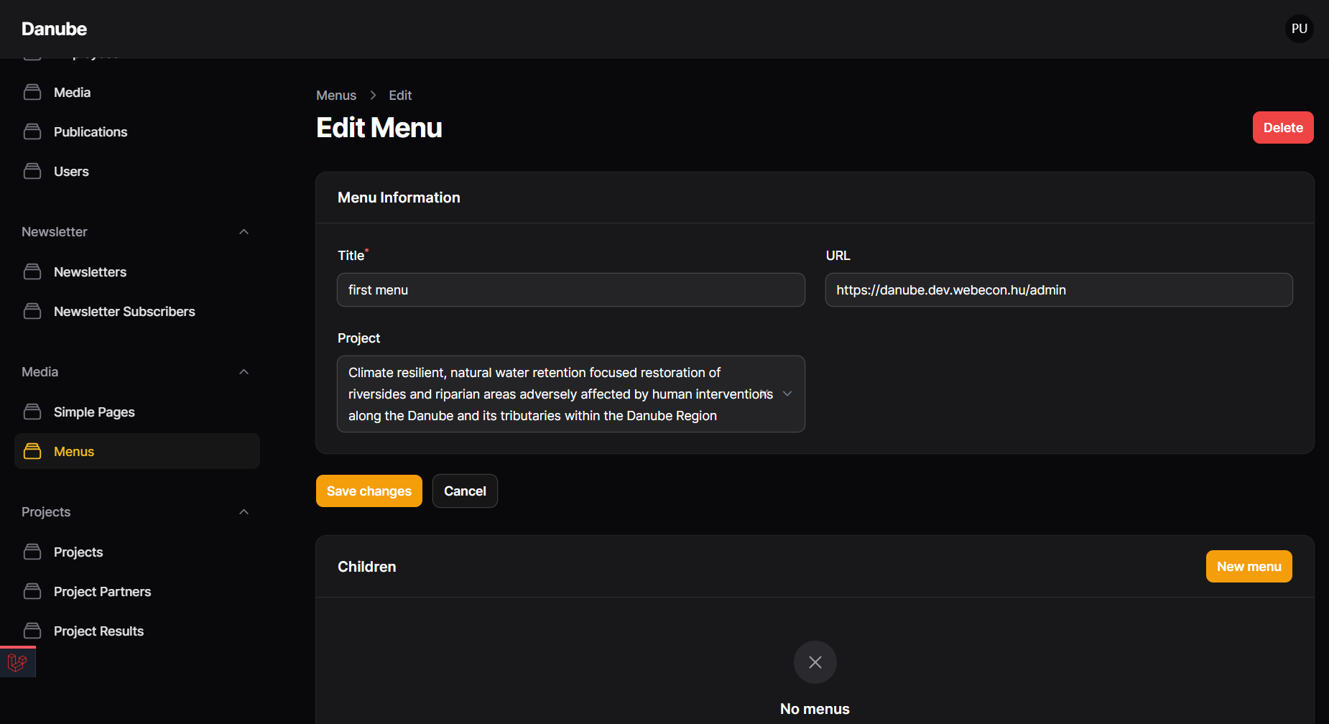

2.10 Projects
In projects menu, the project admin is able to edit project information:
- Banner
- This banner of the project will be displayed on the programme website, at the projects page, as the small project card’s banner.
- Banner short description
- This will be displayed on the programme website, at the projects page, as the small project card’s description.
- Description - under discussion!
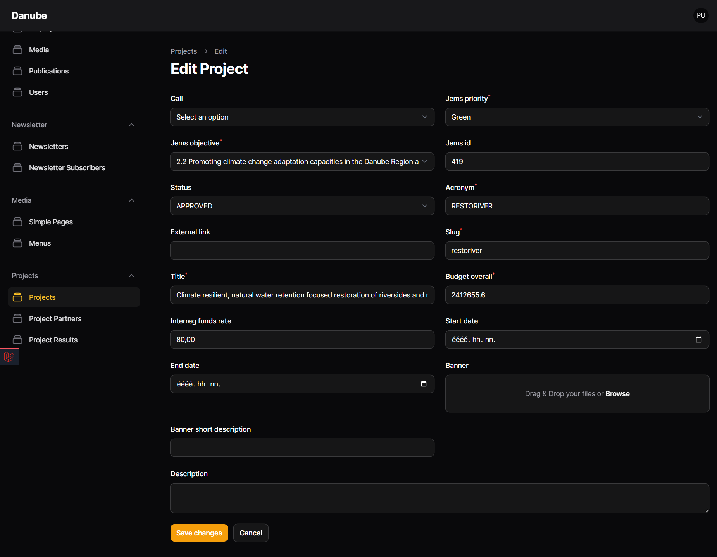

2.11 Project Partners
In this menu, the project admin is able to edit and add new project partners. By default, all of the project partners are coming from JEMS.
- Role
- Here the project admin is able to select from Partner and Lead partner roles. When adding a new Lead partner role, an admin user will be created.
- Organisation name
- The name of the partner’s organisation.
- Homepage
- This will be the link to the partner’s outer website.
- Banner
- This will be the small banner image for each project partner card on the About us page.
- Address
- Country selector
- For displaying the flag on the About us Project partner’s card.
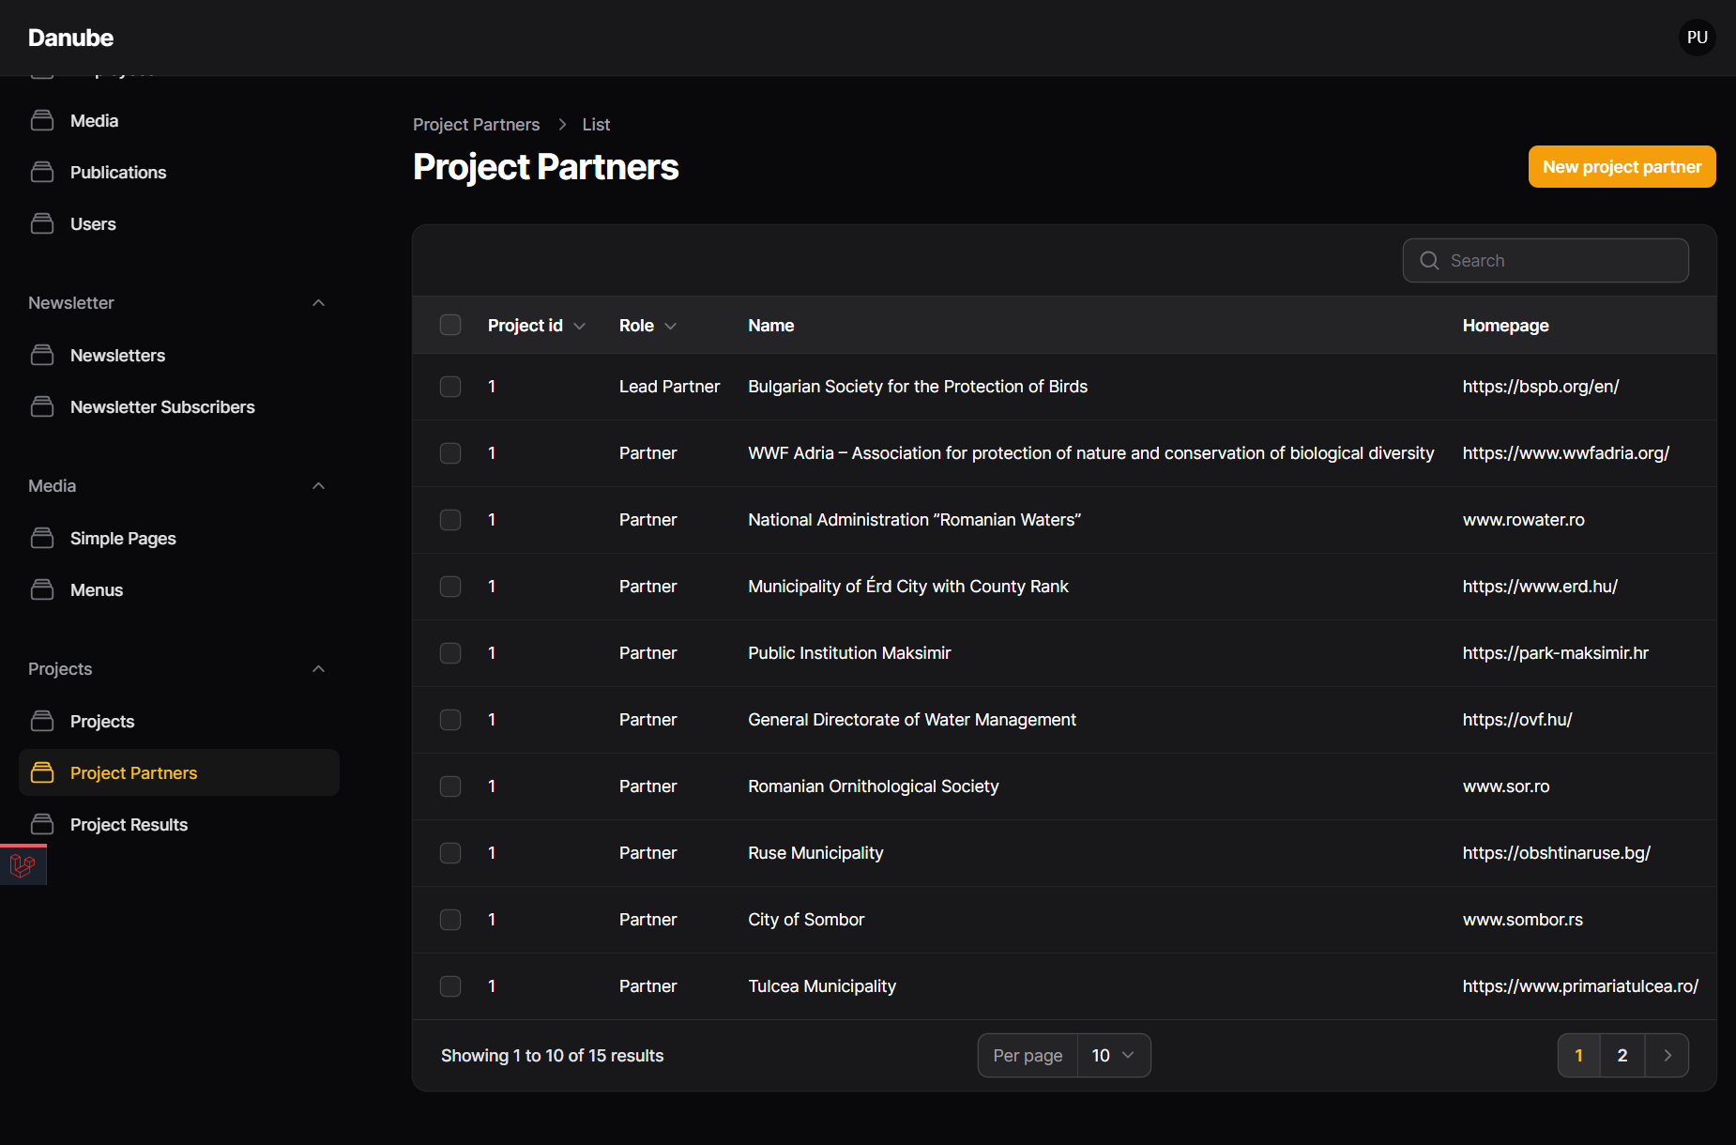
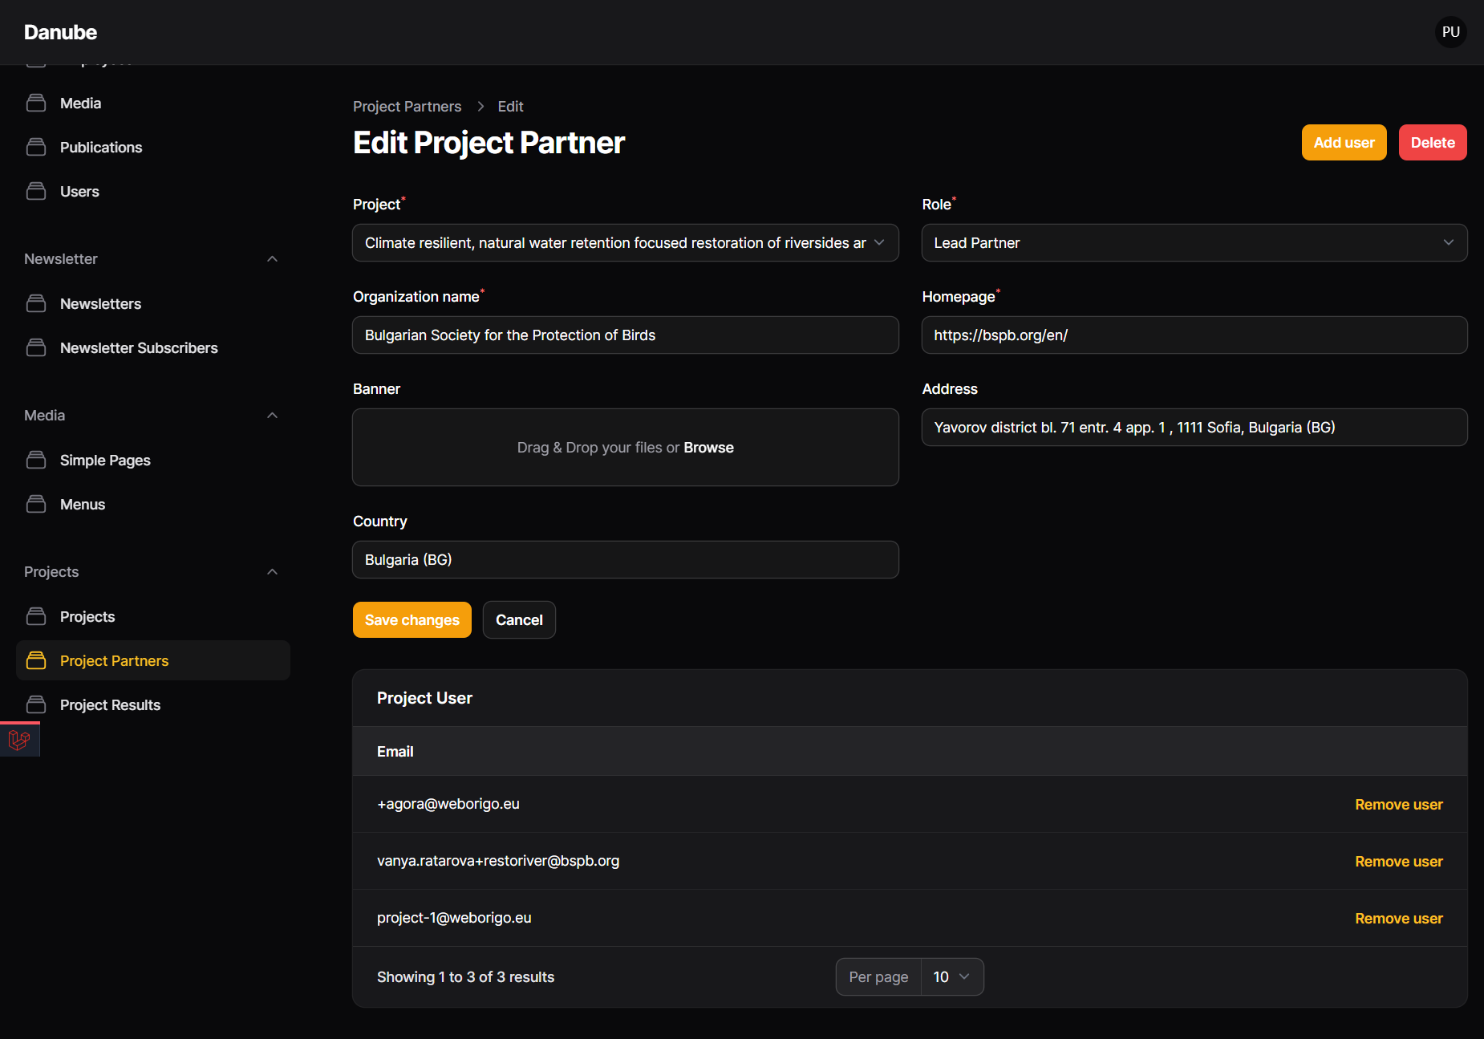
2.12 Project Results
The project results are coming from Jems and in this menu, the project admin is able to edit them:
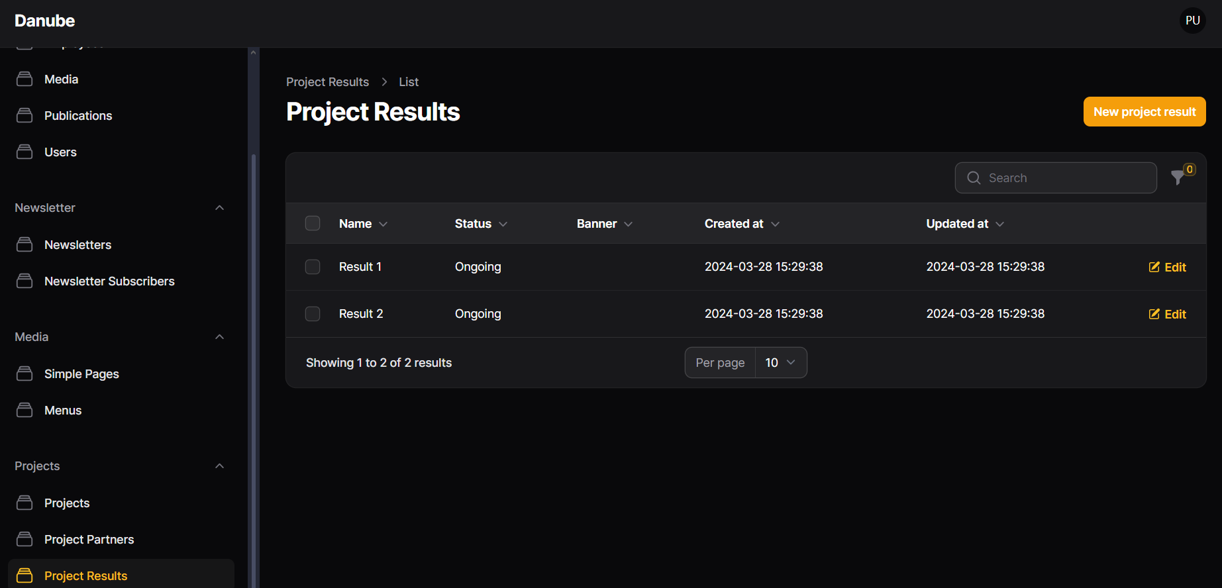
- Banner name
- This will be the result page’s title and the banner title.
- Jems description
- This is the original description that comes from Jems. This is displayed on each individual result’s page banner description (/projects/acronym/results/number).
- Result description
- This is also the original description that comes from Jems, but this is displayed on the result collection page, which is a static page. (/projects/acronym/results/).
- Banner
- This will be the individual result page’s banner image.
Content section
More additional content can be added through the content section, with longer description/content field, additional collapse and downloadable document display options. Project admins are able to add multiple content boxes with clicking on “Add to contents button” below.
- Content
- The description itself, always displays on the left side with using some code fragments:
color change of the text, for example <color:#ff0000>red text</color>
or a “nested” collapse (collapse inside collapsed content box) is possible:
<collapse>
<collapse-title>Info</collapse-title>
<collapse-body>info text</collapse-body>
</collapse>
- Title
- Main title of the content box.
- If it’s a collapsed content box, only the title is visible when the collapse is closed
- Medias
- Choose any media (uploaded in Media menu) to display here as well as in the Library.
- Background color
- Choose any background color (even white) for a framed and highlighted content box display.
- In case of white background color, the text color is black.
- In case of colorful background, the text color is white.
- If no background color is chosen, there frame won’t be displayed, only the content.
- Collapsed toggle bar
- This feature makes the whole content box collapsed.
- The guidelines under the toggle bar are for using code fragments inside content.
- Banner
- To display one image on the right side of the content box.
- Iframe
- By adding a link to the iframe section, a custom outer-service survey can be displayed if compatible.
