Local Partner Analysis

Deliverable D.1.1.3

Written by: Prof. dr Gordana Gardašević

RTD HEALTH CLUSTER, Prijedor, Republic of Srpska, BiH

**Local Partner Analysis**

**D.1.1.3**

**DIGI4Care**

Content

Introduction 3

Methodology 4

Local Partner Analysis..................................................................................................................................................5

AUSTRIA 5

CZECH REPUBLIC 7

SLOVAKIA 9

HUNGARY 11

ROMANIA 13

BULGARIA 15

REPUBLIC OF SRPSKA 17

Introduction

The collective DIGI4Care effort aims to strengthen synergies and foster cross-country cooperation thus narrowing the innovation gap between the older and newer Member States, as well as non-EU countries in the Danube Region. The structure of Specific Objective 1 (SO1) of the DIGI4Care project, titled "Enabling the uptake of digital solutions in healthcare, from prevention to rehabilitation" (see Fig.1) is dedicated to promoting and facilitating the integration of digital solutions throughout the entire patient pathway, from prevention to rehabilitation. This objective culminates in the creation of a Digitally Enabled Integrated Care Model (ICM) Strategy (O1.31) and corresponding institutional-level Action Plans (O1.42), all of which are validated by tangible transnational uptake cases in SO2 pilots. These pilots cover the entire uptake process, addressing required skills, roles of participating actors, financial resources and models, and strategies for removing bottlenecks and overcoming potential obstacles.

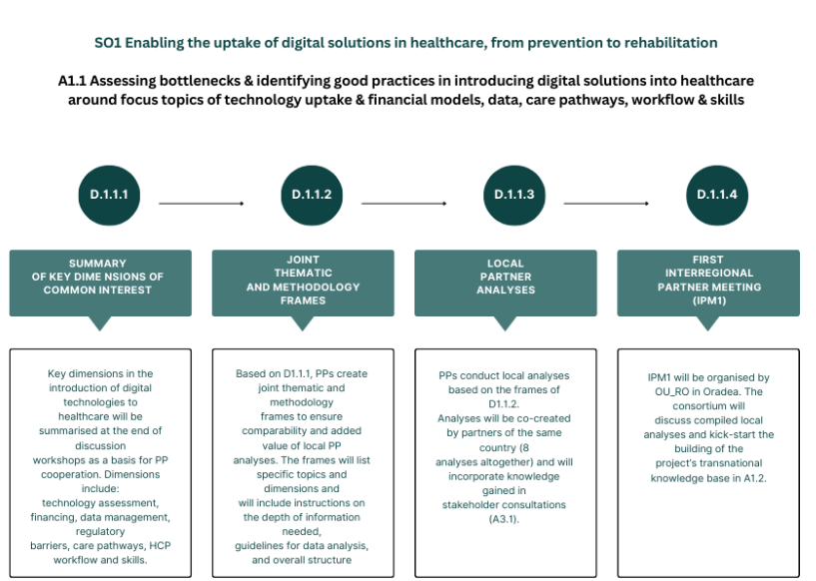Local partner analyses are based on the methodology outlined in D1.1.2 - Joint Thematic and Methodology Frames, and they incorporate insights gained from stakeholder consultations. The analysis of local partners is the third deliverable for Activity A1.1.

**Fig.1. The structure of Specific Objective SO1 of the DiGI4Care project**

1 O.1.3 Digitally Enabled Integrated Care Model (ICM)

2 O.1.4 Institutional-Level Action Plans to the ICM Strategy

Methodology

The DIGI4Care project uses various tools for gathering and analyzing insights, including online workshops, questionnaires, and discussions, to encourage open dialogue and the exchange of ideas regarding key dimensions. This approach emphasizes a scientific and investigative framework, viewing the diversity of development among countries and partners not as a challenge, but as an opportunity for enhanced collaboration.

The background for Deliverable D1.1.3—Local Partner Analysis is based on the methodology outlined in D1.1.2 to effectively conduct local analyses and provide relevant insight. This methodology enables structured evaluation based on the perceptions of project partners of the maturity of national or regional contexts regarding the introduction and use of digital health solutions. By systematically collecting project partners' perceptions about the maturity of these contexts, this approach highlights strengths, established good practices, and identifies areas for improvement (barriers) concerning the implementation and utilization of digital health initiatives.

The questionnaire provided by D1.1.2 aims to further process and clarify the collected data, providing a clearer understanding where organized workshops were insufficient. It covers the following key dimensions: Readiness to Change, Structure and Governance, Funding, Data Management and Security, Digital Infrastructure, Integrating Digital Solutions into Health Service, Workforce Capacity Building, Population Approach and Citizen Empowerment, Innovation Management, Evaluation Methods, Breadth of Ambition, and Removal of Inhibitors. The analyses based on these dimensions are co-created by partners from the same country, resulting in eight analyses in total. Partners are also requested to provide a numerical assessment using a maturity scale (specific) for each dimension, based on their qualitative analysis and the guiding questions. This assessment scale ranges from 0 to 5, accompanied by a brief interpretation to foster a shared understanding of each rating. The assessment scales are included in the questionnaire and serve as the basis for the spider diagrams representing the partners’ results, providing a quantitative tool for evaluation. The summary of the local partner analyses based on questionnaire results is provided by this Deliverable.

Finally, as the fourth and final deliverable of Activity 1.1, the findings of local analyses were presented and discussed at the Interregional Partner Meeting (D1.1.4), organised in Oradea, Romania in September 2024.

Local Partner Analysis

AUSTRIA

The oversight of digital health in Austria is managed by the Federal Ministry of Health, the Federal Target-based Governance Commission, and ELGA GmbH. The stakeholders, including the Federal Government, regions, and statutory health insurance bodies, have designated digital health as a priority area in the recent Gesundheitsreform 2023. As part of this reform, they have agreed on the first national Austrian eHealth Strategie, which will be in effect from 2024 to 2030. Established protocols are under the Austrian Medical Devices Act and the Medical Device Regulation (MDR). The definition of an assessment framework for digital health applications is a priority in the national eHealth Strategy. Continuous efforts are made to foster innovation and collaboration among stakeholders. The most important sources for funding digital health innovation are public funding, European Union grants and private investments. Moreover, there are dedicated budgets within the national healthcare plans and specific digital health initiatives.

The GDPR and the Austrian Data Protection Act offer extensive privacy protections. In addition, the Austrian Health Telematics Act (Gesundheitstelematikgesetz, GTeIG) specifically addresses the handling of health data. It ensures that the collection, processing, and exchange of individually identifiable digital health data are carried out with strict adherence to privacy and security standards. The GTeIG reinforces patient rights regarding ownership, consent, and access to their health data, further enhancing data protection in the healthcare sector.

The digital infrastructure is well-developed, but there is a need for improvement in some areas, especially in rural regions. For example, there is limited data exchange speed due to the use of secure networks. The government is continuously working on enhancing digital health infrastructure through national and EU initiatives. Telemedicine platforms and AI-driven diagnostic tools are used for diagnosis and treatment, while remote monitoring devices (e.g., HerzMobil, MySugar) are used for follow-up care. Digital health data is used for predictive analytics, improving care delivery, and enhancing health system planning and resilience. Organizations such as the Ludwig Boltzmann Institute, AIT, and various health tech startups, as well as startup associations and incubators/accelerators, strongly promote digital health.

Digital solutions enhance citizen empowerment by enabling appointment booking, self-monitoring, and access to personal health records. Nonetheless, the primary barriers include regulatory complexities, opposition from certain healthcare providers, and financial limitations. Efforts such as regulatory reforms, stakeholder involvement, and increased funding for digital health initiatives are being implemented to address these challenges. The overall assessment results are depicted in Fig.2.

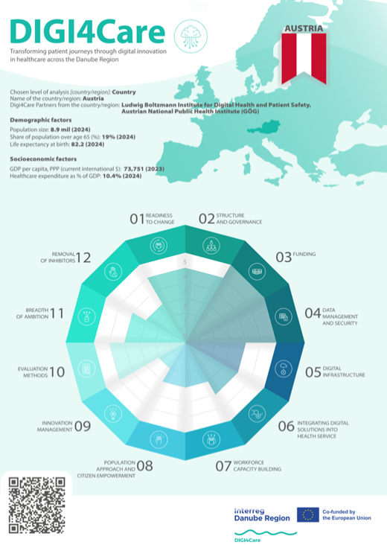

**Fig.2. Key dimensions assessment - Austria**

CZECH REPUBLIC

Digital health is prioritized field in the Czech Republic and supported by dedicated governance bodies and mechanisms. The Ministry of Health collaborates with various governmental and non-governmental organizations to oversee the development and implementation of digital health strategies. The Czech Republic has established protocols for certifying and regulating digital health tools used in healthcare delivery, which comply with European Union regulations, such as the Medical Device Regulation (MDR). Initiatives like the Czech National eHealth Strategy encourage collaboration among research universities, tech companies, and healthcare providers to develop and implement digital health solutions. Additionally, there are grant programs and institutions, such as CzechInvest, to support business development in this area. The National eHealth Strategy sets goals for the development and implementation of digital health systems. The system-level integration of successful digital health solutions is also an articulated aim of decision-makers in the region. There is a clear recognition that for digital health to achieve its full potential, it must be integrated seamlessly into the existing healthcare system, rather than being implemented as isolated projects or addons.

The primary sources of funding for digital health innovation include National Recovery Plan, National eHealth strategy, European Regional Development Fund (ERDF), government grants, and public-private partnerships. There are also emerging financing opportunities through venture capital, especially for startups that focus on innovative healthcare solutions. These funding sources provide the financial support needed for research, pilot projects, and the initial phases of implementation.

There are laws concerning data security, such as the Act on Electronic Health Care and the Personal Data Protection Act, which address different aspects of the data lifecycle, including collection, processing, storage, transmission, use, and destruction. These laws are especially important in the context of digital health, as they aim to protect sensitive health information. However, the implementation and enforcement of these laws can differ across regions, resulting in inconsistencies in data security practices.

The state of digital infrastructure in the healthcare system is a significant concern. The existing digital infrastructure is often fragmented, with different systems and technologies that do not communicate effectively with each other. However, there are governmental efforts underway to address these challenges, including initiatives to develop and promote the adoption of standardized technical frameworks that ensure compatibility across different systems.

Digital health and health informatics are increasingly being incorporated into the training curricula for healthcare professionals, particularly for those in fields such as radiology, nursing, and medical IT. This ensures that new healthcare professionals are equipped with the skills needed to work with digital health technologies from the start of their careers.

The primary issues that our region seeks to address through digital health include improving healthcare accessibility, particularly in underserved areas, reducing the inefficiencies in current healthcare delivery systems, enhancing early diagnostic capabilities through advanced technologies like AI-driven imaging systems, and ultimately improving patient outcomes. There is also a strong emphasis on making healthcare more patient-centered by integrating digital tools that empower individuals to manage their health more effectively. Also standardized methodologies for certifications and other implementation related processes is missing. The overall assessment results are depicted in Fig.3.

**Fig.3. Key dimensions assessment - Czech Republic**

SLOVAKIA

In Slovakia, digital health is becoming increasingly important area, as evidenced by the establishment of dedicated organizations and governance mechanisms. The Ministry of Health plays a central role in guiding digital health initiatives, supported by the National Health Information Center (NHIC). The NHIC oversees the implementation of electronic health records (EHRs), telemedicine, and other digital health services. Slovakia is aligned with broader European Union strategies, including the European Health Data Space and other EU digital health initiatives. The certification process for medical devices, including digital health tools, is governed by the standards established under the EU Medical Device Regulation (MDR), which came into effect in May 2021. This regulation provides a comprehensive framework to ensure the safety and effectiveness of medical devices, including software and digital health applications. At the national level, the Slovak Ministry of Health, in collaboration with the State Institute for Drug Control (ŠÚKL), is responsible for regulating and certifying these tools. In recent years, the National Institute for Value and Technologies in Healthcare (NIHO), which functions as a Health Technology Assessment (HTA) agency, has been established. However, despite its focus on technology, most of NIHO's assessments have concentrated on pharmaceuticals rather than digital technologies. Although the Slovak Ministry of Health collaborates with universities and research institutions, these partnerships have not yet produced significant advancements in digital health technologies. Efforts to connect medical faculties with technology departments within Slovak universities have been slow to result in impactful developments in telemedicine, health informatics, and AI-driven healthcare solutions.

The national health strategy, along with related plans such as the National Health Strategy 2030 and the Operational Program Slovakia (OPS), includes provisions for digitalization and research and development in healthcare health as part of their overarching objectives. These plans allocate resources to various aspects of healthcare, including digitalization. The funding landscape for digital health innovation in Slovakia is supported by a mix of national, European Union, and private sector funds, but several challenges hinder its full potential. The primary sources are: Slovak Research and Development Agency (APVV), the Slovak Ministry of Health, EU Structural and Investment Funds (ESIF) and Resilience Fund, Horizon Europe, etc. Slovakia has established laws and regulations that address data security throughout the entire data lifecycle, including collection, processing, storage, transmission, use, and destruction, which are particularly relevant to digital health. The primary legal framework governing data security in Slovakia is closely aligned with the European Union's General Data Protection Regulation (GDPR). The primary legal frameworks governing these aspects are the General Data Protection Regulation (GDPR) and Slovak Act No. 18/2018 Coll. on Personal Data Protection. The current state of digital infrastructure in Slovakia’s healthcare system represents a substantial barrier to the diffusion of digital health technologies. Overcoming these challenges will require a coordinated effort from government authorities, healthcare providers, the private sector, and other stakeholders to build, upgrade, and sustain the necessary infrastructure. Digital health and health informatics are increasingly acknowledged as vital components of healthcare; however, their integration into the pre-service training curricula for health and health-related support professionals remains underdeveloped.

Slovakia is progressively integrating several digital health solutions into its diagnosis, treatment, and follow-up procedures. This trend reflects the increasing adoption of digital technologies aimed at enhancing the efficiency and effectiveness of healthcare delivery. Some of these solutions include Electronic Health Records (eHealth), ePrescription (E-RECEPT), mobile health apps for patients, diabetes management tools, and telemedicine services. However, Slovakia's healthcare system faces significant challenges in adopting these digital health solutions due to various contextual barriers. Legal and regulatory complexities, such as the European Union's General Data Protection Regulation (GDPR) requirements and the lack of a dedicated legal framework for digital health, create uncertainties and hinder innovation. Additionally, resistance from healthcare professionals—who may be unclear about the reliability and impact of digital tools—further slows progress. There are also considerable technological barriers, including inconsistencies in digital infrastructure, particularly in rural areas, and the need for system interoperability. The overall assessment results are depicted in Fig.4.

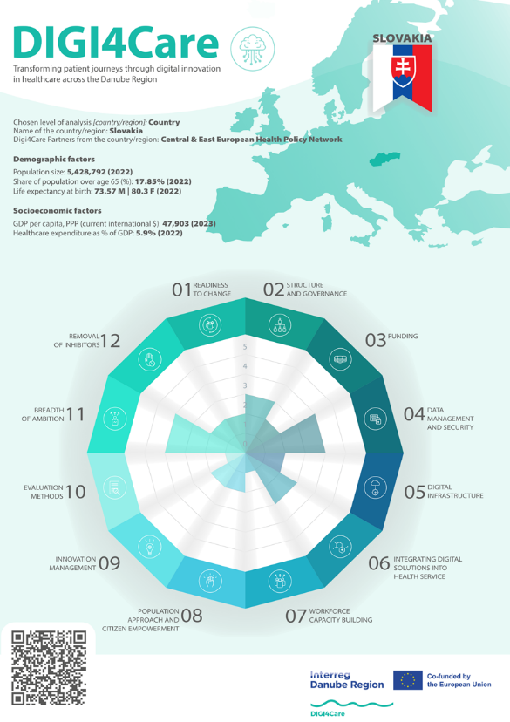

**Fig.4. Key dimensions assessment - Slovakia**

HUNGARY

Hungary's policymakers have recognized the substantial opportunities within digital health and are actively pursuing the digitization of healthcare. This commitment is evident in a series of recent government strategies focused on this area. The country features a unique, relatively centralized, and data-rich health sector, characterized by a single insurer managing public healthcare. This insurer collects comprehensive data on care provision, including the date, location, level of care, type of service provided, and the rationale behind each care episode. Hungary employs a unified system that offers a shared platform for electronic health records encompassing the entire insured population. However, there is no single document that encapsulates Hungary's digital health strategy. Instead, several concurrent strategies exist, addressing either broader domains that include digital health or more specific segments within it. Current national strategies addressing digital health include Healthy Hungary 2021−2027 Health Sector Strategy, National Digitalisation Strategy 2022-2030, National Health Informatics Strategy 2021-2027, Digital Health Industry Development Strategy, Artificial Intelligence Strategy of Hungary (2020), Hungary's Competitiveness Strategy 2024-2030. These strategies collectively aim to enhance the integration and effectiveness of digital health in the country.

Establishing a robust mechanism for the system-level integration of digital solutions, particularly in the field of AI, is essential for reducing fragmentation within the innovation landscape. This approach aims to streamline the various isolated efforts in this area. In Hungary, due to its EU membership, regulations governing the use of digital health solutions operate on two levels: the EU level and the national level. The country has relied on European Union funds for its digital health financial resources. The relevant EU financial instruments in this area include the Digital Europe, EU4Health, and Horizon Europe programs, as well as the Connecting Europe Facility, European Structural and Investment Funds, and the European Social Fund Plus. Additionally, the EU's Recovery and Resilience Facility is expected to play a significant role in the digitalization of Hungary's healthcare system. However, due to political challenges, the timeline for its disbursement has not yet been established.

Hungary has established national laws that outline specific requirements for data security and access controls. To modernize the existing legal framework and stay aligned with the growing digitalization and the constantly evolving cybersecurity threat landscape, the EU cybersecurity rules from 2016 have been updated through the NIS2 Directive, which took effect in 2023. The General Data Protection Regulation (GDPR) governs data privacy and processing, detailing the responsibilities of data controllers and processors, as well as the rights of data subjects. Another important EU-level regulation is the European Health Data Space (EHDS), which aims to empower individuals by providing increased digital access to and control over their electronic personal health data, applicable to both primary and secondary uses.

While differences among healthcare service providers present significant challenges, particularly regarding varying levels of IT infrastructure and equipment, Hungary’s digital healthcare system has made notable advancements, such as the implementation of the EESZT system. This system facilitates data sharing between healthcare institutions; however, many medical systems remain isolated. Currently operational digital solutions are being integrated into care delivery in a fragmented manner. Certain specialties, like pathology and radiology, also leverage digital health solutions. For instance, telepathology is used in several Hungarian institutions to support remote consultations. Since 2019, providers have been able to report the preparation, sending, evaluation, and return of colonoscopy samples via telepathology to the National Health Insurance Fund and receive reimbursement for these services.

Hungarian universities have already integrated digital education elements into the curriculum. For instance, Semmelweis University (Hungary’s oldest and largest medical training institution) offers different courses for medical students, dental students and pharmaceutical students. The Digital Health Sciences Institute offers courses in medical and pharmaceutical informatics (e.g. "Introduction to Medical Informatics, "Biostatistics in Clinical Medicine".

Hungary still needs to address several challenges to enhance its use of digital health solutions. The main hurdle is the shortage of adequate resources and healthcare professionals. Significant financial investment is required for the purchase, development, and integration of new digital solutions. The overall assessment results are summarized in Fig.5.

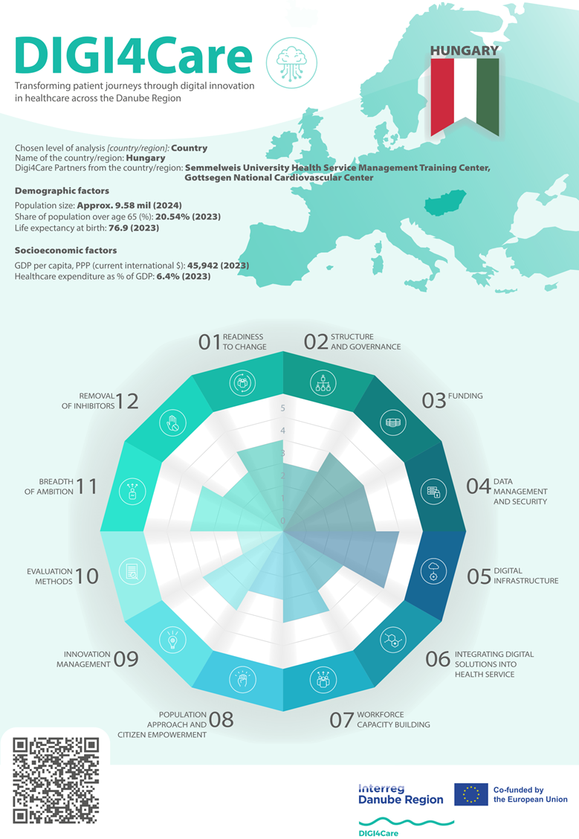

**Fig.5. Key dimensions assessment - Hungary**

ROMANIA

In 2023, Romania has prioritized digital health through the National Recovery and Resilience Plan (PNRR). As part of this initiative, investments are being made in IT systems and digital infrastructure at 210 hospitals across the country. Additionally, a new law, HG 832/2024, has been introduced to establish a strategy for artificial intelligence within the administrative sector, including the medical industry. This law outlines the National Strategy for Artificial Intelligence for the years 2024 to 2027. Romania also encourages collaboration between various sectors and academia. A notable example is the Innovation and e-Health Centre at the University of Medicine and Pharmacy Carol Davila in Bucharest. This centre is dedicated to implementing innovative strategies and policies in e-health, aligning with the university's vision, mission, and policies, as well as national, European, and international standards. The PNRR has initiated projects aimed at enhancing the digital system of the NHIH and digitizing at least 200 hospitals. Additionally, there are plans to launch other projects focused on the development of telemedicine and the digitization of the Ministry of Health (MH) and its subordinate institutions.

Decision No. 271/2013 approves the Cybersecurity Strategy of Romania and outlines an Action Plan for implementing the national cybersecurity system. Law No. 362/2018 addresses the protection of individuals concerning the processing of personal data by competent authorities for the prevention, discovery, investigation, prosecution, and combating of crimes, as well as for the execution of punishments, educational measures, and safety measures. It also governs the free movement of this data. This law aims to establish a high standard of security for networks and IT systems.

There are some examples of digital health solutions being integrated into diagnosis. The ITaka medical platform is a cloud-based online medical application that can be accessed from anywhere without needing local installation. It provides features like online scheduling with automatic SMS notifications, unique medical files tailored to each specialty, integrated imaging, and comprehensive statistics—all in one convenient place. The platform was developed with doctors’ working styles in mind, making it an effective tool to assist with daily administration tasks. The system-level integration is primarily outlined in the National Plan for the Digital Decade for Romania 2030 and the PNRR program. However, implementation is still pending. A newly established Centre for Patients’ Safety Management is coordinated by the Research Centre for Information Technology, Electronics, and Automatics at Oradea University. Its goal is to achieve comprehensive integration of national virtual networks, incorporating various innovative and successful IT and communication solutions, particularly for the national health system. As this initiative is a work in progress, results will be available for analysis, further development, and publication in 2025.

The Romanian Government and the EU offer training programs aimed at developing advanced digital skills through the National Recovery and Resilience Plan, which is available to all workers in public administration (<https://formaredigitalaanfp.ro/>). At UMF Cluj, there is a Master's program in Biostatistics and Bioinformatics. Similar programs are also available at UMF Bucharest and "Politehnica" University of Bucharest. National Strategy for Research, Innovation and Smart Specialization 2022-2027 aims to strengthen scientific research, upgrade technological capabilities in industrial sectors (including health), encourage innovations associated with smart specializations, increase employees in research and development, and enhance European and international collaboration.

The major obstacles in the diffusion of digital health in the system are the lack of specialized human resources in this field, lack of skills, limited source of funding, lack of legal framework, resistance from key stakeholders. The overall assessment results are summarized in Fig.6.

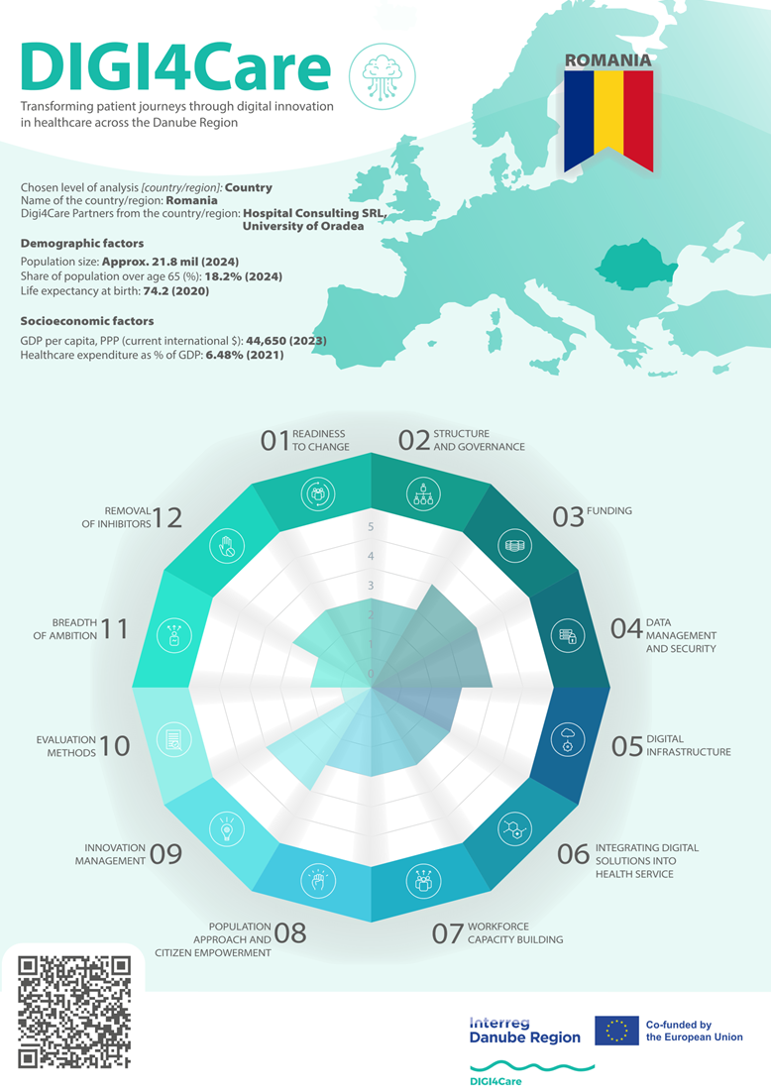

**Fig.6. Key dimensions assessment – Romania**

BULGARIA

Bulgaria aims to comply with EU directives for the certification and governance of digital health tools utilized in healthcare delivery. Currently, the major challenge in developing this regulation is the state's capacity and expertise to ensure a smooth and efficient process for implementing digital health services. Moreover, Bulgaria lacks a dedicated body specifically responsible for digital health initiatives. However, digital health is somewhat prioritized through various governance bodies and mechanisms, including the Ministry of Health, the National Council on Prices and Reimbursement of Medicinal Products (NCPRMP), the National Health Insurance Fund, the Digital Health and Innovation Cluster Bulgaria, as well as various E-Health projects and funding sources. The state needs to be more proactive in creating conditions for cross-sectoral collaboration among different stakeholders. However, the civil sector in Bulgaria tries to develop cross-sectoral partnerships to facilitate the integration of digital health into its healthcare system. Several initiatives and partnerships have already been established, such as the Innovative Health Initiative (IHI), Digital Bulgaria 2025 National Programme, Digital Transformation Strategy (2020-2030), Digital Health and Innovation Cluster Bulgaria and WHO Collaboration. The effective integration of successful digital health solutions at the system-level is a key objective for decision-makers in Bulgaria. This ambition is evident in various national strategies and programs that highlight the significance of digital transformation in healthcare.

Funding for digital health innovation in Bulgaria is sourced from multiple avenues, including national programs, European Union funds, and private investments, such as venture capital. Key initiatives include the European Union Funds and the National Programme “Digital Bulgaria 2030.” Throughout the years, Bulgaria has developed plans to support the expansion and maintenance of digital health infrastructure, which encompasses devices, software, and related technologies. These plans are integrated into national strategies and are backed by various funding mechanisms.

Bulgaria has a legal framework for data security that covers the personal data protection, but not the full data lifecycle. The primary laws that Bulgaria is compliant with include Personal Data Protection Act (PDPA) and EU General Data Protection Regulation (GDPR).

The areas of successful digital healthcare implementations are Electronic Health Records (EHRs) and Data sharing, Telemedicine services, E- Prescriptions and e-Medical Referral, Health-Related Mobile Applications, Health-Related Mobile Applications. The key organizations driving digital healthcare innovations are the National Innovation Forum, Sofia Tech Park, the Institute for Computer Science, Artificial Intelligence, and Technology (INSAT), the Digital Health and Innovation Cluster Bulgaria, and the National Council on Prices and Reimbursement of Medicinal Products (NCPRMP). The Digital Health and Innovation Cluster Bulgaria has actively promoted digital health innovations. Recent initiatives include launching a health tech subsidiary focused on medical devices and clinical data integration solutions, which marks a significant step in broadening the scope of healthcare technology in the country.

Several substantial contextual barriers hinder the adoption of digital health solutions in Bulgaria's health system. These barriers encompass legal, cultural, financial and skills-related challenges such as fragmented legal framework, resistance from critical stakeholders, patient trust and acceptance, limited funding for digital health, lack of skills and training, and inadequate training programmes. The overall assessment results are summarized in Fig.7.

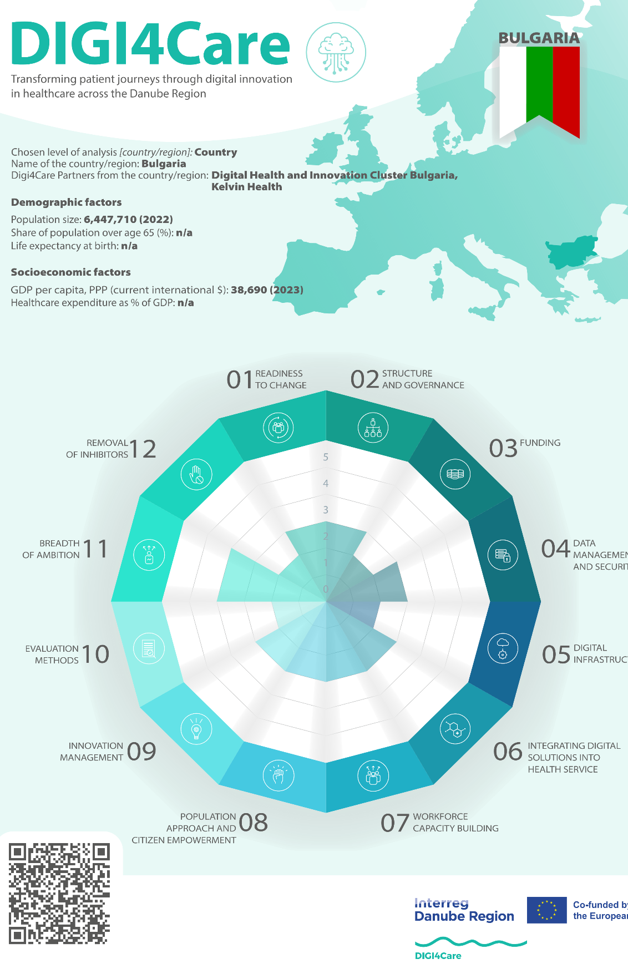

**Fig.7. Key dimensions assessment - Bulgaria**

REPUBLIC OF SRPSKA

Digital health in the Republic of Srpska needs to be prioritized more through dedicated governance bodies or mechanisms. While there are ongoing efforts to implement digital health strategies, such as the Integrated Health Information System (IZIS) and a recent digitalization strategy, these initiatives face significant challenges. Key issues include regulatory gaps, inadequate infrastructure, and a lack of comprehensive governance frameworks. The newly developed Strategy for the Advancement of Science, Technology, Higher Education, and the Information Society for 2023-2029 aims to encourage collaboration across sectors. The Republic of Srpska needs to establish comprehensive protocols for the certification and regulation of digital health tools intended for healthcare delivery. Although progress has been made with initiatives like the Smart Digitalization concept and the digitalization strategy in healthcare, there is still a need for specific regulations and legal frameworks. These should focus on certification, data privacy, and the use of digital health technologies. Developing more structured protocols and guidelines is essential to support the safe and effective implementation of digital health tools.

Digital health projects in the Republic of Srpska primarily rely on public funding, and additional efforts are needed to diversify and increase funding sources to support ongoing digitalization efforts. The most important sources for funding digital health innovation in the Republic of Srpska include the Compulsory Health Insurance Fund (HIF), Public Funding, Annual Budgets of Health Institutions, and Out-of-Pocket Payments by Healthcare Users.

In the Republic of Srpska, no comprehensive law specifically covers data security for the entire data lifecycle relevant to digital health. While there are some regulations related to healthcare data management and privacy, they do not fully address all aspects of data security, such as collection, processing, storage, transmission, use, and destruction, specifically for digital health. The existing framework is fragmented, and more robust, comprehensive legislation is needed to ensure secure data management throughout the entire lifecycle of digital healthcare.

There are several examples of cross-sectoral cooperation aimed at integrating digital health solutions at a system level. One notable initiative is the Integrated Health Information System (IZIS), which connects all healthcare institutions and facilitates electronic health records, prescriptions, and referrals. Additionally, AI-driven solutions are being integrated into healthcare, such as the use of RBfracture software in radiology at PHH “Sveti Vračevi” and the Lokomat system for rehabilitation at PHI “dr Miroslav Zotović.” These projects involve collaboration between healthcare institutions, government bodies, and private sector partners, aiming to enhance healthcare services through innovative digital technologies. In 2024, the cardiology clinic at the University Clinical Center of the Republika Srpska in Banja Luka has acquired one of the most modern devices that will significantly improve diagnostics and examinations in this area. The device has excellent features, some of which are high image resolution and software supported by artificial intelligence that will help in obtaining more information about the condition of the heart muscle and valves. Essentially, the device will make diagnoses much faster, especially in severely hospitalized patients, and in addition, it will affect the more precise preparation of patients from the cardiac surgery department.

The state of digital infrastructure in the health system of the Republic of Srpska is perceived as a major obstacle in the diffusion of digital health. The region faces challenges such as insufficient internet connectivity, outdated hardware and software in healthcare facilities, and limited integration of digital systems. These issues hinder the effective implementation and adoption of digital health solutions, making it difficult to fully leverage the benefits of digital technologies in healthcare. Significant improvements in digital infrastructure are needed to support the widespread use of digital health in the system. The overall assessment results are summarized in Fig.8.

**Fig.8. Key dimensions assessment – Republic of Srpska**

The overall assessment results for all eight partners are summarized in Figure 9.

**Fig.9. Key dimensions assessment – Summary**