


Regional Action Plan of Montenegro
Activity 1.3

TABLE OF CONTENTS
1. Introduction 4
1.1 General information of the Partner 4
1.2. Overall and specific objectives of the Action Plan 4
2. Regional Analysis 6
2.1. Natural and cultural assets 6
2.2. Social and economic conditions in the region 9
2.3. Transhumance and Its Connection with Wood, Forests, and Biodiversity 11
2.4. Summary of the regional assessment 12
2.5. Challenges and opportunities 13
3. Strategic framework 17
4. Actionable measures 20
4.1. Action 1- Organize Training in Decorative Wood-Based Skills (g) 23
4.1.1. Relevance of the measure 23
4.1.2 Nature of the action 23
4.1.3. Activities performed under the Action 23
4.1.4. Potential Danube Wood(s) Cultural Route points involved 24
4.1.5 Stakeholders involved 24
4.1.6. Timeframe 24
4.1.7. Indicative costs 24
4.1.8. Output and result indicators 24
4.2. Protection of Katuns and Cultural Landscapes (a) 25
4.2.1. Relevance of the measure 25
4.2.2. Nature of the action 25
4.2.3. Activities performed under the Action 25
4.2.4. Potential Danube Wood(s) Cultural Route points involved 26
4.2.5. Stakeholders involved 26
4.2.6. Timeframe 26
4.2.7. Indicative costs 27
4.2.8. Output and result indicators 27
5. Implementation plan and monitoring system 28
5.1. Monitoring framework 28
5.2. Evaluation plan 28
5.3. Action indicators 28
6. Potential funding opportunities 30
7. Conclusion 31
7.1. Summary of key points 31
7.2. Future directions and recommendations 31
8. List of sources 32

1. Introduction

General information of the Partner
PROJECT | Danube Wood(s) Route
PARTNER ORGANISATION CONCERNED | Regional Development Agency for Bjelasica, Komovi and Prokletije
COUNTRY | Montenegro
NUTS2 REGION | Northern Montenegro
CONTACT PERSON | Jelena Krivcevic
E-MAIL ADDRESS | jkrivcevic@bjelasica-komovi.co.me

Overall and specific objectives of the Action Plan
The Danube Wood(s) Cultural Route Regional Action Plan of Montenegro (RAP) is an integral component of the broader Danube Wood(s)Route initiative, aligning closely with the strategic directions defined by the Common Danube Wood Strategy. The primary aim of the RAP is to support the sustainable use of forest resources and the valorisation of wood-related cultural heritage by translating transnational goals into actions tailored to the needs and strengths of northern Montenegro.

The Montenegrin RAP is rooted in the regional analysis conducted for the Bjelasica, Komovi and Prokletije area and surrounding municipalities (Plav, Gusinje, Berane, Andrijevica, Kolašin, Mojkovac, BijeloPolje, Petnjica), where forest coverage exceeds 60% and where unique traditions of wood use persist in architecture, crafts, oral heritage, and rural life. The region also hosts significant biodiversity and a strong tradition of rural tourism, especially in mountainous areas shaped by centuries of transhumance and forest use.

The RAP proposes concrete, small-scale measures that connect ecological conservation with cultural preservation, economic development, and social cohesion. In doing so, it not only addresses issues such as deforestation risk, underutilized wood crafts, and rural depopulation but also promotes green innovation, local entrepreneurship, and inclusive tourism development.

A core objective of this RAP is to establish broad consensus among regional stakeholders—including rural households, cultural institutions, tourism providers, women’s groups, and protected area authorities—on shared priorities for integrating forest and wood heritage into local development. This includes identifying locations with cultural and ecological value, improving their visibility and accessibility, and integrating them into meaningful visitor experiences.

The RAP supports the creation of wood-inspired tourism infrastructure and services, such as traditional guesthouse upgrades, forest-themed interpretation trails, and decor that reflects local heritage. These interventions aim to diversify rural tourism offers, extend the season, and empower host communities. The action plan also promotes community-based conservation, including the protection of forest biodiversity, vernacular wooden structures, and oral traditions.

Capacity building is another key element. Through hands-on training, mentoring, and peer exchange, the RAP enables local actors to take active roles in the cultural route’s development and management. Special focus is placed on engaging women, who hold essential knowledge of decorating, crafting, storytelling, and hosting, but are often underrepresented in planning processes.

By supporting sustainable forest-based entrepreneurship, the RAP encourages the use of legal and locally-sourced wood in crafts, design, and tourism infrastructure. It aligns with broader sustainability frameworks, including the EU Green Deal, EUDR (Deforestation Regulation), and circular economy principles. One important tool supporting this alignment is the Good Travel Seal certification, which helps rural tourism households adopt environmentally responsible and culturally authentic practices. The RAP promotes this certification as a practical way to benchmark and improve the sustainability of rural tourism offers while enhancing visibility and credibility with eco-conscious travelers.

Finally, education and public awareness form a core pillar. The RAP proposes school-based learning, youth forest workshops, and multimedia campaigns that celebrate Montenegro’s wood heritage and promote respectful engagement with nature.

In summary, this Regional Action Plan serves as a bridge between vision and implementation, helping Montenegro contribute actively to the Danube Wood(s)Route while honoring and revitalizing its own forest-based traditions. Through its emphasis on sustainability, community ownership, and cultural identity, the RAP strengthens Montenegro’s role in shaping a more resilient and creative Danube region.

Regional Analysis
The regional analysis for the Montenegrin Regional Action Plan (RAP) was conducted to identify the main challenges and opportunities within the northern mountainous regions of Montenegro, particularly the areas surrounding Bjelasica, Komovi, and Prokletije. These areas represent a unique convergence of dense forest cover, high biodiversity, cultural heritage, and rural tourism potential. The analysis informs the selection of strategic actions presented in Section 4, ensuring they respond directly to local needs and capacities.

Natural and cultural assets
Montenegro is among the most forest-rich countries in Europe, with 61.5% of its land covered by forests—a total of 827,000 hectares, of which an impressive 99% are naturally regenerating. This makes Montenegro one of the few countries in Europe where primary forest functions remain intact. Its diverse forest types, ranging from primeval beech stands to mixed fir and pine ecosystems, support high endemism and relict species.

Annex: Visual Data for Section 2.1 - Natural and Cultural Assets of Montenegro
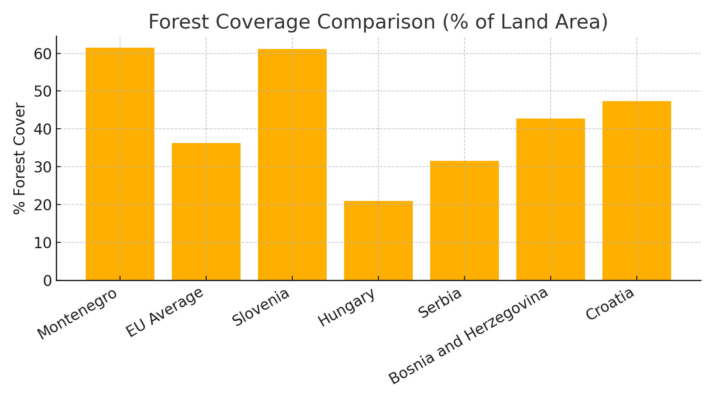
Figure 1: Forest cover as percentage of land area. Montenegro stands out with over 60% forest cover, significantly above the EU average. Data sources include Eurostat 2020 and FAO Global Forest Resources Assessment 2020.

These forests serve as habitat for a range of protected species including brown bear (Ursus arctos), Eurasian lynx (Lynx lynxbalcanicus), wolf (Canis lupus), golden eagle (Aquila chrysaetos), capercaillie (Tetrao urogallus), and Balkan chamois (Rupicaprarupicaprabalcanica). According to the national biodiversity report, 55 forest species in Montenegro are currently listed as vulnerable, endangered, or critically endangered.

Table 2: Selected Forest Species in Montenegro and Their IUCN Status
Species | IUCN Status
Brown bear (Ursus arctos) | Least Concern
Eurasian lynx (Lynx lynxbalcanicus) | Endangered (Regional)
Wolf (Canis lupus) | Least Concern
Golden eagle (Aquila chrysaetos) | Least Concern
Capercaillie (Tetrao urogallus) | Near Threatened
Balkan chamois (Rupicaprarupicaprabalcanica) | Least Concern
IUCN Red List of Threatened Species. Retrieved from https://www.iucnredlist.org

Montenegro’s forests store a significant amount of carbon—estimated at 46.7 million tonnes, with about 90% stored in above-ground biomass, making them a vital tool in climate change mitigation efforts. Their provisioning, regulating, and cultural ecosystem services include soil protection, water regulation, air purification, renewable energy through biomass, and resources for medicinal herbs and wild food.
Table 2: Forest Carbon Stock in Montenegro
Category | Value
Total Forest Carbon Stock (Mt) | 46.7
Above-Ground Biomass (%) | 90%
Montenegro National Forest Inventory and Biodiversity Strategy (2022). Government of Montenegro.

However, forests in Montenegro are not only ecosystems—they are also living cultural landscapes. In many northern and eastern regions, especially in Bjelasica, Komovi, Prokletije, Kuči, and Hajla, forest use is deeply embedded in traditional practices. The katun system, a seasonal transhumance settlement model, represents a fusion of ecological adaptation and cultural resilience, relying heavily on local wood for architecture, tools, fences, and storage structures.
Wood is central to the vernacular identity of these regions. Katuns, the seasonal settlements used for transhumance, often feature log construction, symbolic wood carvings, and multi-functional wooden structures such as drying racks, storage huts, and stables. These are designed with ecological knowledge: using local species (e.g., beech for structure, juniper for insect protection), adapting to terrain and climate, and constructed through collective community effort.

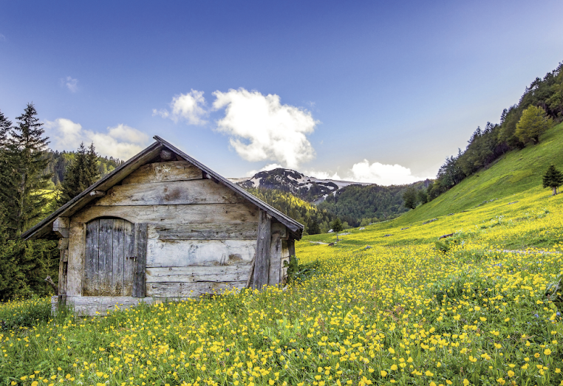
Katun on Bjelasica Mountain, photo by RDA BKP
The intangible heritage connected to forests is equally rich. Epic poetry and ritual music, performed with the gusle (a single-string instrument carved from maple), is a defining feature of Montenegrin identity and is closely tied to forest resources. Other knowledge systems include herbal medicine, seasonal foraging, wood carving, and open-fire cooking in forest settings.
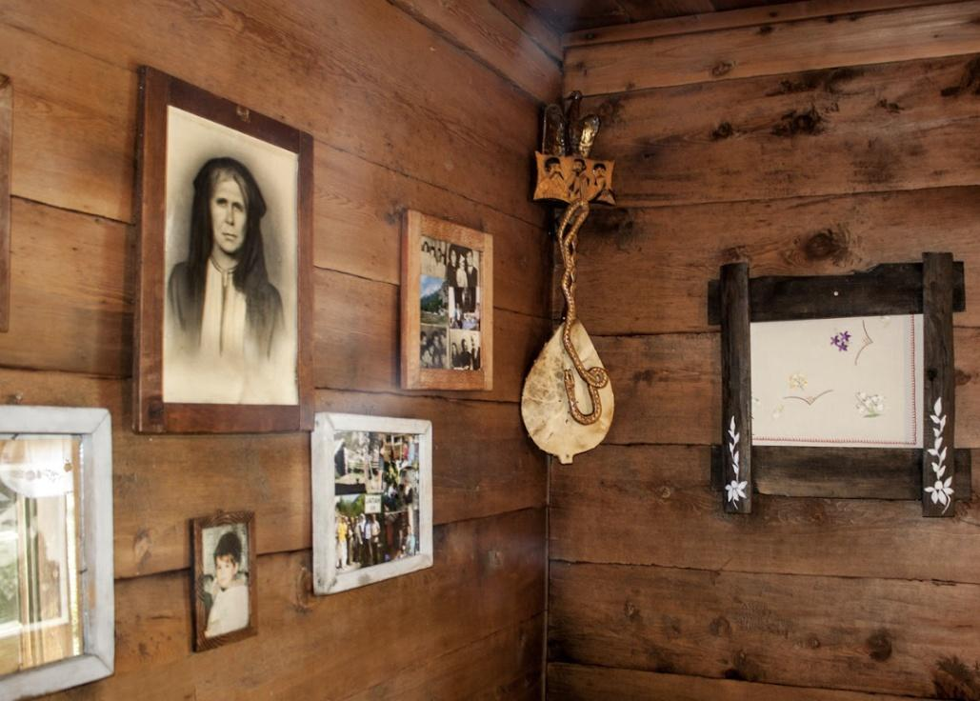
Gusle – national instrument in Montenegro
Montenegro's commitment to conservation is reflected in its significant network of protected areas, which together cover 13.2% of the country’s territory. Forest ecosystems form the ecological backbone of many of these areas. The country boasts five national parks—Durmitor, Biogradska Gora, Lovćen, Prokletije, and Skadar Lake—as well as several regional nature parks, including Komovi, Piva, and Orjen. Among them, Biogradska Gora National Park is one of the last remaining primeval forests in Europe, with trees over 400 years old and exceptional biodiversity.
These forest-rich landscapes are not only protected for their ecological value but also represent centuries of harmonious coexistence between people and nature. The boundaries of many parks include seasonal settlements and traditional katun systems, where forest use, pasture management, and cultural practices intersect. However, these areas are still underutilized in terms of their cultural interpretation and could play a much larger role in sustainable, heritage-based tourism.
Yet these assets face multiple pressures: depopulation of rural areas, loss of traditional knowledge, unsustainable timber practices, and increased tourism in ecologically fragile zones. The erosion of intergenerational knowledge transfer is particularly visible in forest-related crafts and rituals, now at risk of being lost unless deliberately revitalized.
Nonetheless, these pressures are counterbalanced by emerging opportunities. Montenegro is experiencing a growing interest in eco-conscious tourism, traditional food and crafts, and authentic rural experiences, especially in the post-pandemic period. This creates a unique window for forest-based cultural heritage to be rediscovered, revalued, and integrated into sustainable development models, particularly through community engagement, women’s knowledge, and youth participation.
The Danube Wood(s)Route offers a transnational platform to connect these local efforts into a broader initiative. Montenegro’s combination of natural richness and cultural depth provides fertile ground to contribute to the Route’s mission—protecting biodiversity, celebrating forest heritage, and supporting rural resilience through nature-based and culture-driven actions.

Social and economic conditions in the region

Montenegro’s Bjelasica, Komovi and Prokletije region is among the most economically challenged parts of the country. These areas are largely rural, mountainous, and sparsely populated, with aging demographics and a persistent trend of youth outmigration. According to national statistics, rural municipalities in the north face unemployment rates significantly above the national average, with limited access to health, education, and digital infrastructure.
Municipality | Estimated Population (2021)
Kolas¡in | 7800
Andrijevica | 4700
Berane | 27000
Plav | 13000
Gusinje | 7000
Petnjica | 5500
BijeloPolje | 46000
Mojkovac | 8000
Total | 119000
Forests in these regions, while ecologically rich, are economically underutilized. The formal timber sector contributes modestly to national GDP, and illegal logging and informal firewood trade remain prevalent in certain areas. Local communities rely on forests primarily for subsistence purposes—fuelwood, wild food, pasture fencing, and construction materials—rather than through structured value chains or certification schemes.
Despite these challenges, there is significant potential for green, wood-related economies. The demand for authentic rural experiences, local craftsmanship, and sustainable tourism has grown, particularly since the COVID-19 pandemic. This opens new development avenues in the form of nature-based tourism, forest therapy, wood-based crafts, and storytelling around transhumance and traditional architecture. However, the development of these sectors requires targeted support, especially in skill development, digital promotion, and access to finance.
Women and older generations play a key role in preserving forest-based knowledge, from herbal medicine and foraging to woodworking aesthetics and seasonal rituals. However, their contributions are often undervalued in local economic development strategies. The risk of losing this intangible knowledge due to depopulation is high unless mechanisms for intergenerational transfer and community-based valorisation are implemented.
In summary, forest-dependent areas of Montenegro face significant socio-economic challenges, but also offer fertile ground for innovation that connects biodiversity protection, cultural heritage, and sustainable economic development.

Demographic Trends
The population across the region has been steadily declining due to long-term outmigration, particularly of young people seeking better opportunities in urban areas or abroad. For instance:
- Kolašin’s population dropped from around 9,949 in 2003 to approximately 7,800 by 2021.
- Andrijevica has fewer than 5,000 residents today, many of them elderly.
- Gusinje and Petnjica, re-established as municipalities in the past decade, face especially high youth emigration.
These demographic shifts result in aging populations, labor shortages in key sectors (especially agriculture and tourism), and weakened community structures—directly impacting forest stewardship and transmission of traditional knowledge.

Economic Situation
The local economy is largely based on:
- Forestry (firewood collection, logging, and informal timber use)
- Agriculture (small-scale livestock, seasonal grazing, and foraging)
- Tourism, which remains underdeveloped but growing

Formal employment opportunities are limited. Unemployment in some municipalities in this region exceeds 25–30%, with a strong seasonal component. Many families rely on subsistence activities, remittances from diaspora, and informal work arrangements.
Forestry remains important for household needs but is rarely part of certified or structured value chains. Illegal logging and unsustainable practices still occur, though community-managed forests in the region (e.g., around Komovi) present more sustainable models.
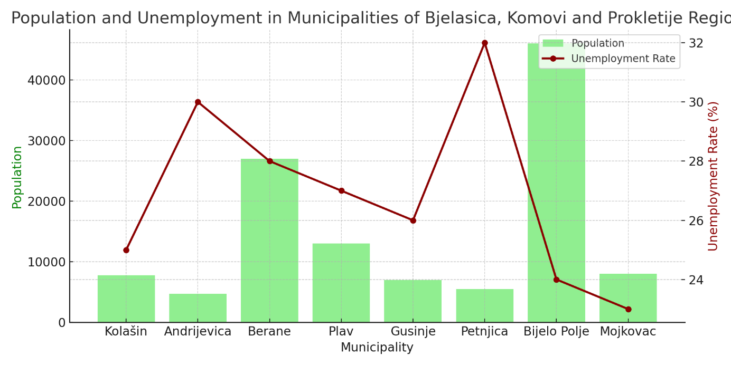
Tourism and Nature-Based Economy
Tourism potential is significant, particularly around Biogradska Gora and Prokletije National Parks, Komovi Regional Park, and the nearby katun (seasonal herder settlement) areas. The katun-based transhumance system is one of the few forms of seasonal economy that maintains both ecological practices and cultural continuity. However, infrastructure remains underdeveloped, especially roads, waste systems, and accommodation capacity.
Rural households offering tourism services often operate informally or on a small scale. There's growing demand for authentic experiences (homecooked meals, guided hikes, workshops on traditional crafts), but most providers lack training, visibility, or investment support.

Gender and Social Inclusion
Women, especially in remote katun settlements, hold critical roles in managing forest-based knowledge—ranging from wood-based interior decoration and food preservation to medicinal plant use and oral traditions. Despite this, their economic contributions are often informal and invisible in policy or economic planning. Initiatives such as rural women’s associations and mentoring programs have emerged but require stronger institutional and financial backing.
Youth disengagement from traditional forest-related practices is accelerating due to poor educational and employment opportunities, yet some pilot initiatives (e.g., ranger programs or festivals involving young volunteers) have shown promise.

Challenge | Description
Depopulation | Outmigration and aging population lead to labor and knowledge loss
Economic vulnerability | Limited income diversification, high unemployment, informal forest use
Gender imbalance in participation | Women's cultural roles undervalued in formal economy
Infrastructure gaps | Poor roads, low digital connectivity, limited tourist infrastructure
Underutilized cultural assets | Katuns, woodcraft, and transhumance heritage lack visibility and investment

Transhumance and Its Connection with Wood, Forests, and Biodiversity
Transhumance — the seasonal movement of livestock between winter villages and highland pastures — is one of the defining land-use systems in the Bjelasica, Komovi, and Prokletije region, as in all of Montenegro. It has shaped not only the mountain landscape but also the identity, knowledge, and economy of local communities for generations. The tradition centers around katuns — temporary summer settlements typically established in forested highland zones — where families reside from late spring to early autumn.
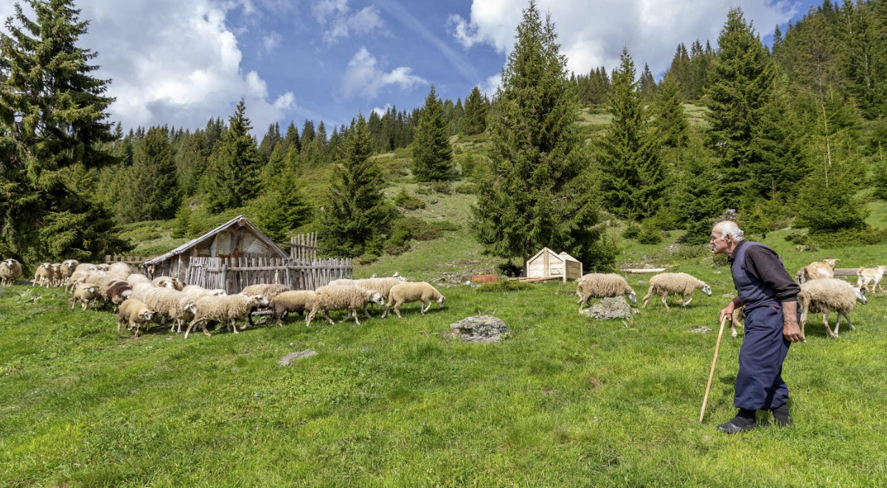Shepherd in katun next to the forest
Wood plays a central role in every aspect of this system. Katun dwellings are traditionally constructed from local hardwoods such as beech and fir, adapted to the terrain and harsh weather conditions of the high mountains. The architecture is vernacular and functional, often consisting of simple log cabins, animal shelters, and storage huts, all built using hand tools and intergenerational techniques. These structures are designed for durability, insulation, and easy repair — using ecological knowledge refined over centuries.
Forests are also the primary source of fuel, tools, and household items. Wooden fences and enclosures define livestock areas, while drying racks for herbs and dairy are common features of katun yards. Traditional tools include the karlica, a shallow wooden bowl used to collect milk or allow cream to rise, and the kaca, a wooden tub used for cheese aging and storage. These items not only serve practical functions but also symbolize self-sufficiency and craftsmanship rooted in forest resources.


Kaca, karlica and tools for traditional katun dishes
Women play a key role in preserving this knowledge. In addition to managing dairy production, they engage in the collection of non-timber forest products (NTFPs) — such as wild herbs, mushrooms, blackberries, blueberries, and rose hips — and prepare forest-based remedies and foods. This includes juices made from young pine cones, syrups from forest berries, and teas from native herbs. Women also select specific wood types for domestic use (e.g., juniper for insect-repelling properties), and pass on cultural knowledge through seasonal practices.
Transhumance also plays a crucial role in the preservation of biodiversity, particularly in forest-edge and high-mountain ecosystems. Seasonal grazing helps maintain a mosaic of open pastures, forest glades, and shrublands that support a wide range of species, including many that are endangered or rare. The movement of livestock facilitates natural seed dispersal, helps prevent forest overgrowth, and reduces the risk of forest fires by controlling underbrush. As such, the katun system represents not only a cultural tradition but also a nature-based practice that supports ecological balance and forest health.

Beyond material culture, transhumance is embedded in oral traditions, seasonal rituals, and songs, many of which are tied to the forest environment. Tools such as the gusle — a single-string instrument traditionally carved from maple or ash — are central to storytelling and epic poetry performed in these landscapes.
Although transhumance is declining due to demographic change, regulatory constraints, and shifts in lifestyle, its cultural and ecological legacy remains strong. Revitalization is possible through community-based tourism, intergenerational learning, and eco-education, particularly when focused on the forest-based elements of the katun way of life.
As part of the Danube Wood(s)Route, Montenegro has the opportunity to present this heritage not as a relic of the past, but as a living model of sustainable land use, forest stewardship, and biodiversity conservation. By engaging local families — especially women — in preserving and interpreting these traditions, the region can contribute a distinctive and authentic voice to the shared wood heritage of the Danube area.

Summary of the regional assessment

The Bjelasica, Komovi, and Prokletije region of Montenegro stands out as one of the most forest-rich and culturally distinctive territories within the Danube region. Over 61.5% of the country’s territory is covered by forest—totaling approximately 827,000 hectares, of which 99% are naturally regenerating. This level of forest integrity is rare in Europe and positions Montenegro as a vital contributor to biodiversity protection, climate regulation, and the preservation of ecological processes.
These forests are not only ecological strongholds; they are also carbon sinks of regional importance, storing nearly 47 million tonnes of CO₂, with around 90% of this stored in above-ground biomass. Forests provide essential ecosystem services such as soil stabilization, water retention, air purification, provision of medicinal plants and wild food, and renewable energy through biomass. They also serve as habitat to species of high conservation value such as the brown bear, Eurasian lynx, Balkan chamois, capercaillie, and golden eagle, making this region ecologically significant in terms of both habitat richness and conservation potential.
At the same time, the cultural heritage of the region is deeply rooted in its forest ecosystems. This is most vividly expressed in the katun system — a transhumant model of seasonal settlement where families relocate to highland pastures during late spring and summer months. Katuns are typically located in high mountain and forest-edge zones and rely heavily on local wood for architecture, enclosures, food preparation tools, and heating. Log construction, symbolic carvings, and multipurpose wooden objects such as drying racks and storage huts are prominent features of this living heritage.
Forests are more than a resource — they are a cultural landscape where practical knowledge, ecological adaptation, and symbolic meaning are intertwined. This knowledge has been passed down orally, especially through women, who play a central role in dairy processing, foraging of forest products, natural medicine, and storytelling. They also maintain wooden culinary tools such as the kaca (a carved wooden container for cheese) and prepare dishes like kajmak in special vessels called karlica, both made from local wood species. These practices reflect a profound understanding of forest materials and seasonal cycles.
Moreover, transhumance has significant biodiversity benefits, particularly in forest-pasture ecotones. Grazing activities reduce shrub encroachment, preserve open habitats needed by rare plant and insect species, and promote ecological diversity by maintaining mosaic landscapes. Livestock also contribute to seed dispersal, soil fertilization, and the maintenance of genetic diversity in native pasture species. These contributions make transhumance not only a cultural but also an ecological asset for forest ecosystems.
Despite these strengths, the region faces mounting pressures. The depopulation of rural and mountain areas, especially among youth, is leading to the erosion of intergenerational knowledge and a decline in traditional forest-based practices. Furthermore, the cultural dimension of forests is underrepresented in tourism and education, while increasing numbers of visitors in sensitive highland zones strain ecosystems and offer limited benefits to local residents. These pressures threaten the sustainability of both the ecological and cultural systems that define the region.
Nonetheless, the region is at a turning point. There is a growing public interest in authentic, nature-connected experiences, traditional foods, crafts, and ecological knowledge. This offers new momentum for sustainable development rooted in forest heritage. Rural tourism, if designed with care, provides opportunities to revive traditional skills, empower women, and attract younger generations back to rural life through diversified livelihoods.
The Danube Wood(s)Route presents a valuable platform to harness this momentum. By connecting Montenegro’s local traditions and forest assets with broader regional initiatives, the project can catalyze community-based, culturally sensitive, and environmentally sustainable practices. With its protected areas, resilient traditional systems, and strong sense of identity, the Bjelasica–Komovi–Prokletije region is well placed to become an area for integrated forest heritage valorization across the Danube region.

Challenges and opportunities

Montenegro’s forest-rich highlands hold immense potential for cultural valorization, biodiversity conservation, and sustainable development. However, several interlinked challenges currently undermine these opportunities and threaten the continuity of forest-based heritage systems such as transhumance. These challenges are outlined below:

1. Depopulation of highland and rural areas
Rural municipalities in the Bjelasica, Komovi, and Prokletije region—such as Andrijevica, Plav, Gusinje, Kolašin, Mojkovac, and BijeloPolje—have experienced a steady decline in population over the past two decades. Young people often migrate to urban centers or abroad in search of better education, employment, and living conditions. This demographic shift reduces the number of active land users and erodes the social fabric of katun-based communities. With fewer families maintaining seasonal settlements or engaging in traditional forestry-related work, entire cultural landscapes risk abandonment.

2. Loss of intergenerational forest knowledge
The outmigration of youth and aging of rural populations severely hampers the transmission of knowledge related to sustainable forest use. Skills in katun construction, selective logging, wood drying and carving, and medicinal plant collection are often held by older generations, especially women. Without targeted initiatives to document and pass on this knowledge, a significant part of the region’s intangible heritage may be lost within a generation. This includes practical ecological understanding—such as the role of certain tree species for structural integrity or pest resistance—which is not typically captured in formal education.

3. Insufficient valorization of forest-based cultural heritage
Although Montenegro’s national and regional parks encompass areas rich in cultural heritage, tourism strategies have largely focused on natural attractions without fully integrating forest-related traditions and material culture. Wooden katuns, symbolic carvings, and foraged products are underrepresented in visitor interpretation materials, tour offerings, and school programs. As a result, rural communities miss economic opportunities linked to cultural tourism, and the broader public remains unaware of the value of these traditions.

4. Unregulated tourism in sensitive forest zones
The post-pandemic tourism boom has brought increasing numbers of domestic and international visitors to forested areas like Biogradska Gora, Komovi, and Prokletije. While this creates new economic possibilities, it also introduces ecological risks—such as trail erosion, disturbance of wildlife, and waste accumulation—when infrastructure and visitor management are lacking. In many cases, tourism benefits bypass local communities altogether, reinforcing inequalities and contributing to resentment toward conservation policies.

5. Poor rural infrastructure
Many katuns and remote villages lack basic services such as reliable roads, electricity, water supply, and mobile or internet coverage. This limits the ability of residents to maintain seasonal livelihoods and discourages new initiatives such as ecotourism or small-scale production of forest-based goods. Without targeted investment in climate-resilient and culturally sensitive infrastructure, efforts to revitalize forest-linked communities will remain marginal.

6. Fragmented institutional coordination and support
Forests in Montenegro fall under multiple governance frameworks, including those for forestry, protected areas, cultural heritage, and agriculture. However, coordination among responsible agencies is often weak, and support programs rarely take into account the integrated nature of rural forest livelihoods. For example, transhumance remains undervalued in forestry and rural development policies, despite its role in maintaining open habitats and traditional land-use patterns. Without a unified approach, local actors struggle to navigate administrative requirements or access funding.

7. Disappearance of traditional forest-based crafts
Crafts rooted in forest resources—such as the making of wooden shingles (šindra), carved cheese vats (kača), and lidded cream dishes (karlica)—are rapidly disappearing due to lack of practitioners and market demand. These items are not only utilitarian but also carry deep symbolic and cultural meaning, often tied to local identity and family traditions. The craftsmanship involved is based on detailed knowledge of wood types, drying processes, and tool use—skills rarely documented or formally taught. Without urgent efforts to support master artisans and involve younger generations, these traditions may vanish, severing a key link between cultural heritage and forest stewardship.

Each of these challenges is a barrier to the region’s sustainable future—but also an invitation to act. Through targeted actions outlined in the following sections, Montenegro can harness the strengths of its forest ecosystems and cultural traditions to create an inclusive, ecologically sound, and economically resilient model.

Opportunities
Despite the pressures facing Montenegro’s forest-based cultural landscapes, the Bjelasica, Komovi, and Prokletije region stands at a unique crossroads where traditional knowledge, ecological richness, and emerging tourism trends converge. As rural communities seek pathways for revitalization and sustainable livelihoods, a number of opportunities emerge to revalue forest heritage not only as a natural asset, but as a driver of inclusive development. These opportunities lie in the growing demand for authentic rural experiences, the strong cultural identity linked to wood and forest use, and the active role of women in preserving and transmitting this knowledge. With the right support, these elements can be transformed into concrete actions that align conservation with creativity, tradition with innovation, and local pride with international visibility. The following chapter summarises the challenges and opportunities identified in Regional Analysis.

Rising demand for eco-conscious and authentic tourism
Montenegro is increasingly recognized as a destination for travelers seeking unspoiled nature, cultural authenticity, and meaningful experiences. The global trend toward sustainability in travel — particularly since the COVID-19 pandemic — presents an opportunity to reposition forest-based and transhumance-related traditions as premium, experience-rich offers. This includes guided visits to katuns, storytelling about forest life, and participation in seasonal activities such as berry foraging or woodcraft demonstrations.

Synergy between natural richness and cultural uniqueness
The Bjelasica, Komovi, and Prokletije region offers a rare blend of high ecological value and distinctive cultural practices tied to forest use. This dual identity can be leveraged to create integrated conservation and development models. For example, combining biodiversity protection goals with cultural landscape management — such as preserving katun settlements and transhumance routes — aligns with both environmental and heritage policy objectives.

Empowerment of women as knowledge holders and tourism innovators
In mountain communities, women play a central role in preserving and transmitting forest-related knowledge, including herbal medicine, seasonal food preservation, woodcarving, and ritual practices. The growing recognition of women’s contributions to sustainable tourism and cultural resilience opens space for targeted support programs that engage them as both custodians and entrepreneurs — helping ensure the continuity of these traditions in modern tourism contexts.

Protected areas and rural tourism networks as operational platforms
The region already includes national parks (e.g., Biogradska Gora, Prokletije) and regional parks (e.g., Komovi) that provide both legal protection and physical infrastructure. Additionally, many households engaged in rural tourism could act as early adopters of new forest-based offers, including thematic trails, interpretive signage, or educational programs. These networks can be mobilized to test and scale up community-driven initiatives linked to the Danube Wood(s)Route.

Development of new training programs inspired by forest heritage
There is strong potential to introduce creative and accessible training modules focused on “Decorating in the Spirit of Forests,” aimed particularly at women and rural households. These trainings would support the use of locally sourced wood, traditional motifs, and natural materials in interior and exterior decoration — reinforcing visual storytelling of forest-related heritage. Such programs could help rural households stand out in the tourism market while strengthening cultural pride and intergenerational learning.

Challenges | Opportunities
Depopulation of highland and rural areas | Community-led eco-tourism revitalizing remote settlements
Loss of intergenerational knowledge (transhumance, forestry, crafts) | Mentorship and training programs to revive traditional skills
Underinterpretation of forest-based heritage in tourism and education | Storytelling and interpretation models for katun and forest culture
Unsustainable tourism in ecologically fragile zones | Sustainable tourism plans with local benefit-sharing
Climate change impacts (fires, storms, drought) | Climate-smart forestry and ecosystem restoration programs
Illegal logging and weak forest governance | Stronger enforcement and community monitoring of forests
Low value-added in wood processing | Development of niche products (e.g., forest-based handicrafts)
Lack of incentives for sustainable forest and land use | EU rural development funds for sustainable forestry and tourism
Aging rural population and youth emigration | Youth-led tourism and agroforestry initiatives
Gender imbalance in access and recognition | Women-focused projects on forest heritage decoration and crafts
Loss of traditional crafts (e.g., shingles, karlica, kaca) | Craft heritage valorized through tourism and training
Fragmented institutional cooperation and limited data exchange | Cross-sectoral cooperation (culture, tourism, environment)
Limited educational programs linked to forests and cultural heritage | Vocational curricula and training on wood, herbs, and traditions
Inadequate infrastructure in remote forest and katun zones | Targeted infrastructure upgrades linked to cultural tourism

Strategic framework

The Montenegro Regional Action Plan aligns with the overarching strategic framework defined in the Danube Wood(s) Cultural Route Strategy, which serves as the common foundation for all partner countries. This includes the shared vision of promoting sustainable forest management, enhancing cultural heritage linked to wood, and fostering rural resilience across the Danube region.
The strategic objectives outlined in the common strategy—biodiversity conservation, heritage valorisation, sustainable tourism development, and community empowerment—guide the development of this Action Plan. All actions and measures proposed herein are designed to reflect Montenegro’s specific context while contributing to the collective goals of the Danube Wood(s)Route initiative.
The Danube Wood(s) RAPs have a well-defined methodological approach with the following stages:

Key Territorial Needs defined in the AF

Danube Wood(s) Cultural Route Common Strategy
Strategic Objectives
Strategic Actions

Draft Regional Action Plan of Montenegro
Regional analysis
Regional challanges and opportunities
Stakeholder suggestions
Actionable measures

Final Regional Action Plan of Montenegro
1. Figure: Development of the Regional Action Plan

To be clear on the basis of Actionable measures, the following table explains the connection of objectives between the objectives Danube Wood(s) project, the Danube Wood(s) Route Strategy, and the RAP. The RAP Key Focus Areas have to be in line with Strategic Actions and Objectives. Actionable measures are grouped under the RAP Key Focus Areas.
Original Key Focus Areas:
- Preservation and Conservation Initiatives ꟷ Actions to conserve forest areas and wood-based cultural heritage, like habitat restoration, reforestation, and the promotion of traditional woodcrafts.
- Economic and Tourism Development ꟷ Building an infrastructure to support tourism products that promote cultural and natural assets related to wood, including workshops, cultural routes, and eco-tourism initiatives.
- Educational and Awareness Campaigns ꟷIncreasing local and stakeholder awareness about the importance of sustainable forest management and wood-based heritage.

To clarify the strategic basis for the Actionable Measures defined in this Regional Action Plan (RAP), the following table explains the connection between the overarching objectives of the Danube Wood(s) project, the Danube Wood(s)Route Strategy, and this RAP for Montenegro. The RAP Key Focus Areas are in full alignment with the transnational Strategic Objectives and Strategic Actions, while being adapted to Montenegro’s specific forest-based cultural and ecological context.

- Preservation and Conservation of Forest Landscapes and Cultural Practices – Integrated actions aimed at protecting natural forest ecosystems, traditional katun settlements, and forest-related intangible heritage, such as transhumance, vernacular wood use, and biodiversity-based practices.
- Sustainable Tourism and Community-Based Valorisation of Forest Heritage – Development and promotion of nature-based and culture-based tourism products that valorise transhumance, forest-related crafts, and local storytelling, while supporting rural livelihoods and sustainable visitor flows.
- Green Economy and Innovation in Forest-Linked Rural Areas – Support for climate-resilient land management, sustainable non-timber forest product use, value-added forest-based crafts, and innovative green entrepreneurship.
- Education, Skills Development, and Public Awareness – Building knowledge and capacity at local and regional levels through educational programs, intergenerational learning, community events, and the promotion of forest heritage via modern and traditional media.

These thematic areas allow Montenegro’s RAP to serve both the transnational goals of the Danube Wood(s)Route and the regional priorities of biodiversity protection, heritage safeguarding, and rural resilience.

2. Figure: Strategic framework of the Regional Action Plan (RAP)
Strategic Objectives (project and strategic objectives) | Danube Wood Cultural Route  Strategic Actions | RAP Key Focus Area
Key Territorial Need: Valorising cultural heritage related to wood through stakeholder engagement and knowledge-sharing.  Danube Wood Cultural Route Strategy Objective: Preserve and/or restore biodiversity and natural resources. | 1.Monitor Biodiversity  2.Strengthen forest governance  3. Promote sustainable forestry practices.  4. Foster cross border collaboration.  5.Actions for the restoration of biodiversity and natural resources.  6.Financial framework for assuring biodiversity payments | Preservation and Conservation of Forest Landscapes and Cultural Practices
Key Territorial Need: Supporting rural economies through forest-linked tourism and local product development.  Danube Wood Cultural Route Strategy Objective: Develop a sustainable forest-based economy and Valorize cultural heritage related to wood | 7.Enhancing and accessibility to forest resources.  8. Enhance market access for regional timer products.  9. Valorisation of forest products and services other than timber.  10. Encourage local entrepreneurship.  11.Fosterinnovation:Invest in research and development for innovative wood-based bio-economy solutions.  12.Promote traditional craftsmanshop  13.Annual festival and events.  14.Establish strong regional networks among key stakeholders.  15.Develop heritage centers. | Sustainable Tourism and Community-Based Valorisation of Forest Heritage
Key Territorial Need: Promoting sustainable forest management and innovation in the forest-based economy.  Danube Wood Cultural Route Strategy Objective: Develop sustainable tourism | 16.Develop cultural tourism products  17.Create active tourism products(hiking, biking..)  18.Capacity building for tourism stakeholders  19.Infrastrcture enhancement  20.Promotion and international visibility | Green Economy and Innovation in Forest-Linked Rural Areas
Key Territorial Need: Enhancing environmental literacy and intergenerational knowledge transmission.  Danube Wood Cultural Route Strategy Objective: Raise awareness and build community engagement. | 21.Educational campaigns.  22.Educational programs.  23.Digital awareness programs.  24.Community workshops.  25.Public information platforms.  26.Stakeholders collaboration forums. | Education, Skills Development, and Public Awareness

Actionable measures
The following table outlines the proposed actionable measures for Montenegro under the Danube Wood(s)Route Regional Action Plan. These measures address both natural and cultural heritage, with a focus on forest preservation, sustainable tourism, traditional knowledge revitalization, and inclusive community development.
Each measure is aligned with the strategic goals of the overall project and adapted to the specific context of the Bjelasica, Komovi, and Prokletije region.

3. Figure: Actionable Measures addressing the identified challenges
No. | Actionable Measures | RAP Key Focus Area
1 | Protection of Katuns and Forest Cultural Landscapes | Preservation and Conservation of Forest Landscapes and Cultural Practices
1 | a) Support the safeguarding and adaptive reuse of katun structures, respecting traditional wooden architecture and materials.
1 | b) Engage local communities and artisans in restoration efforts, including shingles (sindra) and traditional wooden tools (karlica, kaca).
1 | c) Promote katuns as part of the living forest heritage through storytelling, interpretation, and education.
2 | Biodiversity and Habitat Protection in Forest-Pasture Zones
2 | d) Maintain open pastures and forest edges through seasonal grazing, preventing overgrowth and supporting rare species.
2 | e) Support research on biodiversity linked to traditional land-use in katun systems.
2 | f) Prevent overuse and degradation of ecologically sensitive forest-pasture mosaics.
3 | Revitalization of Wood-Related Traditional Knowledge
3 | g) Organize training on wood-based decorative skills, carving, symbolic motifs, and sustainable wooden crafts.
3 | h) Include women and youth in knowledge transmission processes and heritage interpretation.
3 | i) Develop wood heritage-related souvenirs and products linked to local identity and markets.
4 | Nature-Based and Cultural Tourism Development | Sustainable Tourism and Community-Based Valorisation of Forest Heritage
4 | j) Develop forest-themed cultural itineraries, including katun stays, trail interpretation, and culinary storytelling.
4 | k) Encourage community-based tourism packages tied to forest crafts and cultural events.
4 | l) Implement interpretative signage and storytelling stations at forest heritage locations.
5 | Infrastructure and Interpretation for Forest Heritage
5 | m) Invest in minimal-impact visitor infrastructure (info points, rest stops, water sources) along forest routes.
5 | n) Encourage sustainable mobility options (e-bikes, trails) in mountain areas.
5 | o) Create micro-museums or exhibits in refurbished katun huts or local schools.
6 | Forest-Based Economy and Innovation | Green Economy and Innovation in Forest-Linked Rural Areas
6 | p) Pilot innovative uses of local wood for eco-friendly construction and artisanal products. | Green Economy and Innovation in Forest-Linked Rural Areas
6 | q) Link forest product value chains with rural tourism and regional branding. | Green Economy and Innovation in Forest-Linked Rural Areas
6 | r) Explore carbon-sequestration schemes through forest stewardship. | Green Economy and Innovation in Forest-Linked Rural Areas
7 | Community Awareness and Engagement | Education, Skills Development, and Public Awareness
7 | s) Organize seasonal fairs, events, and storytelling workshops centered around forest heritage. | Education, Skills Development, and Public Awareness
7 | t) Support intergenerational dialogue and mentoring on traditional practices. | Education, Skills Development, and Public Awareness
7 | u) Promote forest guardianship through citizen monitoring and youth ranger programs. | Education, Skills Development, and Public Awareness
8 | Education and Forest Culture | Education, Skills Development, and Public Awareness
8 | v) Integrate forest heritage into school curricula, including field classes and seasonal camps. | Education, Skills Development, and Public Awareness
8 | w) Develop cross-border youth exchanges on forest and cultural topics. | Education, Skills Development, and Public Awareness
8 | x) Fund participatory research and oral history collection among elders. | Education, Skills Development, and Public Awareness
9 | Professional Capacity Building and Knowledge Exchange | Education, Skills Development, and Public Awareness
9 | y) Provide targeted training for rural tourism actors on forest-linked heritage. | Education, Skills Development, and Public Awareness
9 | z) Facilitate cooperation between universities, CSOs, and public authorities. | Education, Skills Development, and Public Awareness
9 | aa) Develop Montenegro’s contribution to the Danube Wood(s)Route as a shared knowledge platform. | Education, Skills Development, and Public Awareness

4. Figure: Actionable measures building on Strategic Actions
Strategic Actions | Actionable Measures
1. -Promote traditional craftsmanship  -Educational programs  -Promote local crafts | g) Organize training on wood-based decorative skills, carving, symbolic motifs, and sustainable wooden crafts.  h) Include women and youth in knowledge transmission processes and heritage interpretation.  i) Develop wood heritage-related souvenirs and products linked to local identity and markets.
2. –Monitor biodiversity  -Strengthen forest governance -Actions for the restoration of biodiversity and natural resources | d) Maintain open pastures and forest edges through seasonal grazing, preventing overgrowth and supporting rare species.  e) Support research on biodiversity linked to traditional land-use in katun systems.  f) Prevent overuse and degradation of ecologically sensitive forest-pasture mosaics.
3.- Support for Museums and exhibitions | o) Create micro-museums or exhibits in refurbished katun huts or local schools.
4.-Enhancing and accessibility to forest resources -Enhance market access for “regional”timberproducts . | z) Facilitate cooperation between universities, CSOs, and public authorities.  aa) Develop Montenegro’s contribution to the Danube Wood(s)Route as a shared knowledge platform.
5. Quality standards for rural tourism and gastronomy. | j) Develop forest-themed cultural itineraries, including katun stays, trail interpretation, and culinary storytelling.
6. Infrastructure enhancement | m) Invest in minimal-impact visitor infrastructure (info points, rest stops, water sources) along forest routes.  n) Encourage sustainable mobility options (e-bikes, trails) in mountain areas.
7. Integrated tourism packages | k) Encourage community-based tourism packages tied to forest crafts and cultural events.
8. Annual festival and events | s) Organize seasonal fairs, events, and storytelling workshops centered around forest heritage.
9. Promote sustainable forestry practices. | p) Pilot innovative uses of local wood for eco-friendly construction and artisanal products.
10. Encourage local entrepreneurship | q) Link forest product value chains with rural tourism and regional branding.
11. Support carbon trading and financial farmework for assuring biodiversity payments | r) Explore carbon-sequestration schemes through forest stewardship.
12. Invest in reseach and development for innovative wood-based bio-economy solutions. | p) Pilot innovative uses of local wood for eco-friendly construction and artisanal products.
13.- Financial framework for assuring biodiversity -Foster cross border collaboration | v) Integrate forest heritage into school curricula, including field classes and seasonal camps.  w) Develop cross-border youth exchanges on forest and cultural topics.  x) Fund participatory research and oral history collection among elders.
14.-Educational programs -Educational campaigns | t) Support intergenerational dialogue and mentoring on traditional practices.  u) Promote forest guardianship through citizen monitoring and youth ranger programs.
15. Digital awareness program | y) Provide targeted training for rural tourism actors on forest-linked heritage.
16. Stakeholders collaboration forums | z) Facilitate cooperation between universities, CSOs, and public authorities.  aa) Develop Montenegro’s contribution to the Danube Wood(s)Route as a shared knowledge platform.

The next section is a structured elaboration of the two actions, which were selected based on their short-term feasibility while maximising long-term effect.

Action 1- Organize Training in Decorative Wood-Based Skills (g)

Relevance of the measure

In the Bjelasica, Komovi and Prokletije region, the natural landscape, forest culture, and transhumance traditions are deeply rooted in local identity. However, few rural tourism households visually express this unique relationship with the forest in their interiors and guest-facing spaces. As cultural tourism and nature-based travel gain momentum, visitors increasingly seek immersive, authentic experiences that connect them with local heritage.

This measure aims to support rural households in visually reflecting the forest heritage of their surroundings through simple, symbolic, and nature-based decorative elements. The idea is not to revive expert-level carving or woodcraft but to encourage the use of forest-inspired motifs, natural materials, and elements of storytelling that reflect life in and with the forest. These could include the use of natural wood, forest plants, old tools, traditional textiles, or replicas of wooden symbols from the katun culture.

The training contributes to strengthening cultural identity, enhancing the tourism experience, and increasing the attractiveness of rural tourism offers while remaining low-cost, accessible, and inclusive.

Nature of the action

This action involves organizing a participatory training cycle focused on helping rural households incorporate elements of forest culture into their homes, guest rooms, or common areas. The focus will be on visual storytelling, use of natural and recycled materials, symbolic objects, and simple do-it-yourself decorations inspired by the region’s natural and cultural heritage.

The training will involve local heritage experts, tourism professionals, and creative facilitators who will guide households in selecting meaningful motifs, arranging interior elements, and communicating the story of forest life to guests. It will include practical demonstrations, peer exchange sessions, and a small exhibition of decorated spaces.

This action will begin with outreach and engagement efforts to identify and recruit interested rural tourism households from across the Bjelasica, Komovi and Prokletije region that are part of Danube Woods Route or close to it. Following this, a tailored set of training materials and inspirational guides will be developed to reflect the forest-based cultural identity of the region. These materials will include visual examples, storytelling elements, and practical instructions for implementing decorative solutions using natural or repurposed materials.

Training will be delivered through a series of interactive workshops and hands-on demonstration sessions, facilitated by local experts in heritage interpretation, creative design, and rural tourism development. Participating households will also receive on-site visits, where trainers will provide individualized advice and assist in implementing decorative changes. The final stage of the action will feature an educational event where the results of the training will be presented, showcasing before-and-after transformations and celebrating the creative contributions of each participating household.

Potential Danube Wood(s) Cultural Route points involved
This action contributes to the cultural valorisation of rural households located within or near existing and future thematic trails envisioned as part of the Danube Wood(s)Route in the Bjelasica, Komovi and Prokletije region. These households represent potential interpretative nodes along the cultural route, where guests can engage with local stories, forest traditions, and natural surroundings in an authentic way.

Participating homes, once decorated, will enhance the immersive quality of the visitor experience by visually communicating forest-based heritage and traditional lifestyles. These interiors—featuring symbolic motifs, natural materials, and storytelling elements—may become part of organized interpretative walks or thematic trails developed through the Danube Wood(s)Route.

In the long term, such households could also serve as learning stations or demonstration points during study tours, educational visits, or cross-border exchanges, contributing to the broader transnational visibility and coherence of the Route.

Stakeholders involved

The successful implementation of this action depends on strong cooperation among local and regional stakeholders who share a commitment to rural development, forest heritage, and sustainable tourism. The Regional Development Agency for Bjelasica, Komovi and Prokletije will take the lead in coordinating the initiative, working closely with local governments and tourism organizations to identify households and promote participation. Women's associations and informal creative networks will be instrumental in supporting the hands-on and community-based aspects of the training, ensuring that knowledge and ideas flow across generations and social groups. In addition, experts in heritage interpretation, interior design, and forest symbolism will be engaged to ensure the training content is both relevant and inspiring. Finally, rural tourism associations and cultural departments of municipalities will support the long-term sustainability of this initiative by promoting it within broader tourism and heritage networks, and possibly integrating it into certification schemes or regional branding strategies.

- Preparation: 1 month (logistics, outreach, material development)
- Implementation: 5 months (workshops, practical works, educational activities)

Indicative costs

- Trainers, facilitators, and coordination: €4,000
- Materials, printing, and decorative kits: €2,000
- Outreach, on-site visits: €2,000
Total estimated cost: €8,000

Output and result indicators
- Number of households trained and advised: 10–15
- Number of decorated interiors reflecting forest heritage: 10
- Number of training sessions and workshops held: 4-6
- Number of inspirational guides/materials produced: 1
- Number of broader educational events and public showcases: 1 online exhibition

Protection of Katuns and Cultural Landscapes (a)

Relevance of the measure

The katuns of the Bjelasica, Komovi and Prokletije region are highland settlements that historically served as seasonal homes for pastoralist families engaged in transhumance. These structures and the cultural landscapes that surround them are not only physical manifestations of traditional livelihoods but also living records of human-nature interaction in mountainous forest zones. Despite their significance, katuns face increasing pressure from abandonment, disrepair, and the absence of legal recognition and policy frameworks.

As interest in sustainable and authentic rural tourism grows, katuns present a unique opportunity for revitalisation, heritage preservation, and cultural tourism development. Protecting these sites supports biodiversity, prevents erosion and degradation of pasture-forest mosaics, and maintains traditional knowledge embedded in architectural forms, land use, and resource management. This measure is critical for ensuring that the forest-linked cultural identity of Montenegro is preserved for future generations while offering viable pathways for economic diversification in mountain areas.

This action consists of a combination of advocacy, documentation, community mobilisation, and small-scale restoration support to promote the legal protection and sustainable use of katuns. The focus is on both safeguarding physical structures and revitalising their cultural and environmental function as seasonal hubs of rural life.

It includes awareness-raising activities, coordination with relevant ministries and municipalities to improve recognition and protection status of katuns, and provision of guidance for households wishing to maintain or adapt their katuns for contemporary use. The action also aims to foster culture and knowledge transmission among communities about traditional construction methods, forest-linked livelihoods, and ecological land-use patterns that have coexisted with local biodiversity for centuries.

Activities performed under the Action

This action begins with the mapping and assessment of existing katun sites across the Bjelasica, Komovi and Prokletije region, including an inventory of architectural elements, historical use, and current status. Alongside documentation, consultations will be held with local families, elders, and community leaders to gather oral histories and traditional knowledge related to katun management and forest use. Based on this input, small-scale conservation and adaptive reuse projects will be initiated in partnership with local stakeholders.

Training and mentoring activities will be organized to support families in maintaining wooden architectural features using traditional techniques. Pilot interpretation activities will also be designed to help integrate katuns into existing and future thematic trails linked to the Danube Wood(s)Route.

Importantly, this action will also pursue both national and international recognition of katuns as unique cultural landscapes. At the national level, collaboration will be sought with cultural heritage institutions to include katuns in registries and protection schemes. At the international level, the initiative will contribute to the application for designation under the FAO’s Globally Important Agricultural Heritage Systems (GIAHS) programme. This recognition would reinforce the value of katuns as living heritage systems and mobilize further conservation and promotional efforts.

Outreach and educational materials will be produced to promote understanding of the ecological and cultural role of katuns among visitors, youth, and the broader public. Partnerships will also be strengthened with academic institutions and national parks to ensure long-term monitoring and sustainability.

Potential Danube Wood(s) Cultural Route points involved

Katuns are emblematic forest-pasture systems that encapsulate the deep historical connection between humans and mountainous forest landscapes. Within the framework of the Danube Wood(s) Cultural Route, they represent invaluable cultural markers that can enrich the narrative of forest-related heritage across the region. These seasonal settlements illustrate a unique form of land use, combining livestock grazing, vernacular wooden architecture, and traditional forest resource management.

In the Bjelasica, Komovi and Prokletije region, katuns occupy ecologically and scenically significant locations along mountain ridges, forest edges, and pasture belts. Their integration into the Cultural Route offers opportunities for multi-sensory interpretation and meaningful visitor engagement. Visitors can experience the spatial layout of traditional katun compounds, learn about tools and practices associated with forest-based livelihoods, and explore the ecological functions of seasonal grazing in maintaining biodiversity.

As the action progresses, selected katuns can become pilot interpretation points with signage, storytelling features, and mobile-friendly digital content. These sites will not only reflect the diversity of forest culture in Montenegro but also illustrate how communities historically adapted to highland environments through sustainable and climate-resilient practices.

Their inclusion in the Danube Wood(s)Route will enhance cross-border visibility, stimulate cultural tourism in lesser-known areas, and support the broader mission of protecting and valorising traditional forest-linked lifestyles.

Stakeholders involved

The implementation of this action will be coordinated by the Regional Development Agency for Bjelasica, Komovi and Prokletije, working closely with local katun communities, municipalities, and relevant ministries. Heritage institutions, agricultural services, and environmental protection agencies will be engaged in shaping the recognition strategy and supporting the GIAHS nomination process.

Community-based organisations, women’s groups, and youth associations will contribute to outreach and intergenerational knowledge transfer, while academic and research institutions will support mapping, documentation, and the development of scientific arguments for heritage value. Cooperation with national parks and tourism boards will ensure alignment with existing development plans and visibility across sectors.

Through this multi-stakeholder approach, the action will not only safeguard physical and intangible heritage but also build the institutional and social basis for long-term stewardship of katun landscapes.

Timeframe

- Mapping, documentation, and outreach: 4 Month
- GIAHS application preparation and stakeholder coordination: 7 Month

- Awareness-raising and promotional campaign: 2 Month

Indicative costs
- Mapping, field visits, and documentation: €3,000

- GIAHS application development and coordination: €5,000

- Interpretation, signage, and outreach: €4,000

- Coordination and expert support: €3,000

Total estimated cost: €15,000

Output and result indicators
- Number of katun sites mapped and documented: 50-70

- Number of community members engaged: 50+

- Number of awareness-raising activities conducted: 2

- GIAHS application submitted: 1

- Number of partnerships supporting recognition and protection: 1

Implementation plan and monitoring system

Monitoring framework
To ensure the effectiveness of sustainable forest management and cultural heritage protection, it is essential to develop a comprehensive monitoring system. Appropriate indicators and metrics help objectively assess the progress and efficiency of Actionable measures.

Evaluation plan
To ensure the effectiveness of actions, a well-developed evaluation plan is essential, enabling the regular review and fine-tuning of outcomes:
- Prepare annual reports on the progress of strategic objectives.
- Hold regular consultations with stakeholders to evaluate results and determine necessary adjustments.
- Involve independent experts to ensure the credibility of evaluations.
- Conduct impact assessments to analyze long-term sustainability and economic effects.

Action indicators
The table below shows the measurable indicators for the implementation of the actions:

Measure  (number) | Indicator |  | How  (method) | Who  (PP or other acronym)
Measure  (number) | Measurement unit | Value | How  (method) | Who  (PP or other acronym)
Action 1 | Number of households trained and advised: 10–15 | 10-15 | 2-3 clusters of households, and even individual households, practical work. Photos and report on activity, sign up sheets. | RDA BKP
Action 1 | Number of decorated interiors reflecting forest heritage | 10 | Activity report and photos before and after. | RDA BKP
Action 1 | Number of training sessions and workshops held | 4-6 | 2-3 clusters of households, or even individual households if group will prefer it. | RDA BKP
Actions 1 | Number of inspirational guides/materials produced | 1 | There will be a guide developed through the activity, so it can be used by other households as educational material. | RDA BKP
Action 1 | Number of broader educational events and public showcases: 1 online exhibition  N | 1 | Online exhibition on social networks and website will be made at the end, to demonstrate the process and show improvements made | RDA BKP
Action 2 | Number of katun sites mapped and documented | 50-70 | Mapping report with locations of active katuns | RDA BKP
Action 2 | Number of community members engaged | 50+ | Database with interviews conducted | RDA BKP
Action 2 | Number of awareness-raising activities conducted: 2 | 2 | At least 2 awareness raising activities – workshops/exhibitions/media reports | RDA BKP
Action 2 | GIAHS application submitted | 1 | Application document according to GIAHS criteria | RDA BKP
Action 2 | Number of partnerships supporting recognition and protection | 1 | Multi stakeholder group consisting of civil sector, farmers, government institutions created to ensure GIAHS application process. | RDA BKP
5. Figure: Indicators for the implementation of actions

Potential funding opportunities
The implementation of the proposed actionable measures—ranging from katun protection and forest heritage promotion to rural tourism development and community engagement—requires a combination of financial resources from national, regional, and international sources. Several relevant funding programmes and instruments align with the priorities of this Regional Action Plan and can support its implementation.

At the national level, the Government of Montenegro offers support through sectoral ministries and agencies, particularly the Ministry of Agriculture, Forestry and Water Management; the Ministry of Culture and Media; and the Ministry of Tourism, Ecology, Sustainable Development and Development of the North. These institutions regularly publish calls related to rural development, cultural heritage, nature conservation, and regional development, which can provide support for training, mapping, promotional activities, and small-scale interventions.

At the European level, multiple Interreg and CBC programmes provide co-financing for transnational, cross-border, and interregional cooperation actions. The following programmes are especially relevant:

- Interreg Danube Region Programme 2021–2027: Supports projects focused on environmental protection, sustainable tourism, cultural heritage, biodiversity, and green innovation. Actions related to the Danube Wood(s)Route and transnational cooperation for heritage valorisation fit within its priorities.
- Interreg Euro-MED Programme 2021–2027: Offers support for projects enhancing biodiversity, natural heritage, and sustainable tourism in Mediterranean countries, with a focus on climate adaptation and cultural landscapes.
- Interreg IPA Cross-border Cooperation Programme Montenegro – Albania 2021–2027: Focuses on improving cultural and natural heritage management, community-based tourism, and cross-border environmental cooperation.
- Interreg IPA Cross-border Cooperation Programme Montenegro – Kosovo 2021–2027: Supports local development, entrepreneurship, rural tourism, and protection of natural resources in shared border areas.
- Interreg IPA Cross-border Cooperation Programme Montenegro – Bosnia and Herzegovina 2021–2027: Encourages sustainable rural development, cultural heritage revitalisation, and environmental protection.
- Interreg IPA Adriatic-Ionian (ADRION) Programme: Targets macro-regional cooperation with a focus on sustainable tourism, cultural heritage, and green innovation across Adriatic and Ionian countries.
- Interreg Europe: Although not geographically focused, this programme allows for the transfer of best practices and interregional policy learning in areas such as heritage preservation, climate resilience, and rural innovation.

In addition to these EU programmes, FAO’s GIAHS initiative represents a critical international opportunity for katun recognition and long-term conservation support. While GIAHS does not offer direct funding, it opens avenues for technical assistance, international visibility, and resource mobilisation.

Other potential funding sources include bilateral donors (e.g. GIZ, ADA, SDC), the European Bank for Reconstruction and Development (EBRD) in support of green rural economies, and private foundations focused on culture, nature, and inclusive development. Corporate Social Responsibility (CSR) programmes by companies operating in forestry, eco-tourism, or agribusiness may also provide co-financing for pilot initiatives or promotional activities.

By strategically aligning each measure with the objectives and criteria of these programmes, and by leveraging partnerships with public institutions, civil society, and academia, the Regional Action Plan can be effectively resourced and translated into tangible impact across the Bjelasica, Komovi and Prokletije region.

Conclusion

Summary of key points
This Regional Action Plan represents a strategic effort to safeguard and valorise forest-linked cultural heritage in the Bjelasica, Komovi and Prokletije region, with a particular focus on the traditional katuns and rural communities located near forest areas. The plan responds to both territorial needs and the shared objectives of the Danube Wood(s)Route, promoting sustainable tourism, preservation of traditional knowledge, and the revitalisation of mountain landscapes.
The two elaborated actionable measures—training rural tourism households to visually reflect forest heritage in their interiors and initiating steps for the national and international recognition of katuns—demonstrate how heritage-based development can be locally grounded yet regionally connected. These measures were chosen for their feasibility, strong local relevance, and transformative potential. Both aim to empower communities, enhance the visibility of intangible and tangible forest-based culture, and strengthen connections between people and their environment.
The actions outlined are cost-effective, participatory, and scalable, offering models for replication in other mountainous and forested regions of Montenegro and the wider Danube macro-region. They align with EU policy objectives on cultural sustainability, climate resilience, and rural development, while reinforcing Montenegro’s potential contribution to the transnational Danube Wood(s)Route.

Future directions and recommendations
To ensure the successful implementation and long-term sustainability of the Regional Action Plan, several future directions are recommended:

Strengthen institutional frameworks: Encourage inter-sectoral collaboration between cultural, environmental, tourism, and rural development stakeholders. A clear policy framework and institutional ownership—especially at the national level—will be critical for ensuring the continuity and formal recognition of the actions proposed.

Ensure funding continuity:
- Secure financing from Interreg and other relevant EU and national programmes, with coordinated planning to synchronise project timelines, partner roles, and measurable outputs. Diversifying funding streams through international foundations, development agencies, or private-sector sponsorship may also be explored.
- Integrate into strategic planning documents: Align the proposed measures with municipal, regional, and national development strategies, including heritage protection policies and tourism master plans, to increase policy coherence and eligibility for structural funds.
- Strengthen community capacity and youth engagement: Foster ongoing education and peer-learning opportunities, particularly for women and youth, who are central to the transmission of cultural knowledge and innovation in heritage-based tourism.
- Establish monitoring and impact evaluation mechanisms: Define indicators for social, environmental, and economic impact of implemented measures. Use results to adjust strategies, promote transparency, and demonstrate value to funders and stakeholders.
- Promote the region internationally: Leverage initiatives such as the GIAHS nomination to position katuns and related landscapes as unique and globally relevant heritage systems. Participation in transnational promotional activities under the Danube Wood(s)Route should be used strategically to attract responsible tourism and raise awareness of Montenegro’s mountain culture.

With these directions, the Regional Development Agency for Bjelasica, Komovi and Prokletije is well positioned to lead a long-term process that not only protects forest-based cultural landscapes, but also turns them into drivers of sustainable development, resilience, and pride for local communities.

List of sources
This Regional Action Plan draws on a variety of strategic, scientific, and policy documents, as well as insights from previous project experiences and regional consultations. The following sources have informed the development of the proposed actions:
- Danube Wood(s)Route – Project Application and Strategic Framework Documents (Interreg DRP)
- UNESCO/FAO Globally Important Agricultural Heritage Systems (GIAHS) Programme Criteria and Guidelines
- FAO (2021). Guidelines for the Designation and Management of GIAHS
- Montenegro Strategy for the Protection and Valorisation of Cultural Heritage (2020–2025)
- Spatial Plan of Montenegro until 2040
- National Strategy for Sustainable Development of Montenegro (2016–2030)
- National Tourism Development Strategy of Montenegro (2022–2025)
- Regional Development Strategy for Bjelasica, Komovi and Prokletije
- Outputs and reports from relevant EU-funded projects implemented in the region, including:
  - CrossReTour Project (IPA CBC Montenegro–Kosovo)
  - Culinary Trail (Interreg DRP)
  - Invisible Women of Montenegro Campaign
- Interviews and field inputs from local stakeholders, municipal authorities, rural tourism providers, and katun community members (2024–2025)
Where applicable, additional knowledge has been integrated from academic publications, cultural inventories, and national registers of intangible cultural heritage.

