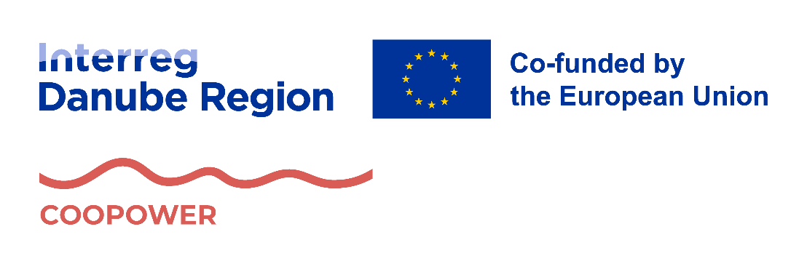


COOPOWER – Country-specific inventory of good practices

Activity 1.2

January 2026
Contents
1. Introduction 4
2. Good practices 6
2.1 Austria 6
2.1.1 AMS Wien U25 / Labor market service for young people under 25 years 6
2.1.2 bOJA - bundesweites Netzwerk Offene Jugendarbeit 8
2.1.3 buntaž 10
2.1.4 Hobby Lobby 12
2.1.5 Jugendinitiative Triestingtal (JIT) 14
2.1.6 m.o.v.e. on Jugendcoaching 16
2.1.7 *peppa – Zentrum für Mädchen* und junge Frauen* 18
2.1.8 Sindbad 20
2.2 Bulgaria 22
2.2.1 International youth center – Burgas, Младежки международен център - Бургас 22
2.2.2 Legal Incubator Program (Програма „Правен инкубатор”) 24
2.2.3 Youth Job Fair – Burgas 26
2.2.4 Mentor the Young – Burgas Mentorship Program 28
2.2.5 Mentor ASTIKA Foundation – Youth Empowerment and Inclusion Programs 30
2.2.6 Youth Employment+ 32
2.2.7 The House of Opportunity Program 34
35
2.2.8 Youth Center Montana 36
2.2.9 International Youth Center Stara Zogara 38
2.3 Czechia 40
2.3.1 O krok napřed (One step ahead) 40
2.3.2 Postupné zaměstnávání (Gradual employment) 42
2.3.3 Spolu-pracujeme, spolu se SPLAVem (We work together with SPLAV) 44
2.3.4 Kudy kam III. (Where to go III.) 46
2.3.5 Mind the Gap 48
2.3.6 Drug free Brno 50
2.3.7 POMA – Podpora mladistvých (Youth support program) 52
2.3.8 Stronger roots 54
2.4 Hungary 56
2.4.1 Focus on the Child programme 56
2.4.2 Incorpora 58
2.4.3 Tanoda Platform 60
2.5 Romania 62
2.5.1 Socio-professional integration workshops 62
2.5.2 JobDirect for NEETs within ALMA initiative (JobDirect pentru tinerii NEET în cadrul Inițiativei ALMA) 64
2.5.3 Integrated services for vulnerable groups – a bridge for the development of local communities (Servicii integrate pentru grupuri vulnerabile – o punte pentru dezvoltarea comunităților locale) 66
2.5.4 Training for Sustainable Employment of Youth and Young Adults 68
2.5.5 I Want My First Job (Vreau Primul Job) 70
2.6 Serbia 72
2.6.1 My First Salary Program 72
2.6.2 Youth Guarantee 74
2.6.3 Youth Employment Partnership in Serbia (YEPS) 76
2.6.4 “Cooperation to Quality” – Career Guidance and Counselling Services 78
2.6.5 Mental Health and Psychosocial Support Programme for Youth in Serbia 80
2.7 Slovakia 82
2.7.1 DASATO Academy 82
2.7.2 Dual Education 84
2.7.3 Graduate Practice (§51 Graduate Practice - school-leaver work experience under the Act on Employment Services) 86
2.7.4 Innovate and Do Business (Inovuj a podnikaj) 88
2.7.5 SPACE Youth Centres 90
2.7.6 Transition Programme “From School to Life” 92
2.8 Ukraine 94
2.8.1 Upskill Now! 94
2.8.2 Promprylad.Renovation 96
2.8.3 Mobile Youth Work in Communities 98
2.8.4 Bootcamps for Schools 100
2.8.5 Upshift Ukraine 102

Introduction
Youth unemployment and labour-market exclusion remain persistent challenges across the Danube Region, particularly for young people facing socio-economic disadvantages, educational barriers, territorial inequalities, or limited access to institutional support. Despite the existence of numerous policies and programmes, many vulnerable young people continue to struggle with fragmented services, insufficient coordination between stakeholders, and a lack of tailored pathways into employment. Addressing these challenges requires not only targeted interventions, but also stronger cooperation across sectors, governance levels, and national borders.
The COOPOWER – Strengthening cooperative employment practices for the empowerment of vulnerable youth project responds to this need by promoting innovative models of intersectoral cooperation that enhance the accessibility, inclusiveness, and effectiveness of labour-market integration measures for young people aged 15–30. Implemented within the framework of the Interreg Danube Region Programme and aligned with Specific Objective 3.1, the project brings together partners from across the Danube Region to jointly identify, test, and scale approaches that better connect employment services, education providers, social services, civil society organisations, and employers.
This Good Practice Catalogue has been developed as part of Activity 1.2 of the COOPOWER project and represents one of the project’s key knowledge-building outputs. Its primary purpose is to identify, document, and systematise existing good practices in youth employment and labour-market inclusion that are based on intersectoral cooperation. The catalogue draws on contributions from all partner countries and presents a diverse set of initiatives, policies, and projects that address the needs of vulnerable young people in different territorial, institutional, and socio-economic contexts
The good practices included in this catalogue reflect a broad understanding of intersectoral cooperation. They range from integrated public services and policy measures to locally embedded projects, social enterprises, and community-based initiatives. While differing in scale and institutional form, all examples share common characteristics: they actively involve multiple sectors, respond to clearly identified needs of vulnerable youth, and demonstrate tangible outcomes in terms of employability, empowerment, social inclusion, or access to education and work. Where available, evidence of effectiveness, evaluation results, and transferability potential are also highlighted.
By showcasing these practices, the catalogue serves several complementary objectives. First, it provides a structured overview of existing solutions that can inspire policymakers, practitioners, and stakeholders working in youth employment and social inclusion. Second, it supports mutual learning among project partners by identifying transferable elements that can inform the development of local pilot actions and cooperation models within COOPOWER. Finally, it contributes to the broader policy discourse at regional, national, and transnational levels by illustrating how intersectoral cooperation can be operationalised in practice and adapted to different institutional environments.
The catalogue should therefore be read not only as a collection of individual examples, but as a strategic resource for strengthening cooperative approaches to youth employment across the Danube Region. It lays an important foundation for subsequent project activities, including pilot implementation, strategy development, and policy dialogue, and ultimately supports the project’s ambition to create more inclusive and resilient labour-market systems for vulnerable young people.

Good practices

Austria

AMS Wien U25 / Labor market service for young people under 25 years
Type of good practice: Policy measure
Type of vulnerable youth: Viennese people between 15 and 25
Area of good practice: Regional – Vienna
Main implementer of good practice
The Public Employment Service AMS U25 is a joint operation with the City of Vienna (Municipal Department on Social Affairs, Social and Public Health Law, MA 40).
Website: https://www.ams.at/arbeitsuchende/u25
Funding/financial model
The U25 is jointly financed by the Public Employment Service (AMS) Vienna and the City of Vienna.
Other institutions involved
It also partners with other social welfare, education, and employment-focused organizations in Vienna.
The Fonds Soziales Wien is a cooperation partner inside U25, offering social services like advice for people in need, support for housing, and financial hardship relief. The Coordination Unit Youth - Education - Employment (KOO JBB) helps coordinate between different youth, education and employment offers, organising them, making them more transparent, and arranging workshops and info sessions. The Coordination Unit Education and Training up the Age of 18 (KOST) supports youth with questions about mandatory schooling, helps match counselling offers, and connects people to relevant support.
Cooperation also exists with waff (for training and qualifying young people) and with other public and social bodies when it comes to financing, social support, housing, and minimal social security.

Context of good practice
The U25 service, opened 2021, is a joint service centre run by the Public Employment Service Vienna (AMS Wien) and the City of Vienna. It acts as a one-stop-shop, bringing together all services related to work, education, and social issues for young people in one location to provide comprehensive support. The primary motivation is to help young people start their careers and reduce the risk of unemployment by offering guidance and opportunities for apprenticeships and other qualifications. The target group is Viennese people between 15 and 25. Especially young people receiving social minimum benefits, or those with additional barriers (education, social, financial) are targeted.
Activities
Young people receive integrated advice on job search, education, social assistance, and personal/social issues in the same centre. The U25 offers consultation on career choice, various career paths, and social and financial matters, placement of suitable apprenticeships and jobs, general information on occupations, job opportunities, labour market trends, training and further education, support for securing livelihoods and for problems that hinder labour market placement, financial assistance and agreements on qualification offers, workshops, and information events on relevant topics.
The organisation and its partners run info afternoons, workshop and help to understand legal rights and services.
Why should it be considered a good practice
By bringing multiple services under one roof so young people don’t need to go to multiple offices for help with employment, education, and social support, the initiative is highly relevant for the target group. In addition, U25 has been evaluated from early days, including satisfaction surveys from young people, measuring outcomes like how many got a job or training.
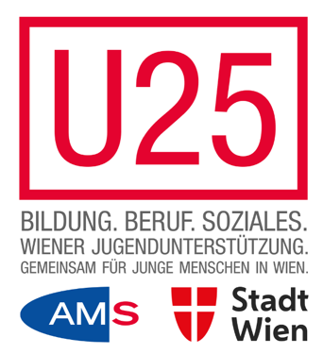

bOJA - bundesweites Netzwerk Offene Jugendarbeit
Type of good practice: Association
Type of vulnerable youth: Youth generally
Area of good practice: National
Main implementer of good practice: Verein bOJA
Website: https://www.boja.at/
Funding/financial model
The financing of bOJA is largely provided by the Federal Chancellery (section Family and Youth) as part of the official youth policy framework.
Other institutions involved
The organization is a member of various networks and organizations, including those focused on participation, poverty reduction, youth clubs, children's rights, and social work. It also has official partnerships with institutions related to climate action and health literacy.
Context of good practice
The bundesweites Netzwerk Offene Jugendarbeit (bOJA) was founded to strengthen and professionalise open youth work in Austria. It functions as a national competence centre, service and networking hub, and a platform for knowledge exchange. Its main aims are to advocate for open youth work, develop strategic concepts, promote cooperation, and establish quality standards.
bOJA responds to the increasing complexity of challenges faced by young people, such as inequality, exclusion, digitalisation, and political disconnection. While some young people grow up in supportive environments, others lack accessible spaces for participation, self-development, and non-formal education. Open youth work offers such spaces, but before bOJA was established, stronger national coordination, quality assurance, and policy recognition were needed.
The organisation’s motivation is to secure equal opportunities and participation rights for all young people, regardless of background. By acting as a national service, competence, and advocacy centre, bOJA works to anchor open youth work within youth policy, strengthen its visibility and impact, and support professional development. Its target groups operate on two levels: directly, youth workers, organisations, and policymakers; indirectly, young people aged roughly 12–25 participating in open youth work settings such as youth centres, street work, and mobile youth work, particularly those with limited access to structured educational opportunities.
Activities
bOJA’s activities aim to strengthen, professionalise, and increase the visibility of open youth work (OJA) in Austria. It lobbies for the field and its objectives, develops and disseminates quality criteria, and supports organisations in applying them through guidelines, reflection and evaluation tools, and a quality label system that supports recognition and funding.
The organisation provides further education, workshops, and conferences to help youth workers address current challenges and develop new methods. bOJA represents the interests of open youth work at national and European levels, cooperating with ministries, social partners, and networks to promote recognition of OJA as a key field of youth policy and to secure sustainable structures and funding.
bOJA also serves as a networking hub, connecting organisations, practitioners, and researchers across Austria through networking events, study visits, and European exchanges. In addition, it initiates and coordinates pilot projects focused on participation, democracy, inclusion, digital youth work, and sustainability, developing innovative approaches and transferable models. As a founding member of the European network POYWE, bOJA contributes to these efforts at the European level.
Why should it be considered a good practice
bOJA provides a nationally anchored, professional, and sustainable framework for supporting open youth work. Its strength lies in combining quality development, professional training, and advocacy with practical support for local youth organisations, bridging the gap between grassroots practice and national policy.
In recent years, it has published several publications and practical tools for professionals and developed a documentation database.
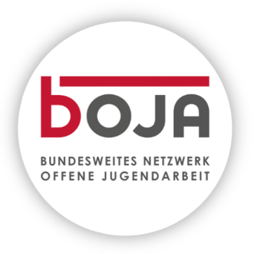

buntaž
Type of good practice: Project
Type of vulnerable youth: Socioeconomically disadvantaged youth
Area of good practice: Regional – Vienna
Main implementer of good practice: buntaž
Website: https://buntaž.com/
Funding/financial model: Donations and sponsoring partnerships
Other institutions involved
Funders / Foundations / Policy / Umbrella Organisations such as MEGA Bildungsstiftung, Bildung tomorrow, Berndorf Privatstiftung or education lab secure funding, strategic guidance, policy advocacy, helping scale & embed programs.
Youth Support / Social Organisations such as Nachbarinnen support the outreach to disadvantaged youth, provide after-school support and help reduce barriers to participation.
Companies such as European Locomotive Leasing and X Automotive support buntaž financially and via corporate volunteering (mentoring, workshops, staff acting as role models) to reach its goals to provide better educational and job opportunities to adolescents.
Context of good practice
buntaž is an Austrian association supporting young people in their transition from school to the labour market or further education. It focuses on improving equal opportunities by addressing barriers in education and vocational training. The founders, Željana Jurić and Anja Szumny, were motivated by their own lack of guidance and the aim to ensure equal chances regardless of family background.
Many adolescents, especially from disadvantaged or migrant families, face structural obstacles such as limited financial resources, weak professional networks, language barriers, or the low attractiveness of VET pathways. The initiative responds through three pillars: inspiration via role model meet-ups, empowerment through skills workshops, and mentoring through individual support.
It works both directly with young people and with schools and institutions to promote systemic change. By combining individual support with efforts to build inclusive structures, the approach helps young people gain skills, confidence, and access to opportunities needed to shape their futures. The main target group consists of youth aged 13–16 from disadvantaged backgrounds. Strong emphasis is placed on accessibility: all offers are free of charge, easy to understand, and embedded in pupils’ everyday school life. The methods—mentoring, role model encounters, and future skills training—are evidence-based, co-developed with teachers, students, and experts, and directly address real-life challenges.
Activities
The association provides tailored support for students who are uncertain about their future, lack guidance from their social environment, or have experienced rejection in job applications. Its programmes help bridge the gap between school and vocational training through role model meet-ups, skills workshops, and mentoring with experienced ambassadors.
Participants meet professionals from diverse sectors and backgrounds, gaining inspiration and first-hand insights into different career paths. Workshops and training sessions, delivered during school hours, focus on future-oriented skills such as using AI tools, navigating application processes, and design thinking. All services are accessible, confidential, and free of charge, offering reliable support during the transition from school to work or further education.
Why should it be considered a good practice
buntaž addresses structural inequalities in education and vocational training with a holistic and innovative approach but also works on the systemic level by collaborating with schools, teachers, and policymakers to create more inclusive structures. This dual focus on individual empowerment and institutional change makes its model sustainable and transferable.
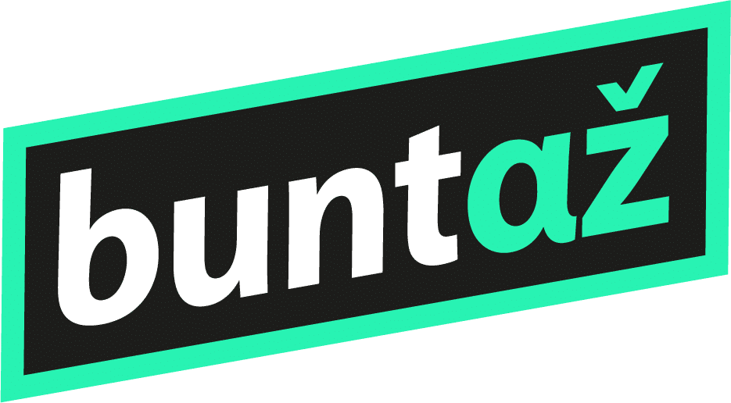

Hobby Lobby
Type of good practice: Association
Type of vulnerable youth: Children aged 8 to 16 years
Area of good practice: National – Austria, Germany, Romania
Main implementer of good practice: Hobby Lobby
Website: https://www.hobbylobby.co.at/
Funding/financial model: Donations and sponsorship
Other institutions involved
Governmental and public institutions (Ministry of Social Services BMSGPK), foundations (UniCredit Foundation, Bildung Tomorrow, Mega Bildungsstiftung) and non-profit organizations, corporate partners and NGOs such as Sindbad (see above). Among others:
- The City of Vienna cooperates in organizing free leisure courses for socioeconomically disadvantaged youth and supports local outreach via schools in Vienna.
- -Teach for Austria cooperates in summer camp learning and leisure programmes, in multiple years they’ve jointly organised learning support plus extracurricular/free time offerings.
- Local schools support recruitment of participants, host courses and help with integrating the programme into the local community.
- Licht ins Dunkel supports Hobby Lobby, particularly in the area of inclusion and provides funding through their “Jubiläumsfonds” programme.
- LebensGross, a social franchise partner of Vienna Hobby Lobby, implements the Hobby Lobby initiative in Graz / Styria.
Context of good practice
The Vienna Hobby Lobby was founded in 2018 to respond to the lack of accessible extracurricular activities for children and young people from socioeconomically disadvantaged backgrounds. Many families in Vienna cannot afford private courses in music, sports, or creative activities, which means their children often miss out on opportunities to develop new skills, build confidence, and connect socially outside of school. The motivation behind Hobby Lobby is to create equal opportunities by offering these activities free of charge, run by volunteers, and organized in cooperation with local schools and community partners.
Its main target group are children and adolescents between 8 and 16 years old who would otherwise have limited or no access to such leisure activities due to financial or social barriers. By providing free courses close to where they live, Hobby Lobby not only promotes personal growth and talent development but also strengthens social inclusion and equal participation in community life. The initiative fosters a holistic approach to learning beyond the school setting.
Activities
The Hobby Lobby in Vienna provides free extracurricular activities for children and young people aged 8–16, creating accessible opportunities for personal development, social connection, and creative exploration, particularly for those facing financial or social barriers. Courses are delivered by volunteers in cooperation with local schools and community spaces, making them easily accessible within neighbourhoods. The activities include sports, creative workshops, and educational support, with a strong focus on confidence-building, teamwork, and soft skills that improve future labour-market prospects.
Beyond the courses themselves, the programme strengthens links between young people and the wider community through volunteer engagement, intergenerational exchange, and civic participation. It also offers supportive workshops for course instructors and youth leaders and runs a Youth Leaders programme that trains motivated young people as co-instructors who mentor younger participants.
Why should it be considered a good practice
There is high demand, demonstrated by waitlists and interest from underserved neighbourhoods. The project has already expanded to multiple districts in Vienna and to other Austrian provinces (Tyrol, Lower Austria, Upper Austria), as well as into other countries (Romania, Germany). This suggests the model is scalable and resonates with young people.
Hobby Lobby has undergone several evaluations, both quantitatively and qualitatively. An SROI (Social Return on Investment) analysis by WU Vienna between September 2022 and June 2023 showed that for every €1 invested, Hobby Lobby produces €21.27 in monetised societal benefit. This strong ratio suggests high cost-effectiveness and value to society.


Jugendinitiative Triestingtal (JIT)
Type of good practice: Initiative
Type of vulnerable youth: 12-23 years olds, depending on activity
Area of good practice: Regional – Lower Austria
Main implementer of good practice: Jugendinitiative Triestingtal (JIT)
Website: https://jini.at/#hero
Funding/financial model
Jugendinitiative Triestingtal is funded by grants from the State of Lower Austria, the federal government, child and youth welfare, and municipal contributions, additional support comes from partnerships with institutions such as the Federal Chancellery and the Education Directorate, as well as donations and sponsorships.
Other institutions involved
JIT built a network with local municipalities, schools, and associations.
Context of good practice
The non-profit association Jugendinitiative Triestingtal (JIT) was established in 2000 in response to limited youth participation and opportunities in the rural Triestingtal region of Lower Austria. Many adolescents and young adults faced few leisure activities, weak involvement in local decision-making, and limited prospects, often leading to out-migration. The initiative aims to strengthen the role of young people in their communities, give them a voice in regional development, and create spaces where they can meet, learn, and contribute.
Its target group is young people aged 12 to 23 living in the Triestingtal region. Motivated by the need to support youth facing social, educational, and personal challenges, the organisation provides low-threshold services such as youth counselling, mobile youth work, and school social work. JIT empowers young people to take ownership of their futures while making the region more attractive and sustainable, and collaborates closely with local municipalities to deliver tailored, needs-based projects promoting mental health, equal opportunities, integration, and empowerment.

Activities
Mobile Jugendarbeit TANDEM: Life-world oriented relationship and counseling services, Streetwork – youth social work in public spaces, Assistance in emergencies and crisis situations, Advocacy for youth.
Schulsozialarbeit@school4u: Free, confidential counseling for school-related, personal, or social questions and problems, Individual and group work, Support in conflicts or crisis situations, Workshops, Networking and referrals to other institutions, Brochures and information.
Jugendintensivbetreuung KLEEBLATT: Individual counseling, crisis intervention, support with educational or career prospects, and the promotion of social skills.
Jugendberatungsstelle ELEMENTS: Free, anonymous, and confidential Coaching, as well as prevention workshops.
GoBIG 2.0: promote health literacy and equity among disadvantaged youth of all genders and backgrounds during adolescence.
Collaboration in Interreg-funded MEET project (Well-being in Education for disadvantaged Youth).
Why should it be considered a good practice
JIT is a good practice as it effectively combines youth empowerment, participation, and regional development in a rural context. It gives young people in the Triestingtal region a strong voice by creating spaces for participation, decision-making, and youth-led projects, strengthening both individual skills and the social fabric of the community.
Its strength lies in a participatory and inclusive approach, with activities co-created with young people and linked to local resources. Close cooperation with municipalities, schools, and regional networks ensures sustainable structures and long-term impact.
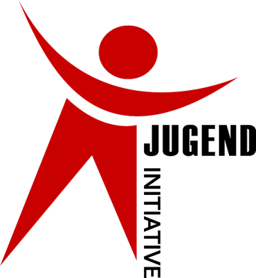

m.o.v.e. on Jugendcoaching
Type of good practice: Project
Type of vulnerable youth: Young people aged 15-25 transitioning from school to further education or training, including NEETs
Area of good practice: Regional – Vienna, districts 1-3 and 20
Main implementer of good practice: Verein Projekt Integrationshaus
Website: https://www.integrationshaus.at/de/jugendcoaching
Funding/financial model: m.o.v.e. on Jugendcoaching is funded by the Social Ministry Service
Other institutions involved
The project is part of the Wiener Ausbildungsgarantie (Vienna Training Guarantee), financed by the Social Ministry Service (Sozialministeriumservice), and embedded in the NEBA Network for Vocational Assistance, which includes 209 providers across Austria. The NEBA network offers six programmes, including the education-fit programme, vocational training assistance, work assistance, job coaching, and a company service, which closely cooperate to support young people at risk of exclusion and people with disabilities in accessing training or employment.
Schools are key partners, providing infrastructure such as counselling spaces for adolescents transitioning from school to further education or training. Regular network meetings ensure smooth cooperation with the youth employment service U25 and career information centres (BIZ). In one vocational training school, BIZ 21 counsellors registered young people on the spot as apprenticeship seekers, ensuring direct linkage to employment services.
Cooperation with VHS Vienna enabled competence checks for adolescents newly arrived in Austria and recommended for basic education programmes. Collaboration with the Municipal Department for Youth and Family (MA 11) and school cooperation teams supported young people at risk of school dropout due to absences. Additional partners include coordination services and target-group specific institutions.
Context of good practice
Initiated in 2009 by the Municipal Department for Integration and Diversity, MA 17, the m.o.v.e. on project is now a part of Vienna's "Youth Coaching" initiative, which is funded by the Social Ministry Service since 2012. In the 15 years of its existence, both the number of staff and schools covered increased from three to 30.
Its main goal is to provide professional guidance and support to young people transitioning from school to a professional career or further education. Parental involvement is also a key focus of the youth coaching. The project's target group includes young people from the 9th grade onwards, primarily up to the age of 19, or up to 25 under certain circumstances (with special educational needs or disabilities). A dedicated, multilingual team works directly at compulsory schools and selected high schools (AHS) in the districts covered.
For NEETs, a new location has been rented in the 2nd district in 2024 to offer counselling. In recent years, the percentage of psychologically challenged youth increased considerably.
Activities
The programme facilitates the transition from school to vocational education or employment through intensive one-on-one counselling, targeted small-group workshops, and real-world encounters. Youth coaches provide personalised guidance to help participants identify strengths, set goals, and explore career or educational pathways. Workshops focus on job application skills, interview preparation, and career planning. Parental engagement is included to ensure a holistic approach. Counselling takes place at schools and in the counselling centre and can range from basic support to up to one year, depending on individual needs.
Why should it be considered a good practice
The programme cooperates closely with schools, social services, and other stakeholders to provide holistic support. All services are gender-equitable and gender-sensitive, and multilingual counselling is ensured by a team fluent in 16 languages. Active since 2009, the project’s 30 staff members supported 2,725 clients in 2024 alone. As part of the Austrian Youth Coaching framework, regularly assessed by the responsible Federal Ministry, national standards are met. The programme received 2nd place at the ESF Innovation Award in 2011, recognising its innovative approach.

*peppa – Zentrum für Mädchen* und junge Frauen*
Type of good practice: Project
Type of vulnerable youth: Girls, young women, FLINTA (many with migrant background)
Area of good practice: Local – 16th district of Vienna (Ottakring)
Main implementer of good practice: Caritas Wien
Website
https://www.caritas-wien.at/hilfe-angebote/kinder-familie/peppa-zentrum-fuer-maedchen-und-junge-frauen/
Funding/financial model
*peppa received funding from the European Union and the Federal Chancellery (section Integration) as well as the Municipal Department for Women, MA 57 and the BKA (section for Women and Equality) as well as the district administration of Ottakring. In addition, is supported by the company Canon and received donations through Caritas.
Other institutions involved
Alongside Caritas Wien as founder and main operator, *peppa works closely with public institutions and local actors. The centre is embedded in a strong local network, cooperating with district administration, social institutions, educational establishments, youth centres, and health services to ensure continuous exchange and joint action.
The City of Vienna integrates the centre into broader urban strategies for integration and youth work. Schools in surrounding districts are key partners, referring pupils and cooperating in homework support and career orientation. Local organisations, health services, and cultural initiatives contribute workshops, counselling, and creative activities, ensuring the centre is part of a wider ecosystem promoting equal opportunities, integration, and the empowerment of girls and young women.
Context of good practice
Founded in 2009 as an intercultural space for girls and young women, one of the key motivations was to provide a protected environment. Girls and young women, as well as trans*, non-binary, inter*, and agender youth aged 10 to 22, often face social and educational challenges that affect their participation and equality in society and lack such a safe space for social participation, resulting in limited opportunities to express themselves. Motivated by the need to provide such a safe, inclusive, and supportive environment, the *peppa centre, offers confidential and free access to counselling, education, information, and recreational activities. The centre aims to promote self-determination and equal opportunities for these diverse young people, including those with migration or refugee backgrounds. Another important driver was the wish to counteract social exclusion, prejudice, and racism, and to strengthen integration.
Activities
By offering mentoring, homework help, language learning, leisure and creative programmes, counselling (including health, career, psychosocial), and community building, *peppa aims to support young women in developing self-determination, equality of opportunity, and the ability to participate fully in society. The centre also responds to a clear demand in the community: early use numbers already showed that many girls with and without migration background were looking for such a place to belong, to be taken seriously, and to navigate challenges like school, family, identity, and future training or work. The location offers space for playing and relaxing, a multilingual library, excursions, festivals, and events. Apart from individual counselling, discussion groups and support with the search for an apprenticeship or job are offered. If necessary, referral to and assistance with authorities and social institutions can be requested.
*peppa counts 20–30 girls per day attending, about 400 annual visitors in some years.
Why should it be considered a good practice
*peppa is transferable: its model of a community-based, safe space for girls and young women can be adapted to other urban contexts facing similar challenges. It has been internally evaluated since its founding, regular reports include both qualitative and quantitative evaluations (outreach, user satisfaction, immediate outcomes) to its funding bodies.
Its integrated approach covering key areas of personal development and social participation allows participants to gain long-term skills for independence and active citizenship.

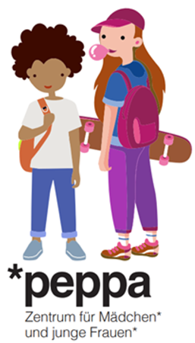

Sindbad
Type of good practice: Social business
Type of vulnerable youth: Students between 13 and 19 years old
Area of good practice: National – Austria, Germany (Görlitz, since 2025)
Main implementer of good practice: SINDBAD social business
Website: https://www.sindbad.co.at/
Funding/financial model: Donations and generating part of its income through services
Other institutions involved
Public funding bodies, corporate financial supporters, foundations, and educational institutions:
Sindbad is funded by the Federal Chancellery, the Innovation Foundation for Education and the Federal Ministry of Labour, Social Affairs, Health, Care and Consumer Protection. It is supported by several private and public foundations such as Berndorf Privatstiftung, Mega Bildungsstiftung and others. In addition, the individual locations have specific public and corporate supporting organsations.
Sindbad cooperates with 26 large companies in Austria from diverse industries, such as ÖBB, KPMG, Erste Bank, Österreichische Bundesforste, Böhringer Ingelheim, Iglo, Hilti, Uniqua and others. The companies cooperate with Sindbad by engaging their employees in the Sindbad Social Academy, where they can actively participate in the mentoring programme or contribute their expertise through trainings and workshops. By taking on these roles, employees gain valuable insights into different life contexts, develop and strengthen their leadership skills, and deepen their awareness of social sustainability. This collaboration not only benefits the young people supported by Sindbad but also fosters personal growth and social responsibility within the companies themselves.
Context of good practice
Sindbad, founded in 2016, is an association that helps young people aged between 13 and 19 years enter the job market or further education. Many in this age group face significant challenges during this transition, as rising youth unemployment is becoming an increasingly pressing problem. Another motivation for Sindbad is that individual encounters strengthen understanding of different life worlds and thus social cohesion.
Sindbad's mission is to address the loss of opportunities and talents among young people on creating more equal opportunities in Austria's education system through personal mentorship and support during critical transition periods.
The organization operates as a social business, combining social impact with sustainable business practices to create lasting change in youth development and educational equity.
Activities
Sindbad operates a comprehensive mentoring programme that connects young people aged 14-19 who are transitioning from compulsory school with volunteer mentors aged 20-35. The programme runs for 8-12 months, with mentors supporting youth during their transition from compulsory school to further education or vocational training.
The individual mentoring support forms the cornerstone of their programme, where each mentor is paired with one young person for an intensive 8–12 month journey through their educational transition period. The mentoring relationship is built through regular meetings that blend recreational activities like bowling with practical career-focused experiences such as visiting companies together and engaging in future planning sessions. This comprehensive approach ensures that support encompasses both enjoyable leisure activities that help build trust and rapport, as well as hands-on practical assistance including collaborative work on job applications and the search for trial internships that prepare young people for their next educational or vocational steps.
Sindbad offers mentors opportunities to develop their leadership qualities through training and supervision.
Why should it be considered a good practice
Well-established programme (by December 2024, 5,782 young people had been reached through the Sindbad program, with a goal of reaching 10,000 participants by 2026) with an extended network of supporting well-known companies which enables its success and scaling to multiple locations throughout Austria and beyond (each location providing localized mentoring services to youth in their respective regions).
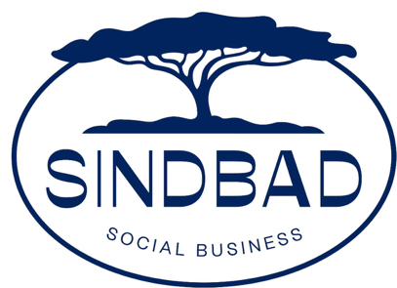

Bulgaria

International youth center – Burgas, Младежки международен център - Бургас
Type of good practice: Project
Type of vulnerable youth
Low educated youth, Youth from ethnic minority, Youth from remote or rural areas, Students at risk, Youth in disadvantaged communities, Youth with limited opportunities
Area of good practice: Regional – Burgas Region, Local – City of Burgas (Meden Rudnik district)
Main implementer of good practice: Municipality of Burgas
Website: https://yicburgas.bg/, https://www.eeagrants.bg/en/
Funding/financial model
The project was initially funded by the EEA Financial Mechanism 2014–2021 under the programme “Local Development, Poverty Reduction, and Enhanced Inclusion of Vulnerable Groups”. The Ministry of Education and Science acted as national programme operator, with the Municipality of Burgas as main implementer. During implementation (2021–2024), all services were provided free of charge to youth and partner organisations aligned with Council of Europe values. From 2025, the centre uses a mixed financing model, offering paid services to external organisations to ensure long-term financial sustainability.
Other institutions involved
Municipality of Reykjavik, Iceland (project partner), Bulgarian Ministry of Education and Science (through its External European Programs Directorate, managing the funding)
Context of good practice
The International Youth Center in Burgas was established in response to the growing need for accessible and inclusive youth services, particularly for vulnerable groups in the region. Many young people in Burgas and nearby municipalities face barriers such as limited educational opportunities, socio-economic hardship, and lack of access to structured support. The project was motivated by the need to empower youth aged 15–29, especially those from ethnic minorities, rural areas, and disadvantaged communities, by offering non-formal education, safe spaces for participation, and opportunities for social inclusion. The initiative aligns with the Bulgarian National Youth Strategy and the Council of Europe’s standards, aiming to promote democratic values, human rights, and active youth engagement in society.
Activities
- Career orientation and development programs
- Non-formal education sessions on topics like human rights, tolerance, social inclusion
- Trainings and workshops on youth leadership, democratic participation, and soft skills
- Art therapy, creative expression, sports events, and intercultural events
- Mental health awareness and well-being activities
- Volunteering opportunities and support for youth-led initiatives
- Mobile outreach programs in rural and smaller municipalities
- International exchanges and events with partner organizations (e.g. Iceland).
Why should it be considered a good practice
The International Youth Center is one of Burgas’ most well-known youth projects, serving as a flagship model for youth empowerment in Bulgaria. Its scale, management, and impact make it a key point for civic participation, education, and social inclusion. The center offers a wide range of training courses, workshops, and programs, including soft skills development, career guidance, financial education, civic engagement, and non-formal education to improve employability. It supports youth in building skills and confidence to compete in the job market and navigate professional challenges.
The project brings together local authorities, NGOs, educators, youth workers, and international partners to implement integrated solutions. It hosts international projects and youth exchanges, such as its partnership with the Municipality of Reykjavik, providing young people with intercultural experiences and broader perspectives on employment and active citizenship in Europe.
The initiative engages thousands of young people, particularly from vulnerable groups such as ethnic minorities, rural areas, and low-income backgrounds. Through non-formal education, mentoring, volunteering, and creative programs, it helps youth develop skills, self-confidence, and employability, combining social inclusion with practical tools for workforce readiness.


Legal Incubator Program (Програма „Правен инкубатор”)
Type of good practice: Project
Type of vulnerable youth: Youth from ethnic minority
Area of good practice: National – headquartered in Sofia, with participants from across Bulgaria
Main implementer of good practice: Association “Initiative for Equal Opportunities”
Website: https://www.equalopportunities.eu/bg/praven-inkubator.html
Funding/financial model
- Trust for Social Achievement Foundation
- Minority Rights Group Europe
- European Union (M.A.R.I.O. program)
- Support from international partners
Other institutions involved
- Trust for Social Achievement Foundation (main funding partner)
- Minority Rights Group Europe
- European Union (through the M.A.R.I.O. program)
- Partner organizations from Poland, Hungary, Croatia, Lithuania, Slovakia, Latvia, etc.
Context of good practice
In Bulgaria, access to free legal aid for low-income individuals is limited, and young lawyers face serious challenges when starting their practice. The program addresses both issues by establishing the first Legal Incubator in Eastern Europe. It supports young legal professionals with mentorship, training, and office space, while also providing legal assistance to vulnerable citizens.
Activities
- Mentorship and training for young lawyers and final-year law students
- Access to fully equipped office space for 12-month practice
- Free legal support for low-income clients
- Scholarships for final-year students
- Youth involvement in legal community work and awareness
- Project development (e.g. “Legality – Roma Legal Lab”)
- Podcast “Equal Opportunities” on legal and social issues
Why should it be considered a good practice
This is a unique and innovative model in Eastern Europe, combining legal practice with social impact. It demonstrates strong intersectoral cooperation between NGOs, education, and international donors. It supports both young professionals and underserved communities, providing high social return. The model is sustainable, adaptable to other professions (e.g. social work, medicine), and complex—combining training, practice, advocacy, and outreach.


Youth Job Fair – Burgas
Type of good practice: Initiative
Type of vulnerable youth
Low educated youth – Youth from disadvantaged urban neighbourhoods, Unemployed youth aged 15-29, NEETs
Area of good practice: Regional – Burgas region, Local – City of Burgas
Main implementer of good practice
Municipality of Burgas and the Local Employment Office (Bulgarian Employment Agency)
Website: https://www.az.government.bg/pages/mladejka-zaetost/
Funding/financial model
- Public funding from the National Employment Agency (Ministry of Labor)
- In-kind support from the Municipality of Burgas (venue, logistics, promotion)
- Voluntary participation from employers, HR experts, and youth centres
Other institutions involved
- Local businesses and HR experts
- Public employers (e.g., municipal companies)
- NGOs and youth organizations
- National Employment Agency (Ministry of Labor and Social Policy)
- International Youth Centre – Burgas (event host and partner)
Context of good practice
The Youth Job Fair in Burgas is part of the national Youth Employment Program coordinated by the Bulgarian Employment Agency. It was created to tackle the persistently high unemployment rate among young people, particularly those disconnected from work, education, or training (NEETs). The event is designed to connect vulnerable youth with local employers, increase their visibility in the labour market, and improve their job-seeking skills in a supportive, real-world environment.
Activities
- Organization of a public job fair event featuring employers, career counsellors, and youth participants
- On-site CV support and career consultations with HR professionals
- Live job interviews, company presentations, and internship opportunities
- Workshops on LinkedIn profiles, soft skills, and professional communication
- Thematic sessions on employability and career planning
- Engagement of youth workers and NGOs that support vulnerable youth
- Social media promotion through YIC Burgas Facebook, sharing real-time updates, videos, photos, and testimonials
- Integration with other youth events such as training weeks, mentoring sessions, and info days
Why should it be considered a good practice
This initiative demonstrates strong intersectoral cooperation between local government, national institutions, employers, NGOs, and youth centres. It provides direct, practical benefits to vulnerable young people by creating real opportunities for employment and training. The integration of workshops, mentoring, and digital tools makes it highly engaging and adaptable to different regional contexts. Its use of social media outreach boosts youth participation, while partnerships with the International Youth Centre – Burgas help embed it within broader youth empowerment frameworks. The model is cost-effective, scalable, and contributes to sustainable youth employment strategies.
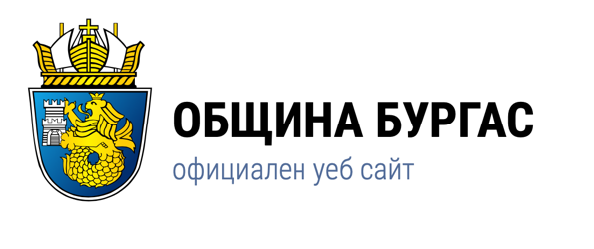
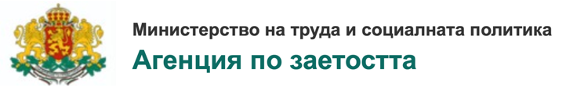

Mentor the Young – Burgas Mentorship Program
Type of good practice: Initiative
Type of vulnerable youth
Low-educated youth, Youth from ethnic minority, Youth from low-income families, Youth with limited access to educational and cultural opportunities, Talented young people from disadvantaged backgrounds
Area of good practice
National – volunteers from across Bulgaria, Regional – volunteers from the Burgas region, Local – City of Burgas
Main implementer of good practice: Uspelite.bg Foundation (NGO media and youth platform)
Website
Program overview: https://uspelite.bg/programata-Mentor-the-Young-vseki-chovek-ima-potentsial-da-se-zanimava-s-tova-koeto-obicha-1
Call for mentors: https://uspelite.bg/stani-mentor-na-talantlivo-dete-v-neravnostoino-polojenie--1
Funding/financial model
- Operated by Uspelite.bg as a non-profit initiative
- Financed through donations, grants, and volunteer support
- Participation is free for youth and based entirely on community and pro bono engagement
Other institutions involved
- Volunteer mentors from diverse professions (journalists, artists, lawyers, doctors, entrepreneurs, etc.)
- Schools, cultural institutions, local communities
- Business professionals and community leaders from Burgas and other cities
Context of good practice
Many talented young people in Bulgaria, including those in Burgas, grow up in economically or socially disadvantaged environments and lack access to guidance, encouragement, and opportunities for personal and professional development. The “Mentor the Young” initiative was launched to connect these youth with inspiring mentors who can support their growth, help them overcome limitations, and empower them to dream bigger. The goal is to ensure that every young person, regardless of background, has access to mentorship and development support.
Activities
- One-on-one mentorship between professionals and young people aged 14–20 from disadvantaged backgrounds
- Regular meetings, communication, and planning of personal development goals
- Mentors help with career orientation, confidence-building, and access to educational and cultural opportunities
- Matching of mentors and mentees based on interests and personal stories
- Events, workshops, and success-story sharing among participants
- Targeted outreach to youth from small towns, villages, or minority communities in/around Burgas
Why should it be considered a good practice
“Mentor the Young” is a powerful example of community-based intersectoral cooperation, connecting youth with professionals from various fields (NGOs, education, business, culture). It is highly functional, with measurable impact on young people's self-confidence, career awareness, and life ambitions. The program is innovative in its personalized approach and adaptable to different contexts, including rural and urban areas. Its low-cost, high-impact model makes it easily scalable and transferable, while also being deeply human-centred and inclusive. It builds long-term relationships that support sustainable personal development.

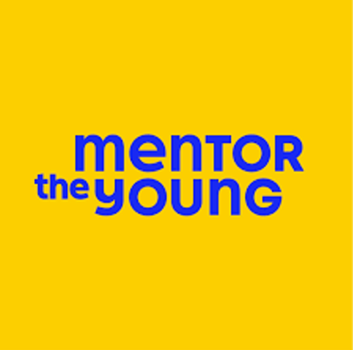

Mentor ASTIKA Foundation – Youth Empowerment and Inclusion Programs
Type of good practice: Initiative
Type of vulnerable youth: Low educated youth, Youth from ethnic minority (especially Roma), Youth from remote or rural areas, Youth affected by violence, discrimination or poverty, NEETs and youth with low access to formal education or employment
Area of good practice: National – and also international through cross-border cooperation via Erasmus+ EEA Grants and civic platforms, Local – City of Burgas
Main implementer of good practice: ASTIKA Foundation – Burgas (NGO)
Website: https://astika.eu/
Funding/financial model
- Grants from national programs, EEA & Norway Grants, and EU Erasmus+
- Project-based funding from international donors
- Collaboration with municipal authorities and in-kind support from local partners
- Volunteer-driven structure for sustainability
Other institutions involved
- Local schools and universities
- Municipal authorities of Burgas
- National and international youth networks
- Council of Europe, EU Erasmus+ Programme, and other donors
- Partners from countries such as Spain, Italy, Turkey, Romania, and North Macedonia
Context of good practice
The ASTIKA Foundation was created in Burgas in 2003 as a civil society organization focused on youth rights, social inclusion, and mental well-being. Recognizing that many young people—particularly from minority backgrounds or poor communities—lack support, the foundation developed multiple initiatives that combine education, creativity, human rights awareness, and civic participation. ASTIKA acts as a long-term advocate and platform for youth engagement, offering opportunities both in Bulgaria and abroad.

Activities
- Non-formal education workshops on human rights, anti-discrimination, and youth participation
- Youth campaigns against gender-based violence, hate speech, and intolerance
- Cultural and creative programs: theatre, art therapy, and storytelling labs
- Organization of international exchanges and Erasmus+ mobilities
- Volunteering and leadership training for young people from vulnerable backgrounds
- Mental health support and peer-counselling projects
- Local youth clubs and initiatives in schools, especially in underserved neighbourhoods
Why should it be considered a good practice
The ASTIKA Foundation has over two decades of experience in designing and running inclusive, creative, and impactful youth programs. It exemplifies intersectoral cooperation, involving civil society, education, local government, and international partners. Its practices are functional, innovative, and tailored to the specific needs of marginalized youth in Burgas and beyond. ASTIKA’s model is replicable, sustainable, and highly adaptable, combining advocacy, education, mental health, and cultural expression to support youth empowerment.
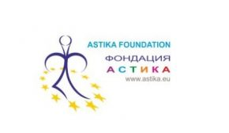

Youth Employment+
Type of good practice: Project
Type of vulnerable youth: Unemployed youth aged 15-29, NEETs
Area of good practice: National
Main implementer of good practice: National Employment Agency
Website
https://burgaslikesyouth.bg/en/2023/10/09/15200-young-people-will-be-supported-to-enter-the-labor-market-through-the-new-project-youth-employment/
https://www.mlsp.government.bg/eng/the-ec-approved-the-human-resources-development-programme-for-the-programming-period-2021-2027
Funding/financial model
The HRDP (2021-2027) is co-financed by the European Social Fund + and the national budget. The program has a budget of more than BGN 3.8 billion, which is expected to support more than 740.000 people in Bulgaria. For the first time, “Youth Employment” is a separate priority in the program, with a budget of over BGN 735 million.
Other institutions involved
- Human Resources Development Program 2021-2027 > European Commission
- Local businesses
Context of good practice
Its main goal is to enhance the competitiveness of young people aged 16 to 29 by providing opportunities for internships, on-the-job training, employment, or participation in training to acquire “soft” skills with employers. This will facilitate the transition of young people from education to employment, allowing them to gain valuable professional experience necessary for filling job vacancies.
Activities
The “Youth Employment+” project provides support to inactive and unemployed young people through:
1. Training for acquiring portable and “soft” skills through key competencies such as “Personal and social competence and learning skills” and “Initiative and entrepreneurship.”
2. Internships with employers for a period of 6 to 9 months.
3. On-the-job training lasting no more than 6 months.
4. Hiring of unemployed and inactive young people for a period of up to 9 months.
5. Providing incentives to employers in cases of concluding an indefinite employment contract with an intern for a position corresponding to the intern’s qualification, offering the same or more favourable remuneration.
6. Providing funds for public transport to and from the workplace for young people for the first month of the internship/on-the-job training/subsidized employment period.
Why should it be considered a good practice
Youth Employment+ should be considered a good practice as it combines training, internships, on-the-job learning, and wage subsidies into a functional package that directly improves the employability of young people aged 16–29. Its design ensures intersectoral cooperation by linking government agencies, employers, training providers, and local authorities, while incentivizing companies to retain interns permanently.
The program also introduces innovative elements for Bulgaria, such as soft-skills training alongside employment measures, which enhances adaptability to different sectors. With more than €735 million allocated under the HRDP (2021–2027) and co-financing from ESF+, the initiative is highly sustainable and transferable, as it is embedded in the EU’s broader Youth Guarantee framework. Its complexity lies in addressing multiple barriers simultaneously (skills, work experience, financial support, and job matching) making it a comprehensive and replicable solution for disadvantaged youth across Bulgaria.

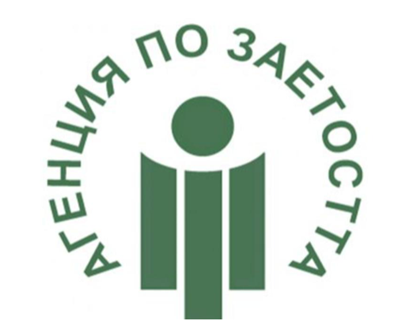

The House of Opportunity Program
Type of good practice: Initiative
Type of vulnerable youth
Low-educated youth, Youth without parental care/brought up in institutional care, Youth vulnerable to risky behaviour
Area of good practice: Local – Sofia Lyulin, Sofia Druzhba, Burgas
Main implementer of good practice: Foundation for Social and Change and Inclusion
Website: https://www.fscibulgaria.org/en/social-services/the-house-of-opportunity/
Funding/financial model
- Mostly run by local, committed volunteers
- Mixture of resources from its partnerships; including key institutions, businesses, volunteers, and other stakeholders
- Donors
Other institutions involved
- Volunteers from local communities
- Local institutions
- Local businesses
- Local municipalities
Context of good practice
The House of Opportunity Program is a network of family-type houses for young people leaving institutions for children deprived of parental care. The Program has been developing since 2007 and is based on advanced practices from Western Europe adapted to the environment and needs of the young people in Bulgaria. The House of Opportunity breaks the cycle of abandonment by helping young people brought up in institutional care to gain skills for independent living in order to become dignified and contributing members of our society.
Activities
Every house in the program offers young people 2 years of residential care and support in:
1. Finding and keeping a suitable job;
2. Managing of personal finances;
3. Housekeeping;
4. Personal health;
5. Development of social skills and skills for building positive and sustainable relationships;
6. Adaptation to independent living;
7. Ongoing support after leaving the program.
Why should it be considered a good practice
The House of Opportunity Program represents a good practice as it provides a holistic, family-type supported housing model for care leavers, one of the most vulnerable youth groups at risk of unemployment and exclusion. It equips young people with essential skills for independent living (job-seeking, financial literacy, health management, and relationship-building) while offering ongoing support beyond the two-year program. The initiative embodies intersectoral cooperation by bringing together NGOs, municipalities, businesses, volunteers, and donors to pool resources and opportunities. Its innovativeness stems from adapting Western European transitional housing models to Bulgaria’s context, where institutionalization has been widespread. The program has demonstrated sustainability by operating continuously since 2007 through a mixed funding model, and its adaptability allows for application to other vulnerable groups such as homeless youth or young refugees. Its complexity lies in addressing both the immediate need for housing and the long-term challenge of labour market integration, making it an exemplary and transferable practice.
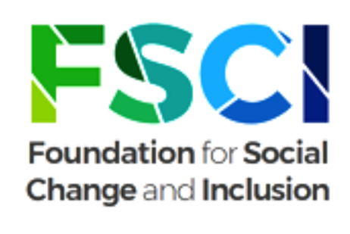

Youth Center Montana
Type of good practice: Project
Type of vulnerable youth
Low-educated youth, Youth from ethnic minority (extra focus on Roma), Youth from remote or rural areas, Youth at risk of dropping out of the education system, Addicted youth
Area of good practice: Regional – Montana Province, Local – Montana Municipality
Main implementer of good practice: Montana Municipality
Website: https://romapolicylab.org/?p=895&utm_source&lang=en
Funding/financial model
- A pool of funding from Montana Municipality and Hringsjá vocational and educational center
- Grant amount: 1 938 284 EUR
Other institutions involved: Hringsjá vocational and educational center (Iceland)
Context of good practice
Montana municipality faces challenges of youth exclusion, high risk of school dropouts, unemployment, and limited opportunities for vulnerable groups (ethnic minorities, NEETs, children from disadvantaged families, etc.). The project aims to establish a Youth Center that provides innovative, educational, cultural, and psychosocial support, thereby enhancing personal and professional development. Target groups include young people aged 15–29, especially those at risk, as well as mediators, youth workers, teachers, municipal staff, and community representatives.
Activities
- Establishment of Youth Center infrastructure with equipment and furniture
- Educational and non-formal learning modules (robotics, digital/media literacy, safe internet use, human rights, civic competence)
- Psychological assistance and individual support services for at-risk youth
- Forums, cultural, civic, and sports initiatives
- Dropout prevention programs for students struggling in formal education
- Engagement of families, communities, and local authorities in youth policies
- Exchange of practices with national and international partners (incl. Iceland)
- Development of bilateral relations with partner organizations
- Capacity building for Youth Center and municipal employees
- Compliance with Council of Europe standards and pursuit of Quality Label
Why should it be considered a good practice
Youth Center Montana qualifies as a good practice since it provides an integrated hub for education, psycho-social support, and civic engagement in a disadvantaged municipality facing high youth unemployment and school dropout rates. It reduces risks of exclusion by offering non-formal learning, digital and civic competence training, psychological counselling, and dropout prevention. It is intersectoral by design, combining the efforts of the municipality, schools, NGOs, mediators, families, employers, and international partners. The initiative is innovative in introducing forward-looking skills such as robotics, media literacy, and safe internet use in a region where such opportunities are rare, while also applying Council of Europe quality standards. Backed by municipal funding and EEA Grants, the practice shows sustainability, especially with staff capacity-building for long-term operation. Its adaptability and transferability are strengthened through exchanges with international partners, and its complexity lies in uniting infrastructure development, youth services, family engagement, and community mobilization into one coherent model.
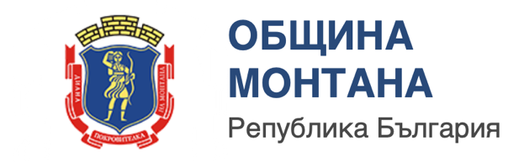

International Youth Center Stara Zogara
Type of good practice: Project
Type of vulnerable youth
Low-educated youth, Youth from ethnic minority (with a focus on Roma), Youth from remote or rural areas
Area of good practice: Local – Stara Zagora
Main implementer of good practice: Municipality of Stara Zagora
Website: https://eeagrants.org/news/empowering-youth-risk-bulgaria?.com
Funding/financial model
The International Youth Centre in Stara Zagora is funded through the EEA and Norway Grants, specifically supported by Iceland, Liechtenstein, and Norway. The center’s financing model relies on this grant funding combined with support from the municipality of Stara Zagora, which ensures local institutional backing and integration into municipal youth policy frameworks.
Other institutions involved
- Iceland
- Liechtenstein
- Norway
- The World without Borders Association
Context of good practice
The International Youth Centre in Stara Zagora was established to respond to high levels of social exclusion, unemployment, and limited civic participation among disadvantaged youth in Bulgaria, particularly young people from Roma communities. The motivation was to empower these young citizens through access to education, human rights training, and leadership development, while fostering their inclusion in society. The target groups are vulnerable youth aged 15–29, with special attention to Roma youth, minorities, and young people at risk of marginalization.
Activities
The center provides human rights education, leadership training, and informal learning opportunities to disadvantaged young people. Trained Roma mediators work directly with Roma youth to strengthen their position in society and improve access to education and employment. The center also organizes international exchange programs, sending volunteers to youth centers in Germany, Sweden, and Luxembourg to acquire knowledge and transfer good practices. Locally, it engages in campaigns such as the Council of Europe’s No Hate Speech initiative in cooperation with the NGO “World without Borders Association.” Around 70 volunteers have participated, contributing to both peer-to-peer learning and intercultural dialogue.
Why should it be considered a good practice
The center is a good practice since it demonstrates functionality, having successfully engaged and empowered disadvantaged youth, especially from Roma communities, through informal education and mediation. It reflects strong intersectoral cooperation, combining efforts from the municipality, international donors, NGOs, volunteers, and the Council of Europe. Its innovativeness lies in adapting international best practices to the Bulgarian context, particularly through international exchanges and the deployment of Roma mediators. The practice has proven sustainability through continued support from both the EEA Grants and municipal structures, as well as recognition through the Council of Europe’s Quality Label Award. It is highly transferable and adaptable, as its model of combining local youth empowerment with international knowledge exchange can be replicated in other disadvantaged regions. Finally, its complexity comes from addressing youth exclusion in a holistic way. It covers education, leadership, civic engagement, anti-discrimination, and employment access, thus making it an exemplary model for youth policy innovation in Bulgaria.

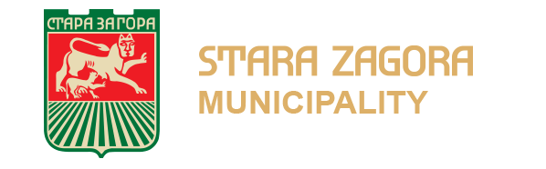

Czechia

O krok napřed (One step ahead)
Type of good practice: Project
Type of vulnerable youth: Young people from institutional care
Area of good practice: Local – Children’s home Nechanice
Main implementer of good practice: Hradecký venkov, o. p. s. (Public Benefit Corporation)
Website
https://www.hradeckyvenkov.cz/aktivity-a-projekty/ukoncene-projekty/o-krok-napred/
http://www.mashradeckyvenkov.cz/storage/1569396533_sb_evaluace.pdf
Funding/financial model
This project was co-financed by the European Social Fund through the Employment Operational Programme and the state budget of the Czech Republic.
Other institutions involved
Local action group Hradecký venkov, EU, MPSV ČR- Employment Operational Programme
Context of good practice
The target group consists of all children and young people from the Nechanice children's home (41 people), with the main focus on young people aged 16-26 (6 people) who left the children's home during the project. The project focuses on comprehensive, systematic, and long-term preparation of young people for leaving institutional care with the aim of integrating them into normal life and society by creating ties in the community, training for personal development, counselling and support, and facilitating contact when looking for future employers.
Activities
- Start of project implementation – round table, discussion of ideas and main needs of the target group
- Support for activities aimed at acquiring work habits and experience in the areas of housing, the labor market, self-awareness, and self-development
- Mentoring programs
- Educational and experiential retreats focused on developing children's financial literacy and independence
- Final evaluation
Why should it be considered a good practice
This project should be considered an example of good practice because it responds to an issue that is always relevant. This makes the project sustainable, as its know-how and materials can continue to be used and applied elsewhere. It is therefore fully transferable. An individual and proactive approach was used, which went beyond the scope of normal care in children's homes. The success and quality of the project is also evidenced by the fact that it has been awarded and recognized at the EU level.
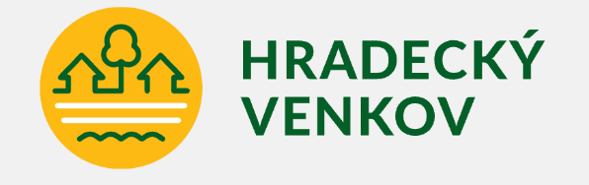

Postupné zaměstnávání (Gradual employment)
Type of good practice: Project
Type of vulnerable youth
Young people outside the labour market, typically from institution care
Area of good practice: Regional – Pardubice region
Main implementer of good practice: Květná zahrada, z. ú. (Registered Institute)
Website
https://www.esfcr.cz/projekty-opz/-/asset_publisher/ODuZumtPTtTa/content/prostupne-zamestnavani?redirect=%2Fprojekt-opz%3Fp_p_id%3DAssetPublisherFilterPortlet_WAR_esfportalportletapplication
Funding/financial model
This project was co-financed by the European Social Fund through the Employment Operational Programme and the state budget of the Czech Republic.
Other institutions involved
Local action group Poličsko, EU, MPSV ČR- Employment Operational Programme, Employment office, municipalities, public and private employers, schools
Context of good practice
The target group consists of people under the age of 30 who are not in employment, education, or vocational training, and people with multiple disabilities in the labour market. The project is based on comprehensive and systematic work with the target group with the aim of integrating them into normal life and society through immediate and sustainable (permeable) employment. The main problem of the target group is their inability to find suitable and stable employment that would provide them with a basic income and a certain degree of security in life.
Activities
- Selection of participants – cooperation of all partners at the local level, exploratory and motivational interviews
- Non-professional training – orientation in everyday life issues, assessment diagnostics, report on each participant
- Professional training – retraining courses
- Transitional employment program – jobs in a training environment, internships, transition to the open labour market
- Individual counselling and support
Why should it be considered a good practice
This project should be considered an example of good practice, as it addressed a real problem in the region and, at the same time, a problem that is also relevant in other areas. It is therefore reusable in other regions. The project provided the target group with a process through which individuals could acclimatize and gradually return to real life. Throughout the process, participants were provided with counselling that they could rely on.
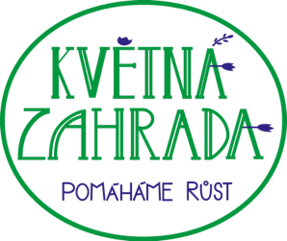

Spolu-pracujeme, spolu se SPLAVem (We work together with SPLAV)
Type of good practice: Project
Type of vulnerable youth: Socially excluded people and people at risk of social exclusion
Area of good practice: Regional – Rychnovsko region
Main implementer of good practice: Sdružení SPLAV, z.s. (Registered Institute)
Website
https://www.esfcr.cz/documents/21802/11962081/06_Spolupracujeme+spolu+se+SPLAVem_abstrakt.pdf/d7b6cb0f-716f-4234-9f7b-034cfff4dbca?t=1568988862025
Funding/financial model
This project was co-financed by the European Social Fund through the Employment Operational Programme and the state budget of the Czech Republic.
Other institutions involved
Local action group Sdružení SPLAV, EU, MPSV ČR- Employment Operational Programme
Context of good practice
The target group of the project are socially excluded people and people at risk of social exclusion in the Rychnov region. The project activities focus mainly on the group of people caring for close ones and people with disabilities. One of the problems the project addresses is the lack of an individual approach to socially excluded people in relation to their employment in the labour market. Both caregivers and people with disabilities face a lack of suitable job opportunities, isolation, and a lack of diverse opportunities. There is also a lack of awareness among the general public and potential employers in relation to these target groups.
Activities
- Selection of project participants
- Joint motivational program – professional seminars led by lecturers, occupational garden therapy (verification of participants' work habits)
- Occupational diagnostic program – individual
- Trial work
- Anti-discrimination campaign
- Networking of organizations
- Project administration
Why should it be considered a good practice
This project should be considered good practice because it addresses a current issue whose solution is also applicable in other regions. Worth mentioning is the job training, which helped participants acquire work habits. This project linked employment and the community through activities where participants could try their hand at gardening, for example, thereby also promoting social integration. The Spolu-pracujeme (We Work Together) project, in collaboration with SPLAV, is an example of good practice, where activities were successfully linked in such a way as to have the greatest possible effect on the target groups. The project enables individual and comprehensive solutions to the life situations of individual project participants.
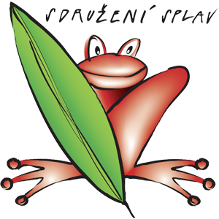

Kudy kam III. (Where to go III.)
Type of good practice: Project
Type of vulnerable youth: Socially-excluded youth
Area of good practice: Local – Local action group Mohelnicko
Main implementer of good practice: Podané ruce o.p.s. (Public Benefit Corporation)
Website
https://podaneruce.cz/projekty-ukoncene/kudy-kam-iii/#1537392530001-aa1a8339-4596
Funding/financial model
This project was co-financed by the European Social Fund through the Employment Operational Programme and the state budget of the Czech Republic.
Other institutions involved
Local action group Mohelnicko, EU, MPSV ČR- Employment Operational Programme
Context of good practice
The project contributes to the social inclusion of socially excluded young people or those at risk of social exclusion living in the Mohelnicko LAG area. The target group are young people aged 15–21 (in individual cases up to 26) growing up in poor or dysfunctional families and at risk of social pathology and social exclusion. The project will remove or mitigate the barriers that the target group must overcome when taking their first independent steps in life. It focuses primarily on changing attitudes and developing basic social skills, which are at risk and insufficient due to the environment in which members of the target group grow up.
Activities
- Preparatory activities
- Mapping the terrain, reaching out to the target group
- Leisure and educational activities, trips, activities focused on financial literacy, the labor market, prevention, etc.
- Individual plans, job or part-time job search, online support (during the COVID-19 pandemic), information service
- Online work, field work, implementation of individual plans
- Monitoring, project control
- Final evaluation of selected locations, informing participants about the end of the project
Why should it be considered a good practice
his project should be considered good practice, as it uses an individual approach, meaning that participants are not just part of a target group, but are given specific tools and goals according to their needs. It is not just about counselling, but also includes activities that help develop key competencies, which in turn build skills and self-confidence. Feedback was based primarily on positive responses, and each participant developed in a specific direction according to their individual path.
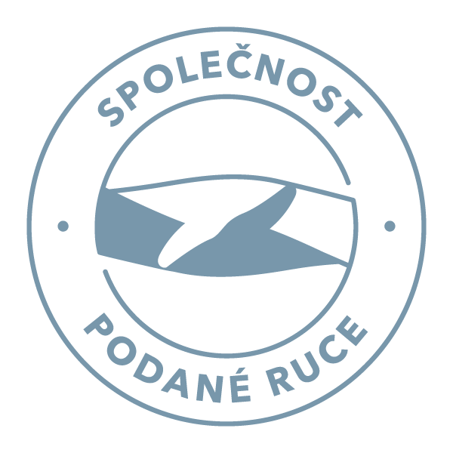

Mind the Gap
Type of good practice: Project
Type of vulnerable youth: Socially-excluded youth
Area of good practice: Local – Local action group Moravský kras, Blansko
Main implementer of good practice: Podané ruce o.p.s. (Public Benefit Corporation)
Website: https://podaneruce.cz/projekty/mind-the-gap/
Funding/financial model
This project was co-financed by the European Social Fund through the Employment Operational Programme and the state budget of the Czech Republic.
Other institutions involved
Local action group Moravský kraj – Blansko, EU, MPSV ČR- Employment Operational Programme
Context of good practice
The project offers a comprehensive support program for young people aged 15–29 who are socially excluded or at risk of social exclusion, for example after being released from institutional care, and who live in the Blansko LAG area. Its primary target group consists of young people facing multiple barriers when entering the labour market and preparing for employment.
The project focuses on developing and improving job search and employment preparation skills, responding directly to the needs of this group. Support is provided through a combination of experiential learning methods, such as workshops and discussion groups, and individual work with highly motivated participants. This individual support takes the form of active case management, allowing for tailored guidance and continuous work on personal and professional development. By combining group-based learning with individual support, the program addresses both general employability skills and specific personal challenges.
Activities
- Contacting people from the target group and selecting project participants
- Fieldwork in Blansko among young people at risk of social exclusion
- Workshops on the labor market, communication and social skills, motivational interviews
- Individual work with project participants
- Project management and evaluation
Why should it be considered a good practice
The project offers a comprehensive support program for young people aged 15–29 who are socially excluded or at risk of social exclusion, for example after being released from institutional care, and who live in the Blansko LAG area. Its primary target group consists of young people facing multiple barriers when entering the labour market and preparing for employment.
The project focuses on developing and improving job search and employment preparation skills, responding directly to the needs of this group. Support is provided through a combination of experiential learning methods, such as workshops and discussion groups, and individual work with highly motivated participants. This individual support takes the form of active case management, allowing for tailored guidance and continuous work on personal and professional development. By combining group-based learning with individual support, the program addresses both general employability skills and specific personal challenges.

Drug free Brno
Type of good practice: Project
Type of vulnerable youth
Young people at risk of addiction and other forms of risky behaviour
Area of good practice: Local – Brno city
Main implementer of good practice: Podané ruce o.p.s. (Public Benefit Corporation)
Website: https://podaneruce.cz/projekty/drug-free-brno/
Funding/financial model
This project was co-financed by the European Social Fund through the Employment Operational Programme and the state budget of the Czech Republic.
Other institutions involved: EU, Employment Operational Programme
Context of good practice
The main goal of the project is to support young people aged 15–19 from socially excluded areas who are at risk of addiction, including pathological gambling, as well as other risky behaviours. The project aims to minimise the health and social risks associated with drug use, drug abuse, and gambling by addressing these issues in a preventive and educational way.
In addition to working directly with young people, the project also includes educational activities for families and individuals. These activities focus on raising awareness of the signs of substance abuse and providing information on available ways to help people who use drugs. By combining prevention, education, and risk reduction, the project responds to the specific needs of young people growing up in socially excluded environments.
Activities
- Contacting people from the target group and selecting project participants
- Group work with young people in schools – risk minimization program
- Individual work – consultations
- Outreach activities for young adults at risk of risky behaviour
- Project management and evaluation

Why should it be considered a good practice
This project can be considered an example of good practice because its concept has already been successfully implemented in Brno in the field of prevention in primary schools and has been effectively transferred to the secondary school environment. Thanks to this continuity, the model has proven to be transferable and applicable in other institutions.
Participants expressed satisfaction with the course of the project, and the service became so highly demanded that new applicants had to be turned away due to limited capacity. The project also had a broader institutional impact, as it motivated the management of some schools to employ a school psychologist or a social pedagogue, demonstrating its influence beyond direct participants.

POMA – Podpora mladistvých (Youth support program)
Type of good practice: Service
Type of vulnerable youth
Socially excluded youth, Young people from financially challenged families
Area of good practice: National
Main implementer of good practice: Člověk v tísni o.p.s. (Public Benefit Corporation)
Website: https://www.clovekvtisni.cz/co-delame/socialni-prace-v-cr/karierni-poradenstvi
Funding/financial model
This project is co-financed by the EU, Scholarship of up to CZK 12,000 per year from the Albatros foundation.
Other institutions involved: EU, Municipalities
Context of good practice
The basic mission of the service is to extend the educational career beyond compulsory schooling for the target group, which consists of young people and adolescents aged 14-26. Ideally, the goal is to formally improve the qualifications of young people so that their employability in the labor market increases. This may involve obtaining an education certificate, high school diploma, or higher education. However, it is essential to take into account the future employability of the chosen profession.
Activities
- Identification of the client's real motivation and potential – individual interviews
- Mediation of a specific field of education
- Support during studies
- Prevention of handicaps – e.g., in the form of tutoring
- Retro-scholarship program – prevents early departure
- Workshops – issues of education, employment in the labour market, prevention of over-indebtedness, etc.
Why should it be considered a good practice
This service should be considered good practice, as it operates on an individual basis and is tailored to each person. The popularity of the service is demonstrated by its expansion to several regions and cities in the Czech Republic, meaning that it can be applied in various locations. The retro-scholarship program is also significant, as it is an effective motivational tool. Volunteers can also get involved in the service, for example as tutors, which strengthens a sense of solidarity.

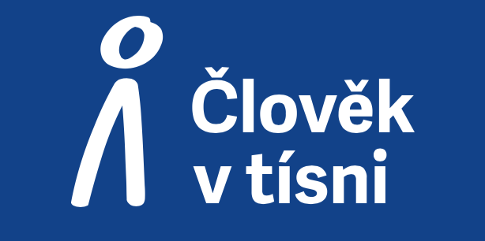

Stronger roots
Type of good practice: Program
Type of vulnerable youth: Not specified
Area of good practice: National
Main implementer of good practice: OSF – Open society fund Prague
Website: https://osf.cz/co-delame/stronger-roots/
Funding/financial model
The program is funded by the European Union through the Citizens, Equality, Rights and Values (CERV) program and the foreign foundations Porticus and Open Society Foundations.
Other institutions involved
In this program many institutions are involved. The program is based on connecting institutions.
Context of good practice
In the Stronger Roots program, civil society organizations learn how to reach out to people in their surroundings, involve them more actively in their work, and build broad communities of supporters, donors, volunteers, and new partners. Strengthening these relationships increases the organizations’ resilience and enables them to contribute more effectively to addressing societal challenges.
Through the program, organizations working in a wide range of fields—such as environmental protection, education, support for people with disabilities, and the promotion of transparency – receive comprehensive support. This support combines financial resources with a unique educational program, in which participating organizations are assisted by experienced mentors and experts in areas such as communication, fundraising, management, and related skills essential for long-term sustainability.
Activities
- Supporting organizations that focus on a wide range of topics
- Distributing funds to organizations
- Providing educational programs with the help of experienced mentors and experts from the field – raising awareness of neglected topics
- Building a community of supporters—the organization is open to people, targets them specifically, and tries to involve them in its work
Why should it be considered a good practice
The Stronger Roots program can be considered a good practice because it successfully brings together organizations and sectors that address important societal issues and actively increases people’s engagement with civil society. By strengthening the ability of organizations to involve supporters, donors, and volunteers, the program contributes to building stronger and more connected communities.
Its effectiveness is demonstrated by the fact that the program has expanded beyond its original context to neighbouring countries, including Hungary, Slovakia, and most recently Poland. This expansion indicates that the concept is transferable and relevant in different national settings. At the same time, the program emphasizes the importance of solidarity by supporting cooperation across sectors and borders, reinforcing shared responsibility for addressing common challenges.
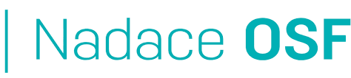

Hungary

Focus on the Child programme
Type of good practice: Project
Type of vulnerable youth: Youth from ethnic minority, Youth from remote or rural areas
Area of good practice: National, Local – Hungary’s most disadvantaged municipalities
Main implementer of good practice
Hungarian Charity Service of the Order of Malta (Magyar Máltai Szeretetszolgálat)
Website
https://fokuszbanagyermek.hu/
https://fete.hu/szakteruletek/fokuszban-a-gyermek/
https://www.researchgate.net/publication/393550998_EVALUATION_OF_THE_FOCUS_ON_THE_CHILD_PROGRAMME_IN_HUNGARY
Funding/financial model
Funded through EU funds:
EFOP-1.4.5-20 (“Focus on the Child – complex child development services in the most disadvantaged settlements”) under the Human Resources Development Operational Programme (EFOP): co-financed by the European Social Fund and the Government of Hungary.
Other institutions involved
Ministry of Interior, European Union (ESF), child protection and family support services, health visitors (védőnői szolgálat), local NGOs and churches, local educational institutions
Context of good practice
In Hungary’s most disadvantaged settlements, young children are born into families facing multiple deprivations, such as substandard housing, low parental education, unemployment, and limited access to health or childcare. Roma families and very young parents are particularly affected. Before the programme, local services were fragmented or absent, early childhood facilities were scarce, health visitors overstretched, and parenting or developmental support rarely reached these communities. As a result, developmental delays were visible by age three, reinforcing cycles of school failure and intergenerational poverty.
The programme was introduced to address this gap by integrating social, health, and educational support at the local level through mentoring, presence points, developmental support, baby kits, and stronger parental involvement, aiming to reduce the impact of marginalisation and poverty through locally available, intensive social work.
Activities
- Home visits and continuous family mentoring from pregnancy onwards
- Parenting guidance and skills development (bonding, daily routines, child stimulation)
- Early childhood play and developmental sessions at local “Presence Points”
- Screening for developmental delays and referrals to specialists
- Cooperation with health visitors (védőnők), paediatricians, and nurses
- Pregnancy and perinatal support (nutrition, hygiene, safe delivery)
- Assistance with immunisations, hygiene, and healthy child-rearing practices
- Distribution of baby kits, hygiene packages, and maternity supplies
- Small-scale housing support to improve safety and sanitation
- Operation of “Presence Points” as local access centres with playrooms and counselling
- Group activities and community engagement for parents and children
- Training and methodological support for local professionals (health, social, education)
- Development of tools and models for integrated early childhood services in disadvantaged areas
Why should it be considered a good practice
The programme addresses an urgent social challenge in Hungary’s most disadvantaged municipalities through an integrated model combining family mentoring, early childhood developmental support, and cooperation with health and social services. Locally accessible “Presence Points” reduce barriers to services and strengthen parental capacity.
Evaluation showed improvements in children’s language and cognitive development, increased parental engagement, and stronger local service capacity through professional training and methodological tools, demonstrating a sustainable and transferable model.
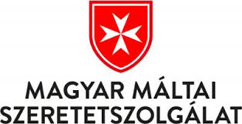

Incorpora
Type of good practice: Project
Type of vulnerable youth: Low-educated youth, Youth with disabilities
Area of good practice
Regional – Budapest, Gödöllő and surrounding areas; agglomeration of the capital
Main implementer of good practice
Maltese Care Nonprofit Ltd. (Máltai Gondoskodás Nonprofit Kft.): a charity organisation founded by the Hungarian Charity Service of the Order of Malta as lead partner.
Website
https://lostmillennials.eu/wp-content/uploads/2024/04/Lost-Millennials_Evaluation-Report_Hungary.pdf
Funding/financial model: Partially funded by the La Caixa Foundation and the ERSTE Foundation
Other institutions involved
Diversity Foundation (Diverzitás Alapítvány), Centre for Single Parents (Egyszülős Központ), Shelter Foundation (Menhely Alapítvány), Impact Hub Budapest, ERSTE Foundation
Context of good practice
In Hungary, the key obstacles to employment include low educational attainment, residence in isolated rural regions, and caregiving responsibilities such as raising young children or looking after elderly or ill family members. Belonging to the Roma community is another barrier due to widespread labour market discrimination, while chronic illness or disability also hinders job opportunities. In addition, employment rates are significantly lower among young people under 25 and older workers over 50 compared to those in their prime working years.
The Hungarian Incorpora focuses on disadvantaged / vulnerable jobseekers, especially those who face barriers in the labour market (e.g. the long-term unemployed, people with disabilities, women, those in extreme poverty, etc.). It also includes new market entrants, homeless people, single parents, and those discriminated against by age or other criteria. Unlike state-run employment services, Incorpora provides more intensive, one-to-one guidance, filling gaps left by overstretched public programmes.

Activities
- Individual counselling, mentoring and coaching
- Job search support and placement
- Entrepreneurship training and support
- Group trainings and workshops
- Follow-up and post-placement support
- Employer engagement and network building
- Coordination and referrals
Why should it be considered a good practice
Incorpora in Hungary provides more tailored and intensive support than public employment services can typically offer, thanks to lower client-to-staff ratios and flexible, personalised counselling. It successfully reaches disadvantaged groups, supports their job readiness, and facilitates labour market entry in a way that complements existing state measures. The programme’s network-based model strengthens cooperation between NGOs, employers, and service providers, creating synergies that improve outcomes. Although its impact is strongest for participants who are already somewhat job-ready, the evaluation concluded that Incorpora fills important gaps left by public services, making it a valuable and replicable approach in the Hungarian labour market context.

Tanoda Platform
Type of good practice: Initiative
Type of vulnerable youth
Low-educated youth, Youth from ethnic minority, Youth from remote or rural areas
Area of good practice: National
Main implementer of good practice
The state designs and funds the programme, but implementation is decentralized – it’s carried out by civil society actors (NGOs, foundations, community associations) at the local level.
Website
https://tanodaplatform.hu/
https://national-policies.eacea.ec.europa.eu/youthwiki/chapters/hungary/44-inclusive-programmes-for-young-people
Funding/financial model
Mainly through EU funds (mainly European Social Fund), under Human Resources Development Operational Programme – earmarked for social inclusion, education and reducing early school leaving) with national co-financing, distributed as project-based grants (typically 2-3 years) to NGOs and local organizations.
Other institutions involved
National ministries, EU Managing Authorities (design, funding), NGOs, churches, local associations (implementation), Schools, municipalities, child services (cooperating institutions)
Context of good practice
The Tanoda programme emerged in Hungary as a response to deep-rooted social and educational inequalities, particularly affecting Roma and socio-economically disadvantaged children. It operates in a context of high child poverty, segregated schooling, and limited family support for learning, where mainstream education often fails to address individual needs. Shaped by Hungary’s National Social Inclusion Strategy and strongly supported by EU Structural Funds, Tanoda provides afterschool tutoring, mentoring, and community activities through NGOs, churches, and local associations. Located mainly in disadvantaged regions, the “tanodas” act as community-based hubs that help reduce early school leaving, improve educational outcomes, and foster inclusion, complementing formal schooling while bridging gaps left by both the state and families.
Activities
Activities vary by Tanoda but often include school preparation, afternoon training, individual development (like computer and language skills), creative arts and crafts, logic games, joint reading, technology courses, and career orientation. Many Tanodas also integrate psychosocial support, mentoring, individualized learning paths, and support for children with specific learning needs or developmental challenges.
Why should it be considered a good practice
The Tanoda programme combines educational, social, and community support in a flexible, locally embedded model. Targeting children from socio-economically disadvantaged background – particularly Roma youth and those at risk of early school leaving—it provides tailored tutoring, mentoring, and personal development opportunities. Afterschool study halls adapt to individual learning needs while fostering self-confidence, cultural identity, and life skills.
Tanoda promotes intersectoral cooperation, linking schools, municipalities, social services, and families, strengthening networks around disadvantaged children. Despite reliance on short-term EU funding, its strong community roots and repeated revival demonstrate resilience and long-term value. The programme’s adaptability and transferability make it a promising model of inclusive education and youth support.
Ministry data show positive impacts on students’ academic performance. In 2022, more girls than boys participated, with girls more likely to continue in high school and boys tending toward vocational training. In 2021–2022, 76% of eighth-grade Tanoda students planned to continue in high school to pursue higher education.


Romania

Socio-professional integration workshops
Type of good practice: Social Insertion Enterprise
Type of vulnerable youth
People with multiple vulnerabilities, who have been “labelled” as “unemployable”.
Area of good practice: Regional – Bucharest and Ilfov area, Romania
Main implementer of good practice: Asociația Ateliere Fără Frontiere (AFF)
Website: https://atelierefarafrontiere.ro/our-story/
Funding/financial model
The circular economy workshops are entities lacking legal personality, with income from economic activities and funds from subsidies and sponsorships used solely for the association's activities of general and non-patrimonial interest.
Other institutions involved
Collaboration with various institutions: economic, social, municipal, and international organisations (https://atelierefarafrontiere.ro/parteneri/)
Context of good practice
The current dominant socio-economic system fosters poverty and marginalisation among the most vulnerable. Categorising disadvantaged people into specific groups results in adverse effects such as increased discrimination and exclusion, the ethnicization of socio-economic issues, and xenophobia. Usually, disadvantaged individuals face multiple challenges.
Social benefits (allowances, aid, etc.) and passive social services aim to stabilise individuals. Still, in Romania, there are no integrated services that activate vulnerable people of working age, combining passive assistance with socio-professional support for labour market integration.
This category, which benefits directly from passive social services that provide only short-term stability, ends up being excluded from the conventional labour market because it faces numerous difficulties and requires support, as well as easier access to housing, health services, autonomy and self-esteem, independent living skills, education, accessibility, training, and more.

Activities
- Employment contract and salary
- Personalised social support services
- Counselling for integration on the labour market
- Psychotherapy
- Pedagogical support for skills training
Why should it be considered a good practice
The approach meets all the criteria for recognition as best practice whilst also doing much to protect the environment.
Functionality: The programme helped 1,800 vulnerable individuals integrate into the labour market and has earned numerous national and international awards.
Intersectoral cooperation: Stakeholders from various sectors are involved in the solution.
Innovativeness: The entire model is innovative, as are the activities of each workshop. For example, in the Remesh, they transform advertising banners and meshes into stylish, ethical, and sustainable products and accessories.
Sustainability: The activities of the social integration workshops help promote a circular, solidaric, and sustainable economy.
Adaptability: All four socio-professional integration workshops operate in different fields (reuse and recycling of IT equipment, fashion and home & deco products, bio-social farm, packaging and logistics), demonstrating their adaptability.
Transferability: The initiative requires considerable effort, but it can be replicated elsewhere, which is what the association's leaders hope to see.
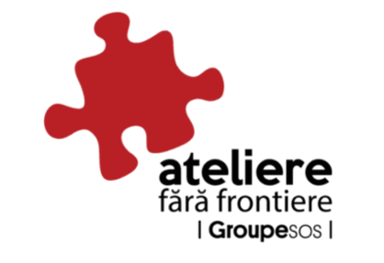

JobDirect for NEETs within ALMA initiative (JobDirect pentru tinerii NEET în cadrul Inițiativei ALMA)
Type of good practice: Project
Type of vulnerable youth
18-29 NEETs, 55% of whom are disabled/of Roma ethnicity/from the child protection system/long-term unemployed
Area of good practice: Regional – Nort-East Region of Romania
Main implementer of good practice: ADV Romania
Website: https://alaturidevoi.ro/en/proiect/jobdirect-for-neets-within-alma-initiative/
Funding/financial model
The project was funded by the European Union, within the Social Innovation Initiative / ESF + SI +
Other institutions involved: INFOR ELEA (Italy), Consorzio Nazionale CGM (Italy)
Context of good practice
In the North-East Region of Romania, many NEET youth face multiple barriers to employment, including limited educational achievement, skills mismatch, lack of access to vocational training and job opportunities, discrimination, systemic obstacles, high unemployment rates, and job insecurity. This highlights the need for targeted interventions, particularly for individuals from vulnerable backgrounds. “JobDirect for NEETs within ALMA initiative” is an active inclusion project designed to empower the most vulnerable young people aged 18-29 from Romania, who are not in education, employment, or training (NEETs), to find work and integrate into society by improving their skills, knowledge, and experience in workplaces across Europe. The selected participants include at least 55% from vulnerable backgrounds, such as young people with disabilities, individuals from the Roma community, and those from the child protection system.
Activities
- Preparation for mobility: career counselling and guidance, job-matching, development of the mobility action plan for each participant, Italian language course, introductory digital skills course, and psychological and emotional support to prepare the participants for a new cultural experience.
- Transnational mobility: work-based learning in Italy, mentoring, social and cultural activities.
- Post-mobility support: self-assessment questionnaire, career counselling, employer engagement, job coaching.
Why should it be considered a good practice
The project can be regarded as good practice because it fulfils the criteria listed below.
Functionality: with a success rate of 93.75% in securing employment, education, or training after mobility, the project has demonstrated its effectiveness in supporting vulnerable young people. Evidence from a comparative study (https://alaturidevoi.ro/en/proiect/jobdirect-for-neets-within-alma-initiative/) supports this finding.
Intersectoral collaboration: various stakeholder groups from multiple sectors participated in the project (10 national partners, two transnational partners)
Innovativeness: the one-stop-shop approach, transnational work experience, and coaching for workplace integration and adaptation support are regarded as innovative within the region.
Complexity: the project involved a variety of activities across several stages, including career guidance, language training, overseas work experience, and assistance in finding employment.


Integrated services for vulnerable groups – a bridge for the development of local communities (Servicii integrate pentru grupuri vulnerabile – o punte pentru dezvoltarea comunităților locale)
Type of good practice: Project
Type of vulnerable youth
Low-educated youth, Youth with disabilities, Youth from ethnic minority, Youth from remote or rural areas
Area of good practice: Regional – Giurgiu and Prahova counties
Main implementer of good practice
General Directorate of Social Assistance and Child Protection Giurgiu
Website
https://eeagrants.org/en/fmo/areas-of-work/programmes-and-projects-information/archive/2014-2021/projects/ro-localdev-0058
Funding/financial model: The EEA and Norway Grants
Other institutions involved: Estuar Foundation, Four Change Association
Context of good practice
In the South Muntenia Region, notable disparities exist between rural and urban areas in social protection, education, training levels, employment rates, understanding of anti-discrimination principles, and community spirit.
Giurgiu and Prahova counties are no different, as they are mainly rural areas with underdeveloped social services. The project aims to improve access to and the quality of social services for at least 1,265 people, members of eight disadvantaged communities in Giurgiu and Prahova counties, through local development initiatives in sectors such as education, employment, social assistance, housing, and anti-discrimination.
To boost employment levels in the labour market, the project provided counselling and information services, professional training (including qualifications for personal assistants, security guards, and carpenters-parquet workers), and mediation, aiming to help 400 unemployed and inactive individuals find jobs.
To aid people with disabilities in Giurgiu County, the project also involved establishing a pilot social service.
Activities
- Long-term vocational training
- Personal growth and creativity development
- Parents' School - parent education program
- Non-formal education club – an innovative method of intervention in education
- Information and counselling
- Work intermediation
- Development of social services in the community
- Campaign to combat and prevent discrimination
Why should it be considered a good practice
The project can be considered good practice because it meets the criteria listed below.
Functionality: The project produced numerous results that helped improve the situation of disadvantaged groups.
Intersectoral cooperation: the project was implemented through collaboration between the public and private sectors
Innovativeness: The project not only helped individuals but also targeted families, using innovative methods such as non-formal education clubs.
Complexity: The project adopted a multifaceted approach centred on local community development; its activities targeted education, employment, social assistance, housing, and anti-discrimination.
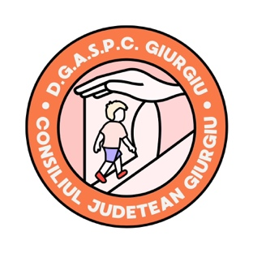

Training for Sustainable Employment of Youth and Young Adults
Type of good practice: Project
Type of vulnerable youth: Unemployed youth with tertiary education
Area of good practice: Regional – Iasi, Romania
Main implementer of good practice
Asociația pentru Sprijinirea Inițiativelor Educaționale (The Association for Enhancing Educational Initiatives)
Website: https://tsemy.org/
Funding/financial model
The project was funded by the European Commission, through funds granted by the National Erasmus+ + Agency Education and Training Key Action 2 (KA2) – Cooperation for innovation and interchange of good practices (Strategic Partnerships for Vocational Education and Training) with reference number 2020-1-PT01-KA202-78621.
Other institutions involved
EIA, S.A. – Atlântica (Portugal), Archivio della Memoria (Italy), Centro Superior de Formación Europa Sur (Spain), Muğla Sıtkı Koçman University (Türkiye), ProEduca (Czech Republic)
Context of good practice
The project tackled youth unemployment across Europe, specifically focusing on young people aged 20–29 with tertiary qualifications who remain unemployed. Many of these young adults face a mismatch between their academic backgrounds and the skills employers seek. TSEMY addressed this gap by developing tailored training that combines personal development, socio-professional skills, and digital tools to better prepare young people for the labour market by fostering stronger links between training and real-world employment needs. The project aimed to promote sustainable employability and empower young adults to take active steps towards meaningful work.
Activities
- Comprehensive review of youth employment contexts and training needs
- Structured training curriculum focused on personal, social, and employability skills
- An interactive e-learning platform
- Training methodology guide for trainers
- Training guide for trainees
Why should it be considered a good practice
The project can be considered good practice because it satisfies the criteria listed below.
Functionality: The main gain of the project was the creation of a course programme, focused on improving young people’s inclusion in the job market and meeting companies’ needs for skilled employees (de Sousa, C., & Romana, F. A., 2024). Training to Achieve Sustainable Employment for Youth and Young Adults. Merits, 4(2), 118-131. https://doi.org/10.3390/merits4020009).
Sustainability: All the materials created within this project are available to the public for free.
Adaptability: The activities conducted can also be tailored to other target groups.
Transferability: The training programme was carried out in collaboration with representatives from six countries, suggesting that the material developed could also be applicable in other nations.

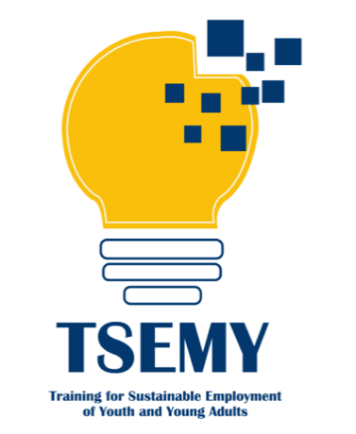

I Want My First Job (Vreau Primul Job)
Type of good practice: Project
Type of vulnerable youth: NEETs
Area of good practice: Regional – Southwest Oltenia Region
Main implementer of good practice: World Vision Romania
Website: https://worldvision.ro/medierea-muncii/vreau-primul-job/
Funding/financial model
The project received co-funding from the European Social Fund via the Human Capital Operational Programme.
Other institutions involved: ASCENDO
Context of good practice
Job mediation is an activity that aims to assist job seekers in securing employment by matching the requirements of vacant positions offered by employers with the applicants' professional training, skills, and preferences. Through this service, the World Vision Foundation intends to support job seekers throughout the entire employment process, from identifying suitable options to selection, interviews, and securing employment. The goal of job placement is to promote employment, which acts as a further step towards the economic development of the communities where we operate. Job mediation is primarily designed for individuals seeking employment. This category also includes young people aged 16-29 who are not in education, employment, or training (NEET), who are the target group for the project.
Activities
- Information and professional counselling services
- Labour market mediation services
- Vocational training for qualification
- Vocational training in entrepreneurship
- Entrepreneurial counselling and support for setting up new businesses
- Organisation of business plan competitions and selection of winning businesses
- Granting of subsidies (micro-grants) for establishing new businesses
- Monitoring the progress of enterprises subsidised through the project

Why should it be considered a good practice
The project can be regarded as good practice because it fulfils the criteria listed below.
Functionality: As a result of the project, 123 NEETs gained employment, 208 individuals participated in vocational training, and 10 businesses were established. The project's success is also reflected in the results of interviews conducted with the beneficiaries (https://worldvision.ro/wp-content/uploads/2025/05/Manual-pentru-activarea-tinerilor-NEETs.pdf).
Adaptability: The activities conducted can also be tailored to other target groups.
Transferability: Within the project's framework, a job mediation methodology for NEETs was also developed and is available online:
https://worldvision.ro/wp-content/uploads/2025/05/Metodologie-servicii-mediere-tineri-NEETs.pdf
Complexity: The project involved a wide range of activities, from information, advisory and mediation services to vocational training and business promotion.

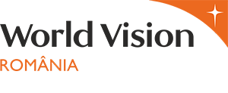

Serbia

My First Salary Program
Type of good practice: Project
Type of vulnerable youth: Low educated youth, Youth from remote or rural areas
Area of good practice: National
Main implementer of good practice
Ministry of Labour, Employment, Veterans and Social Affairs of the Republic of Serbia
Website: https://mojaprvaplata.gov.rs/
Funding/financial model
The “My First Salary” program is funded by the Government of Serbia through the Ministry of Labour, with employers receiving financial incentives for each young person they hire and train. This financing model encourages active participation from both public and private sector employers, ensuring sustainable opportunities for youth to gain practical work experience.
Other institutions involved
Private and public sector employers, local employment offices/field branches, and educational institutions providing career support
Context of good practice
In Serbia, youth unemployment was particularly high, reaching 25.5% in the first quarter of 2020, with many young people facing an average waiting time of approximately two years before securing their first job. Motivated by the need to provide structured opportunities for young people to enter the labour market, gain practical work experience, and enhance their employability, the “My First Salary” program specifically targets individuals who have completed secondary or higher education but lack prior work experience.
Activities
- Offering financial incentives to employers for hiring youth
- Structured mentorship and on-the-job training programs
- Monitoring and evaluation of employment outcomes
- Coordination between government bodies and employers
Why should it be considered a good practice
The “My First Salary” program is considered a good practice because it has demonstrably improved youth employment outcomes while fostering strong intersectoral cooperation between the government, employers, and educational institutions. Its sustainable model, which combines financial incentives with structured mentorship, not only maximizes effectiveness but also has significant potential for replication in other regions or countries.


Youth Guarantee
Type of good practice: Project
Type of vulnerable youth: Low-educated youth, Youth from remote or rural areas
Area of good practice: Local – Niš, Kruševac, Sremska Mitrovica
Main implementer of good practice
Ministry of Labour, Employment, Veteran and Social Affairs of the Republic of Serbia
Website:
https://www.minrzs.gov.rs/sr/dokumenti/ostalo/sektor-za-rad-i-zaposljavanje/garancija-za-mlade
Funding/financial model
The Youth Guarantee Program is funded by the Government of Serbia as part of a pilot initiative aimed at addressing youth unemployment. In addition to government funding, the program is supported by contributions from social partners, including private sector employers, NGOs, and educational institutions, which actively participate in providing employment, internship, and training opportunities. This combined funding and partnership model ensures the sustainability of the program, encourages intersectoral collaboration, and creates a robust network of support for young people, enabling them to access quality opportunities and successfully transition into the labour market.
Other institutions involved
The Youth Guarantee Program involves a wide range of institutions working together to support young people. Local employment offices coordinate placements and guidance, while private sector employers provide opportunities for internships and employment. NGOs and civil society organizations contribute additional support services, and educational institutions offer further training and internship opportunities, creating a comprehensive network of intersectoral cooperation.
Context of good practice
Many young people under 30 in Serbia face unemployment or experience long delays in accessing employment or further education opportunities. Motivated by the need to address this challenge, the Youth Guarantee Program aims to ensure that all youth receive a quality offer of employment, an internship, or further education within four months of becoming unemployed or completing formal education, thereby facilitating smoother entry into the labor market. The program specifically targets young people under 30 who are unemployed or have recently completed their studies.
Activities
- Coordinating offers of employment, internships, or education for young people
- Engaging employers, NGOs, and educational institutions to participate in placements
- Providing guidance and support to youth to access opportunities
- Monitoring and evaluating the effectiveness of placements and employment outcomes
Why should it be considered a good practice
The Youth Guarantee Program is considered a good practice because it provides structured pathways that enable young people to enter employment, internships, or further education quickly and efficiently. It demonstrates strong intersectoral cooperation by engaging government bodies, private sector employers, NGOs, and educational institutions in a coordinated effort. The program’s design allows for adaptation and transfer to other cities or regions, making it a flexible model for broader implementation. Additionally, it effectively addresses key barriers to youth employment in a targeted and measurable way, ensuring tangible results for the participants.
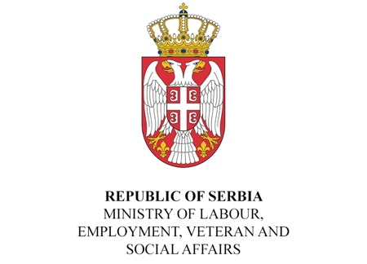

Youth Employment Partnership in Serbia (YEPS)
Type of good practice: Project
Type of vulnerable youth
Low-educated youth, Youth from remote or rural areas, Young people lacking work experience and facing barriers to entering the labour market
Area of good practice: National
Main implementer of good practice
International Labour Organization (ILO) in cooperation with the Government of Serbia (2009-2010)
Website
https://www.ilo.org/publications/final-evaluation-report-project-youth-employment-partnership-serbia
Funding/financial model
Funded through a collaboration between the International Labour Organization and the Government of Serbia, ensuring strong institutional support and sustainability. The program is further supported by contributions from employers and local partners who provide apprenticeships and training opportunities, creating a comprehensive and collaborative funding model that engages multiple sectors in supporting youth employment.
Other institutions involved
- Private sector employers offering apprenticeships and internships
- Educational institutions providing vocational training
- NGOs supporting youth employability initiative and career support
Context of good practice
Many young people in Serbia face significant challenges in finding employment due to a lack of work experience and insufficient practical skills. Motivated by the need to enhance youth employability, the Youth Employment Partnership (YEPS) provides vocational training, apprenticeships, and employment matching to help young people successfully enter the labor market. The program specifically targets low-educated youth and those from rural or remote areas who encounter barriers to accessing job opportunities.

Activities
- Vocational training and skills development programs
- Matching youth with apprenticeship or employment opportunities
- Coordinating collaboration between the government, educational institutions, and private sector employers
- Monitoring and evaluating employment outcomes for participants
Why should it be considered a good practice
The Youth Employment Partnership (YEPS) is considered a good practice because it effectively demonstrates intersectoral cooperation between government bodies, educational institutions, and the private sector. The program measurably improves the employability of vulnerable youth while operating as a sustainable model supported by long-term institutional partnerships. Its design and outcomes also make it highly transferable, allowing similar approaches to be adapted and implemented in other regions or sectors facing comparable challenges.
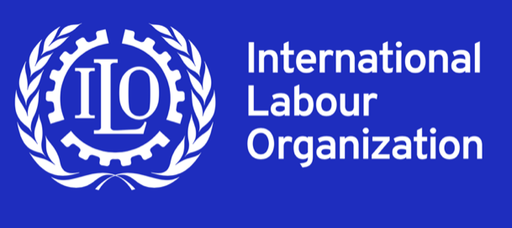

“Cooperation to Quality” – Career Guidance and Counselling Services
Type of good practice: Project
Type of vulnerable youth
Low-educated youth, Youth from remote or rural areas, Youth lacking sufficient career guidance or support to enter the labour market
Area of good practice: Local
Main implementer of good practice
Ministry of Tourism and Youth of the Republic of Serbia and CSO Belgrade Open School (2023)
Website
https://www.bos.rs/en/implemented-project/100/876/cooperation-to-quality_-available-career-guidance-and-counseling-services-for-everyone.html
Funding/financial model
One-off project supported by the Ministry of Tourism and Youth of the Republic of Serbia, and the activities will be implemented in 2023 model that engages multiple sectors in supporting youth employment.
Other institutions involved
- Secondary schools and educational institutions
- Civil society organizations (CSOs) supporting youth employability
- Local employment offices and municipal youth services
Context of good practice
Many young people in Serbia face limited access to quality career guidance and counselling, which restricts their ability to make informed decisions about education, training, and employment opportunities. To address this challenge and enhance youth employability, the “Cooperation to Quality” project aimed to strengthen career guidance services at the local level, ensuring that young people can access professional support tailored to their specific needs. The program specifically targets low-educated youth, those from rural or remote areas, and any young person requiring guidance to successfully enter the labour market.

Activities
- Providing professional development and training for career counsellors
- Strengthening collaboration between schools, CSOs, and local youth offices
- Offering career counselling sessions and guidance programs for youth
- Developing and implementing quality standards for career guidance services
Why should it be considered a good practice
The “Cooperation to Quality” project might be considered a good practice because it significantly improves access to quality career guidance for youth while demonstrating strong intersectoral cooperation at the local level. The program introduces innovative standards and methods for career counselling, ensuring that services are effective and relevant. Additionally, its design is adaptable to different municipalities and target groups, making the approach highly transferable and suitable for replication in other contexts.

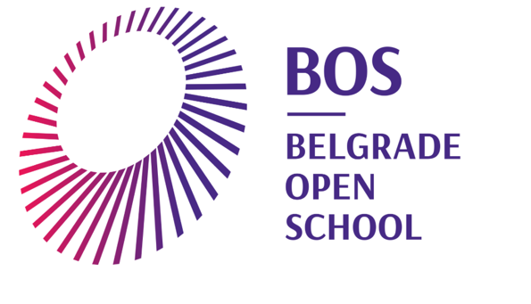

Mental Health and Psychosocial Support Programme for Youth in Serbia
Type of good practice: Policy measure
Type of vulnerable youth
Low-educated youth, Youth experiencing mental health challenges
Area of good practice: National
Main implementer of good practice: UNICEF Serbia
Website
https://www.unicef.org/serbia/en/mental-health-and-well-being.com
https://svejeok.rs/
Funding/financial model
The Mental Health and Psychosocial Support Program for Youth is funded through a combination of government budgets and international support, including contributions from UNICEF and the Kingdom of Norway.
Other institutions involved
The program involves a wide range of institutions working together to provide comprehensive support. Key partners include the Ministry of Health, Ministry of Education, Ministry of Labour, Employment, Veterans and Social Affairs, Ministry of Youth and Sports, Ministry of Human and Minority Rights and Social Dialogue, and the Ministry of Family Welfare and Demography. In addition, local youth offices and civil society organizations actively participate, creating a coordinated network that ensures mental health services are accessible, effective, and tailored to the needs of young people across the country. Local employment offices and municipal youth service
Context of good practice
In Serbia, a significant number of young people experience mental health challenges, including anxiety and depression, a situation that was further exacerbated by the COVID-19 pandemic. Motivated by the urgent need to provide accessible and non-stigmatizing support, the Mental Health and Psychosocial Support Programme was developed to deliver comprehensive services tailored to the needs of youth. The program specifically targets vulnerable groups, including low-educated young people and those from rural or remote areas, ensuring that mental health support reaches those most at risk.
Activities
- Establishment of an expert group comprising professionals from various sectors to address mental health protection.
- Provision of online and offline counselling services through platforms like svejeok.rs.
- Development of a legislative framework to enhance local-level service provision.
- Organization of awareness campaigns to reduce stigma associated with mental health issues.
- Training programs for educators, health professionals, and youth workers to better support young individuals.
Why should it be considered a good practice
The Mental Health and Psychosocial Support Programme for Youth is considered a good practice because it exemplifies effective intersectoral cooperation among multiple ministries and organizations, ensuring coordinated and comprehensive support. It provides accessible, age-appropriate services that address a critical gap in mental health support, particularly for youth in underserved areas. By incorporating young people’s participation in decision-making processes, the program ensures that services meet their needs while also contributing to the reduction of stigma surrounding mental health issues.

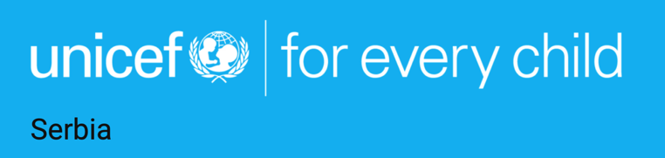

Slovakia

DASATO Academy
Type of good practice: Initiative
Type of vulnerable youth
Secondary school students aged 15-19 whose access to mentoring, real-world projects and career guidance is limited outside the capital city.
Area of good practice: Regional – Trnava, Trenčín, Žilina, Košice regions (multi-regional model)
Main implementer of good practice
DASATO – non-profit organisation focused on personal and career development of high-school students across Slovakia.
Website: https://www.dasato.org/academy/
Funding/financial model
Primarily private/philanthropic funding complemented by a participant fee, with full scholarships available.
DASATO states that the student fee covers only a small share of the real cost (about 12%) of the real cost while the rest is covered by grants and sponsors. Current fee options are published on the program website (e.g., €360 one-off, or instalments), and scholarships are available.
Other institutions involved
Secondary schools and regional/local institutions collaborate as hosts for “Projects in Practice,” alongside NGOs and companies (e.g. Košice Self-Governing Region)
Context of good practice
DASATO Academy aims to empower secondary-school students across regional Slovakia to find their post-secondary direction, gain real-world experience while still at school, and contribute to their communities, acting as a bridge between school, work, and civic engagement. The multi-regional programme places student teams on real briefs from companies, NGOs, and public bodies.
The Academy responds to the need for clearer post-secondary pathways and stronger practice-oriented skills by combining mentoring, structured workshops, and real project work with public, private, and non-profit partners. Its target group is high-school students seeking to develop 21st-century skills, gain authentic experience, and build a supportive youth community beyond standard curricula. The programme runs as a year-long, after-school cycle integrating mentoring, workshops, and “Projects in Practice”.
Activities
Over a ten-month cycle, participants attend workshops and mentoring sessions, complete “Projects in Practice” with partners from the non-profit, public, and private sectors, and contribute to tangible projects benefiting their communities. The programme begins in late summer, with students meeting weekly for workshops and one-to-one mentoring, followed by a three-month project phase with feedback from mentors and host organisations.
Students can also take part in optional, student-led projects to develop their own ideas. The programme includes over 30 workshops, a development weekend camp, the Gallup strengths test, and support to present results at the end of the year. In some regions, workshops take place at university innovation parks, with teams delivering several sector projects. The average time commitment is 4–5 hours per week, and the cycle concludes with a final presentation ceremony in June.
Why should it be considered a good practice
The programme follows a simple and effective model that delivers consistent results each year. Students receive mentoring, develop key skills, and work on real tasks in cooperation with schools, local authorities, NGOs, and companies. Its clear structure has enabled implementation in four regions.
Beyond completed projects, participants improve their employability, civic engagement, and peer networks outside the capital. The programme aligns with COOPOWER’s goals by delivering practical outcomes, fostering cross-sector cooperation, achieving lasting impact, and offering an easily transferable model.


Dual Education
Type of good practice: Policy measure
Type of vulnerable youth
Secondary VET students aged 15+ whose skills need to be aligned with employer needs (reducing skills gaps).
Area of good practice: National
Main implementer of good practice
State Institute of Vocational Education (Štátny inštitút odborného vzdelávania – SIOV), in cooperation with employers and VET schools.
Website
https://siov.sk/vzdelavanie/dualne-vzdelavanie/uvod-dualne-vzdelavanie/
https://www.minedu.sk/system-dualneho-vzdelavania/
https://www.slov-lex.sk/ezbierky/pravne-predpisy/SK/ZZ/2015/61/
Funding/financial model
The system is publicly funded at the national level as a state policy measure financed from the education budget, with employer co-funding. Employers co-invest by providing workplace training, mentors, and stipends, while the state grant offsets part of these costs.
Operates as a regulated national system under Act No. 61/2015: schools deliver the school-based component and employers must be materially, professionally and personnel-wise prepared to provide practical training at the workplace (implying company-side provision of training capacity/resources).
Other institutions involved
Employers; secondary vocational schools (SOŠ); Employers’ Council for VET (Rada zamestnávateľov pre OVP)
Context of good practice
Slovakia’s Dual Education System (DES) links school studies with paid in-company practice based on a training contract. It is a nationally regulated VET model introduced on September 1st 2015 by Act No. 61/2015. It creates a formal partnership between the student and the employer, combining school-based learning with in-company practical training under a dual/training contract. The Ministry of Education frames the DES as a pathway available since the 2015/16 school year to increase students’ employability and better align VET outcomes with labour-market needs. Implementation is nationwide through cooperating VET schools and participating employers, with employer-side coordination provided by the Employers’ Council for VET (RZOVP). Key legal procedures (e.g., publication of opportunities once a dual agreement is concluded) are specified directly in the Act.
Activities
- Training/dual contract between student, school and employer (student studies at school and trains at the employer)
- Work-based learning on company premises while the employer provides the practical training environment.
- School–employer cooperation on recruitment and programme delivery (schools maintain active cooperation with lower-secondary schools for intake).
Why should it be considered a good practice
It represents intersectoral cooperation (school–employer–state) addressing skills gaps and reduces NEET risk after graduation. This model may be transferable across sectors/regions.
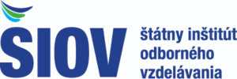

Graduate Practice (§51 Graduate Practice - school-leaver work experience under the Act on Employment Services)
Type of good practice: Policy measure
Type of vulnerable youth
Recent graduates under 26 who completed full-time education and have not had regularly paid employment since
Area of good practice: National
Main implementer of good practice
Public Employment Services of the Slovak Republic - the Central Office of Labour, Social Affairs and Family (UPSVaR) with local labour offices.
Website
https://www.upsvr.gov.sk/sluzby-zamestnanosti/nastroje-aktivnych-opatreni-trhu-prace/prispevky-pre-obcana/51-prispevok-na-vykonavanie-absolventskej-praxe.html?page_id=12940
https://static.slov-lex.sk/static/SK/ZZ/2004/5/20250701.html
Funding/financial model
Public funding - Public budget + EU (ESF+) under Programme Slovakia.
The labour office pays the participant a monthly allowance equal to the statutory subsistence minimum for one adult and also reimburses accident-insurance premiums. The allowance is paid within 15 working days after each month and is reduced for leave or other recorded absences per the attendance sheet. Employers are not paid wages under §51; their role is to host and supervise the placement.
Other institutions involved: Employers (host companies)
Context of good practice
The §51 Graduate Practice is a statutory, non-employment placement created to ease the transition from school to work. It lets a school-leaver/graduate gain occupational skills aligned with the attained qualification directly at an employer. Eligible graduates/ school-leavers first register as jobseekers (at least one month) and enter §51 via two written agreements: one between the labour office and the participant, and another between the labour office and the employer. During practice, the participant remains a jobseeker and must not be in an employment relationship while the labour office administers the measure and pays the public allowance. Employers host the practice on their premises, provide supervision, keep attendance, and issue a completion certificate; the standard placement runs 3–6 months at about 20 hours per week, with limited leave and excused absences as defined by law. The measure addresses the “no experience, no job” barrier in a controlled, time-limited way.
Activities
Practice runs 3–6 months, 20 hours per week. The employer sets the start date and schedule. After two months, the participant gains a right to 10 working days of leave (sickness or family-care absences are excused). On completion, the employer issues a certificate of practice confirming the experience.
Why should it be considered a good practice
The measure addresses barriers to first work experience and entry into employer settings by offering a structured, time-limited, non-employment placement with supervision and a public allowance. This statutory, nationwide active labour market measure tackles the “no experience, no job” trap by giving recent graduates and school leavers part-time placements with real employers, lowering employer risk while providing practical workplace experience.
The measure is intersectoral, coordinating Public Employment Services with host employers and local institutions in disadvantaged areas. Public Employment Services administer the scheme and pay a monthly allowance at the statutory subsistence minimum, while host employers provide supervised, safe workplace practice and certify completion. Anchored in national law with stable public financing, the design integrates counselling, contractual cooperation, training, supervision, certification, and income support. It is cost-effective, easy to scale, and delivers measurable outcomes such as transitions into employment and post-placement retention, making it a robust and transferable model for improving youth employability.


Innovate and Do Business (Inovuj a podnikaj)
Type of good practice: Initiative
Type of vulnerable youth
Youth from remote or rural areas, Secondary-school students (approx. 15–19) whose access to mentors, firms and innovation opportunities is typically limited outside major cities.
Area of good practice: Regional – Košice region
Main implementer of good practice: Innovation Center of the Košice Region (ICKK)
Website
https://ickk.sk/2023/10/26/inovuj-a-podnikaj-novy-predmet-na-strednych-skolach/
https://ickk.sk/wp-content/uploads/2025/08/Startup-report-25_singlepage-preview.pdf?
Funding/financial model
The programme is co-financed by the European Union under the Programme Slovakia framework. Key learning resources are provided free of charge to participating students, including the programme’s e-learning component available to all enrolled schools.
Other institutions involved
- Košice Self-Governing Region (KSK) – regional support/endorsement
- Secondary schools (pilot cohort: 16 schools in the Košice Region).
- Regional companies & mentors (talks, site visits, mentoring via Business/Biznis Tours)
Context of good practice
The program responds to the need for entrepreneurial, innovative and presentation skills among secondary-school students and for stronger school-to-practice links. ICKK and regional partners brought a new elective course into schools, combining classroom learning with visits to firms/universities, mentoring and a student innovation challenge. The aim is to help students identify problems, test ideas and gain real-world exposure while still at school.
Activities
The programme delivers a year-long elective subject at participating secondary schools, guiding students from problem discovery and idea validation through teamwork to pitching, using both classical and interactive teaching formats. Led by ICKK, the curriculum is anchored in practice through Business/University Tours—curated visits to companies, universities, and innovation actors—organised in cooperation with regional partners.
Schools apply online, receive teacher training at the start of the year, quarterly online upskilling, and a dedicated mentor. Students develop their own ideas into projects, supported by structured learning resources, including the Inovuj a podnikaj handbook and free e-learning access. Entrepreneurs, investors, and innovators contribute as mentors and guest speakers.
The pathway culminates in the Founders Challenge, a regional competition and mini-acceleration with targeted training, a preparatory camp, final pitching, prizes up to €4,000, and formal certificates. From 2024/2025, participation requires enrolment in the subject. Beyond the competition, ICKK and partners provide long-term support, university connections, and admission benefits at UPJŠ, engaging a network of around 32 business partners across the region.
Why should it be considered a good practice
The programme offers a strong, practice-oriented pathway that connects classroom learning with real-world experience. An elective subject is embedded in the school timetable, supported by teacher training, quarterly upskilling, and a mentor assigned to each school, ensuring consistent delivery quality. Learning is reinforced through free resources, Business/University Tours, and regular contact with entrepreneurs, investors, and innovators as role models.
The year culminates in the Founders Challenge, which provides targeted training, a preparation camp, final pitching, and follow-on support, enabling student teams to move beyond the classroom. This end-to-end design builds entrepreneurial skills, confidence, and presentation abilities while strengthening school-to-practice links and lowering participation barriers by covering costs. The model is sustainable and transferable, based on reusable materials, a growing regional partner network, and EU co-financing, and can be replicated using the same core building blocks.
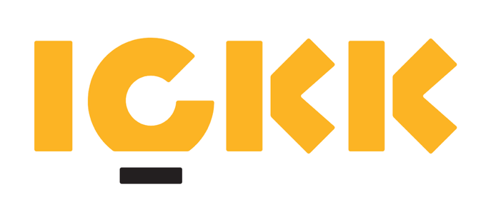

SPACE Youth Centres
Type of good practice: Regional project/initiative (Region-run network of youth centres)
Type of vulnerable youth
Young people up to 19, in risk of NEET or needing additional support (career, education, life skills, well-being)
Area of good practice
Regional – Banská Bystrica region, centres in Banská Bystrica, Banská Štiavnica, Brezno, Lučenec, Revúca, Rimavská Sobota, Zvolen
Main implementer of good practice
Banská Bystrica Self-Governing Region (BBSK) with support from the Regional Development Agency of BBSK, n.o. (Rozvojová agentúra BBSK, n. o.)
Website
https://www.bbsk.sk/centra-mladeze-space
https://www.tvojspace.sk/
Funding/financial model
Public (regional) funding with EU co-financing — the initiative is run by the BBSK and co-financed by the European Union under Programme Slovakia
Other institutions involved
The network operates in cooperation with municipalities and local schools across seven towns in the Banská Bystrica Region and collaborates with the Ministry of Labour, Social Affairs and Family.
Context of good practice
SPACE is a regional “one-stop” youth work model (youth work hubs) run by the Banská Bystrica Self-Governing Region (BBSK), designed to give young people a safe, supportive place to develop and get tailored help with study, work and life decisions. Services are free of charge and available across seven towns in the Banská Bystrica Region - Banská Bystrica, Banská Štiavnica, Brezno, Lučenec, Revúca, Rimavská Sobota and Zvolen - ensuring region-wide access.
Core activities include career guidance, coaching, psychological support, informal learning/workshops (life-skills, entrepreneurship), creative/tech labs (Innolabb), a safe community space, and international work placements as it connects youth to EU-supported mobility and employability projects (e.g., ALMA). The initiative explicitly aims to support youth employment and prevent NEET status, and centres had already helped hundreds of young people.
Launched in 2022 by BBSK, the network was distributed across the region from the outset to keep support close to young people in district towns and smaller localities, with a clear aim to prevent NEET status and strengthen youth employability.
Activities
Centres provide free walk-in and scheduled support: career guidance and job-search help, navigation of education and training pathways, coaching and life-skills development, and, where appropriate, psychological and social counselling. The offer includes workshops, community and creative activities (including tech/creative labs), connections to internships and mobility (such as ALMA), mentoring, and signposting to specialised services (public employment services, youth counselling, social support). The programme is standardised across the network yet adaptable to local needs in each town.
Why should it be considered a good practice
It provides integrated, one-stop access to counselling, skills development and opportunities across the entire Banská Bystrica Region. The model is built on intersectoral collaboration between the region, municipalities, schools and specialised youth-work staff, with documented uptake – hundreds of young people supported to date. It is also readily transferable, as a standardised regional concept with centres replicated across multiple towns.

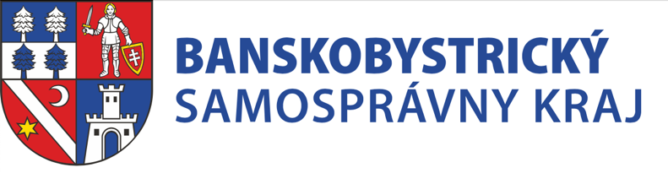
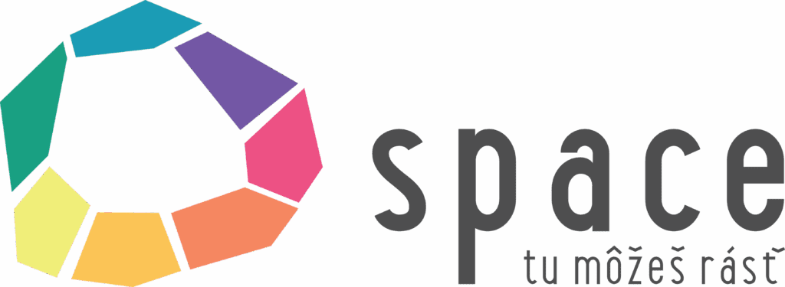

Transition Programme “From School to Life”
Type of good practice: Initiative
Type of vulnerable youth: Youth with disabilities, Youth from ethnic minority
Area of good practice
Regional - Banská Bystrica Region, with activity documented in the Banská Bystrica, Brezno and Lučenec districts.
Main implementer of good practice
ALTERNATÍVA – Centre for Independent Living, n.o. (ALTERNATÍVA – Centrum nezávislého života n. o.)
Website
https://www.alternativacentrum.sk/tranzitny-program-zo-skoly-do-zivota/o-nas
https://www.euroguidance.sk/nckp/alternativa/
Funding/financial model
Non-profit funding from grants and donors, with public campaigns (e.g., tax-donation “2%”) and corporate/charitable support. Employers act as hosts for practice, while the NGO provides the youth service.
Other institutions involved
Local employers (host practice/work experience), with cooperation from local schools/families and community partners.
Context of good practice
The programme addresses a clear gap: many young people with disabilities or social disadvantage leave school without work experience or workplace support and struggle to enter adult life and the labour market. ALTERNATÍVA applies a person-centred, strengths-based approach that treats young people as partners, builds on their abilities, and helps them identify supportive persons while preparing for job interviews and work tasks. The target group are young people with disabilities or social disadvantage in Central Slovakia (Banská Bystrica Region) transitioning from school to work and community life.
Support combines individual guidance and workplace assistance. The team sets goals with each participant, matches them with a host employer, and provides job coaching on site, including workplace adaptation, practice of routines, and feedback-based adjustments. Non-formal learning strengthens social and life skills, while employers are supported so that placements are meaningful for both sides.
Activities
The programme delivers weekly one-to-one, person-centred support focused on identifying strengths, setting short-term goals, and mapping supportive persons in the young person’s environment. It includes job-search and interview preparation, including how to explain disability or disadvantage and request reasonable adjustments.
Participants enter workplaces through supported transit placements, with on-the-job coaching during the adaptation phase. Progress is reviewed jointly with employers, support intensity is gradually reduced once placements stabilise, and alternative matches are arranged if needed. Employers receive ongoing advice on task clarification, communication, and adjustments.
Why should it be considered a good practice
The programme provides integrated, one-stop access to counselling, skills development, and real work opportunities across the Banská Bystrica Region through intersectoral cooperation between municipalities, schools, employers, and youth-work professionals. It addresses the critical school-to-work transition for young people with disabilities using a lightweight, NGO-led model based on person-centred planning and on-the-job coaching.
The approach is practical, easy to replicate without heavy infrastructure, and grounded in real employer partnerships. Its credibility is confirmed by documented uptake, regional anchoring, and public recognition (Roma Spirit 2024), making it a transferable and field-tested model for improving employability and social inclusion.
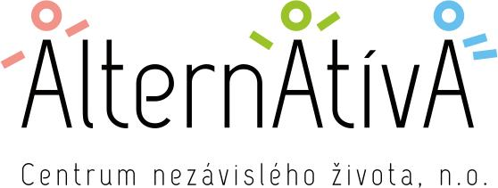

Ukraine

Upskill Now!
Type of good practice: Project
Type of vulnerable youth: Low-educated youth, Youth from low-income families, IDPs
Area of good practice: National, implemented in different Ukrainian regions
Main implementer of good practice: Kyiv School of Economics (KSE) and Promprylad.Renovation
Website
https://kse.ua/about-the-school/news/to-train-10-000-specialists-for-the-ukrainian-labor-market-kyiv-school-of-economics-and-promprylad-launch-a-joint-project/
Funding/financial model
International donor funding combined with private sector contributions and scholarships for participants.
Other institutions involved: Private sector employers, local schools, universities, municipalities
Context of good practice
Ukraine’s labour market is undergoing rapid transformation due to both wartime disruptions and global digitalization trends. Thousands of professionals have been displaced, while employers urgently need new specialists. Young people, women, and veterans often lack access to retraining opportunities that match labour market demand.
The Upskill Now! program responds to this challenge by creating a nationwide platform for professional retraining and career development. It combines market research, targeted training, and direct employer engagement to ensure that at least 10,000 participants quickly acquire practical skills and find meaningful employment in Ukraine’s recovering economy.
Activities
- Short-term intensive courses in digital literacy, IT, entrepreneurship, and project management.
- Development of soft skills (teamwork, communication, leadership, problem-solving).
- Career guidance and mentorship with business professionals.
- Partnerships with companies to provide internships and entry-level job opportunities.
- Hybrid learning model (online and offline) to ensure access for youth from remote areas.
Why should it be considered a good practice
- Directly addresses the mismatch between education and labour market needs
- Provides fast, practical upskilling to 10,000+ specialists
- Supports vulnerable groups with accessible education models
- Builds strong employer partnerships ensuring employability and jobs
- Contributes to overcoming Ukraine’s staffing crisis during wartime
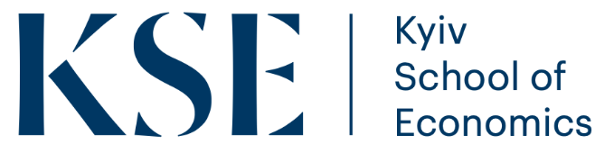

Promprylad.Renovation
Type of good practice: Commercial activity/Social enterprise
Type of vulnerable youth
Youth from remote or rural areas, Youth from low-income families and IDPs
Area of good practice: Local – Ivano-Frankivsk
Main implementer of good practice
Promprylad.Renovation (innovation center, Ivano-Frankivsk)
Website: https://promprylad.ua/en/
Funding/financial model
- Impact investment from private sector and individual investors
- International donor funding (education, youth empowerment, social inclusion projects)
- Revenue from commercial activities (office rental, coworking, events) reinvested into educational and social initiatives
Other institutions involved
- Local schools, vocational colleges, and universities (educational partnerships)
- Private sector employers and investors (internships, job opportunities)
- NGOs and cultural institutions (community and youth engagement)
- International donors (financial support, capacity building)
- Municipal authorities of Ivano-Frankivsk
Context of good practice
Ivano-Frankivsk faces the dual challenge of revitalizing post-industrial spaces while supporting youth employment and community development, particularly for vulnerable groups such as IDPs, rural youth, and young entrepreneurs with limited access to resources. Promprylad.Renovation responds by transforming a former industrial plant into an integrated hub for education, culture, business, and social innovation, combining modern workspaces with structured learning and entrepreneurial programmes as a model of urban regeneration and youth empowerment.
Activities
- Educational programs: workshops, bootcamps, and training in digital literacy, entrepreneurship, creative industries, and social innovation
- Soft skills development: teamwork, leadership, problem-solving through project-based learning
- Career orientation & mentorship: connecting youth with business leaders and professionals from different industries
- Community engagement: hackathons, cultural events, and participatory projects where youth co-create local solutions
- Entrepreneurship & incubation: support for youth-led startups and social enterprises
- Safe and inclusive spaces: coworking areas, labs, and creative studios accessible for IDPs and vulnerable groups
- Partnerships with employers: to ensure internships and entry-level jobs for graduates of training programs
Why should it be considered a good practice
Inclusivity: ensures participation of vulnerable youth (IDPs, rural, low-income backgrounds)
Accessibility: hybrid educational formats, physical safe space, and scholarships make programs open to all
Integration: combines business, culture, and education to give youth real opportunities for skills, jobs, and entrepreneurship
Sustainability: financial model mixes investments, donors, and own revenue, ensuring continuity
Scalability: the Promprylad model of urban and social innovation can be replicated in other Ukrainian cities
Resilience: helps young people adapt to wartime challenges, prepare for reconstruction, and contribute to economic recovery
The initiative has already incubated dozens of startups, hosted hundreds of cultural and educational events, and provided mentorship to youth-led projects. Its financial sustainability model — combining commercial revenue, donor support, and impact investment — ensures long-term continuity. By bridging private investment with community needs, Promprylad demonstrates how industrial revitalization can directly benefit vulnerable youth and local development.
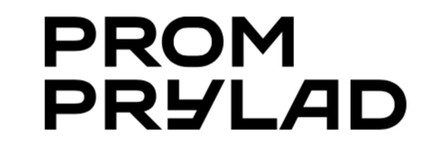

Mobile Youth Work in Communities
Type of good practice: Project
Type of vulnerable youth: Low-educated youth, Youth from remote or rural areas
Area of good practice: Regional – Chernihiv and Sumy regions
Main implementer of good practice
Regional Youth Centres of Chernihiv and Sumy regions, supported by partner organisations - NGO “Molodizhna Platforma”, NRC
Website: https://youthplatform.com.ua/proiekty/mobilna-molodizhna-robota/
Funding/financial model: external organisation NORAD
Other institutions involved: Local municipalities, schools, NGOs, career guidance experts
Context of good practice
Rural youth in Chernihiv and Sumy regions face double isolation: first, due to limited infrastructure and lack of youth centers, and second, due to wartime insecurity and displacement. Many young people cannot access modern training, career guidance, or cultural opportunities, which deepens inequality with urban peers.
Mobile Youth Work was launched to bring opportunities directly to where young people live. By deploying mobile teams equipped with trainers, career advisors, and interactive learning tools, the project ensures that vulnerable youth in remote villages can access skills development and feel part of a broader community.
Activities
- Creation of mobile youth work teams to rural communities.
- Development of tailored educational programmes including workshops, trainings, excursions, and interactive games.
- Career orientation activities enabling youth to explore modern professions and identify their strengths.
- "Start Your Career" training sessions focusing on soft skills (communication, teamwork, creativity) and hard skills (CV writing, interview preparation).
- The project has proven impact: within its first cycles, mobile teams reached dozens of remote communities and engaged hundreds of young participants in structured learning. Its portability and adaptability make it a highly transferable model that could be replicated across other underserved Ukrainian regions.
Why should it be considered a good practice
- Increases access to opportunities for vulnerable youth in remote and rural areas.
- Provides both soft and hard skills essential for labour market integration.
- Innovative mobile approach ensures outreach beyond urban centres.
- Highly adaptable and transferable model that can be replicated in other rural regions.
- Promotes intersectoral cooperation between youth centres, municipalities, NGOs, and schools.


Bootcamps for Schools
Type of good practice: Project
Type of vulnerable youth
Youth from remote or rural areas, Youth with limited access to modern education
Area of good practice: Regional - Kmlenytskyi region
Main implementer of good practice: Platform for Social Change
Website
https://social-change.com.ua/en/rozpochynayemo-seriyu-butkempiv-dlya-shkil-hmelnytskoyi-oblasti/
Funding/financial model: Funded by Platform for Social Change
Other institutions involved
Local schools of Khmelnytskyi region, Teachers and educational staff, Private sector experts (mentors, trainers)
Context of good practice
In Khmelnytskyi region, many schools — particularly in rural communities and those hosting IDPs — face serious resource gaps. Limited access to modern education, extracurricular activities, and digital tools leaves students at risk of exclusion. The war has deepened these challenges, with displaced youth needing both academic and emotional support. The Bootcamps program addresses this by combining intensive skills training, mentorship, and mental health support, helping students and teachers co-create projects that improve their schools and communities
Activities
- Educational Bootcamps: Intensive learning experiences designed to equip students and educators with the knowledge and tools to drive meaningful change in their schools and communities.
- Soft Skills Development: Focus on essential 21st-century skills such as teamwork, leadership, effective communication, critical thinking, and problem-solving.
- Mental Health Support: Integrated sessions and resources aimed at promoting emotional well-being, resilience, and a supportive school environment.
- Community Project Co-Creation: Collaborative project development where students and teachers work together to design and implement impactful initiatives that address local challenges.
- Grants for High Engagement: Schools demonstrating the highest levels of participation and engagement receive grants to bring their co-created projects to life and scale their impact.
Why should it be considered a good practice
Youth empowerment: equips vulnerable youth with 21st-century skills that are not part of the regular school curriculum.
Inclusivity: engages schools from rural and remote areas, as well as those with IDP students.
Practical outcomes: financial support and mentorship ensure that ideas are implemented, not just theoretical.
Holistic approach: combines education, community engagement, and mental health support.
Scalability: the model can be replicated in other Ukrainian regions facing similar challenges
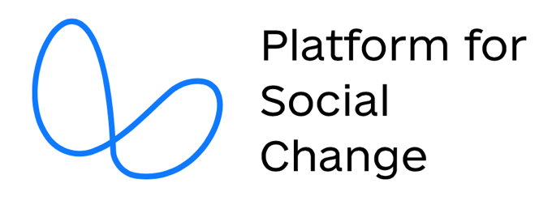

Upshift Ukraine
Type of good practice: Project
Type of vulnerable youth
Youth with disabilities, Youth from remote or rural areas, Youth from low-income families, IDPs
Area of good practice: National – implemented in different cities across Ukraine
Main implementer of good practice: UNICEF Ukraine
Website: https://www.unicef.org/ukraine/upshift
Funding/financial model
UNICEF funding with support from international donors and partners.
Other institutions involved: Local youth NGOs, municipalities, private sector
Context of good practice
Across Ukraine, many young people – particularly from vulnerable backgrounds such as IDPs, low-income families, and rural areas – lack access to funding and mentoring to implement their ideas. Traditional school curricula rarely provide space for entrepreneurship or social innovation.
The UPSHIFT program fills this gap by combining training in project management and teamwork with grants and mentorship. It enables youth teams to design and implement their own social initiatives, empowering them to become active contributors to their communities.
Activities
- Training in project management, teamwork, and leadership.
- Small grants for youth-led projects.
- Mentorship from professionals in relevant fields.
- Development of social innovation initiatives by youth teams.
Why should it be considered a good practice
Upshift empowers youth to be active agents of change, enabling them to design and implement their own social initiatives. The program is globally recognized and has been successfully adapted to the Ukrainian context.
In Ukraine, UPSHIFT has already supported hundreds of youth-led projects ranging from mental health campaigns to eco-initiatives and digital startups. Its proven methodology, recognized and applied globally, ensures both quality and adaptability. The program’s focus on agency and ownership makes young people not just beneficiaries, but drivers of social change.
